|  |  |
| --- | --- |
| 3GPP TR 38.854 V18.0.0 (2023-09) | |
| Technical Report | |
| 3rd Generation Partnership Project;  Technical Specification Group Radio Access Network;  NR;  NR support for high speed train scenario in frequency range 2 (FR2)  (Release 18) | |
|  | |
|  |  |
|  | |
| The present document has been developed within the 3rd Generation Partnership Project (3GPP TM) and may be further elaborated for the purposes of 3GPP. The present document has not been subject to any approval process by the 3GPPOrganizational Partners and shall not be implemented. This Specification is provided for future development work within 3GPPonly. The Organizational Partners accept no liability for any use of this Specification. Specifications and Reports for implementation of the 3GPP TM system should be obtained via the 3GPP Organizational Partners' Publications Offices. | |

|  |
| --- |
|  |
| ***3GPP***  Postal address  3GPP support office address  650 Route des Lucioles - Sophia Antipolis  Valbonne - FRANCE  Tel.: +33 4 92 94 42 00 Fax: +33 4 93 65 47 16  Internet  http://www.3gpp.org |
| ***Copyright Notification***  No part may be reproduced except as authorized by written permission. The copyright and the foregoing restriction extend to reproduction in all media.  © 2023, 3GPP Organizational Partners (ARIB, ATIS, CCSA, ETSI, TSDSI, TTA, TTC).  All rights reserved.  UMTS™ is a Trade Mark of ETSI registered for the benefit of its members  3GPP™ is a Trade Mark of ETSI registered for the benefit of its Members and of the 3GPP Organizational Partners LTE™ is a Trade Mark of ETSI registered for the benefit of its Members and of the 3GPP Organizational Partners  GSM® and the GSM logo are registered and owned by the GSM Association |

Contents

Foreword 7

1 Scope 9

2 References 9

3 Definitions of terms, symbols and abbreviations 9

3.1 Terms 9

3.2 Symbols 9

3.3 Abbreviations 9

4 Introduction 9

5 FR2 HST deployment scenario 10

5.1 General 10

5.2 HST scenario and RRH parameters 12

5.2.1 Unidirectional deployments 12

5.2.2 Bidirectional deployment 14

5.2.3 RRH Parameters 17

5.3 Train roof-mounted high-power CPE parameters 18

5.3.0 Introduction 18

5.3.1 Number of panels per CPE 18

5.3.2 Placement of CPE panel(s) 19

5.3.3 Number of CPE devices 19

6 FR2 high speed feasibility evaluation 19

6.1 Evaluation Parameters 19

6.1.1 RRH antenna array parameters for evaluation 19

6.1.2 RRH antenna element parameters for evaluation 20

6.1.3 CPE antenna array parameters for evaluation 20

6.1.4 CPE antenna element parameters for evaluation 20

6.2 Channel model for FR2 HST 21

6.2.1 Pathloss model used for link budget evaluation 21

6.2.2 Channel modelling for performance requirements 23

6.3 FR2 Feasibility Evaluation 27

6.3.1 Idle/inactive mode 27

6.3.2 Connected mode 27

6.3.2.1 Number of Rx beams 27

6.3.2.1.1 Scenario-A 28

6.3.2.1.2 Scenario-B 29

6.3.3 Link Performance and Throughput Performance 33

6.3.3.1 Link Performance Evaluation from Samsung 33

6.3.3.1.1 Scenario-A, Uni-directional RRH Deployment 33

6.3.3.1.2 Scenario-A, Bi-directional RRH Deployment 35

6.3.3.1.3 Scenario-B, Uni-directional RRH Deployment 37

6.3.3.1.4 Scenario-B, Bi-directional RRH Deployment 37

6.3.3.2 Link performance Evaluation from Huawei 37

6.3.3.2.1 Scenario A 37

6.3.3.2.1.1 Scenario A, Bi-directional 37

6.3.3.2.1.2 Scenario A, Uni-directional 38

6.3.3.2.2 Scenario B 39

6.3.3.2.2.1 Scenario B, Bi-directional 40

6.3.3.2.2.2 Scenario B, Uni-directional 43

6.3.3.3 Link level performance from Ericsson 44

6.3.3.3.1 Scenario-A, Uni-directional RRH Deployment 44

6.3.3.3.2 Scenario-A, Bi-directional RRH Deployment 47

6.3.3.3.3 Scenario-B, Uni-directional RRH Deployment 47

6.3.3.3.4 Scenario-B, Bi-directional RRH Deployment 50

6.3.3.4 Throughput Performance from Nokia 51

6.3.4 Mobility Performance 55

6.3.4.1 System-level evaluation of mobility performance by Nokia 56

6.3.4.1.1 Legacy RRM requirement mobility performance 56

6.3.4.1.1.1 Uni-directional Scenario-A without DPS 57

6.3.4.1.1.2 Uni-directional Scenario-A with DPS 60

6.3.4.1.1.3 Uni-directional Scenario-B without DPS 62

6.3.4.1.1.4 Uni-directional Scenario-B with DPS 64

6.3.4.1.1.5 Bi-directional Scenario-B without DPS 66

6.3.4.1.1.6 Bi-directional Scenario-B with DPS 68

6.3.4.1.1.7 Bi-directional Scenario-A without DPS 70

6.3.4.1.1.8 Bi-directional Scenario-A with DPS 72

6.3.4.1.2 Enhanced RRM requirement mobility performance 73

6.3.4.1.2.1 Uni-directional Scenario-A without DPS 76

6.3.4.1.2.2 Uni-directional Scenario-A with DPS 78

6.3.4.1.2.3 Uni-directional Scenario-B without DPS 80

6.3.4.1.2.4 Uni-directional Scenario-B with DPS 82

6.3.4.1.2.5 Bi-directional Scenario-B without DPS 84

6.3.4.1.2.6 Bi-directional Scenario-B with DPS 86

6.3.4.1.2.7 Bi-directional Scenario-A without DPS 87

6.3.4.1.2.8 Bi-directional Scenario-A with DPS 90

6.3.4.1.2.9 Uni-directional Tunnel scenario without DPS 92

6.3.4.1.2.10 Uni-directional Tunnel scenario with DPS 94

6.3.4.1.2.11 Transition at the tunnel entrance/exit without DPS 96

6.3.4.1.2.11.1 Transition from open-space Scenario-A to the Tunnel 98

6.3.4.1.2.12.1 Transition from open-space Scenario-B to the Tunnel 99

6.3.4.1.3 Conclusions on mobility performance 100

6.3.5 Receive time difference 103

6.3.6 Maximum supported Doppler frequency 103

6.3.7 Maximum supported Speed 103

6.3.8 Beam dwelling time 104

6.3.8.1 Simulation results 104

6.3.8.2 Beam coverage analysis 109

7 Identified RAN4 requirements 112

7.1 CPE RF core requirements 112

7.1.1 Minimum Peak EIRP 114

7.1.2 Beam Correspondence 115

7.2 RRM requirements 116

7.2.1 Idle/inactive mode 117

7.2.2 Connected mode 117

7.2.2.1 UE UL transmit timing 121

7.2.2.1.1 Random Access based timing adjustment 121

7.3 Demodulation performance requirements 122

7.3.1 UE demodulation requirements 123

7.3.2 BS demodulation requirements 134

8 Conclusion 141

Annex A (informative): Change history 142

# Foreword

This Technical Report has been produced by the 3rd Generation Partnership Project (3GPP).

The contents of the present document are subject to continuing work within the TSG and may change following formal TSG approval. Should the TSG modify the contents of the present document, it will be re-released by the TSG with an identifying change of release date and an increase in version number as follows:

Version x.y.z

where:

x the first digit:

1 presented to TSG for information;

2 presented to TSG for approval;

3 or greater indicates TSG approved document under change control.

y the second digit is incremented for all changes of substance, i.e. technical enhancements, corrections, updates, etc.

z the third digit is incremented when editorial only changes have been incorporated in the document.

In the present document, modal verbs have the following meanings:

**shall** indicates a mandatory requirement to do something

**shall not** indicates an interdiction (prohibition) to do something

The constructions "shall" and "shall not" are confined to the context of normative provisions, and do not appear in Technical Reports.

The constructions "must" and "must not" are not used as substitutes for "shall" and "shall not". Their use is avoided insofar as possible, and they are not used in a normative context except in a direct citation from an external, referenced, non-3GPP document, or so as to maintain continuity of style when extending or modifying the provisions of such a referenced document.

**should** indicates a recommendation to do something

**should not** indicates a recommendation not to do something

**may** indicates permission to do something

**need not** indicates permission not to do something

The construction "may not" is ambiguous and is not used in normative elements. The unambiguous constructions "might not" or "shall not" are used instead, depending upon the meaning intended.

**can** indicates that something is possible

**cannot** indicates that something is impossible

The constructions "can" and "cannot" are not substitutes for "may" and "need not".

**will** indicates that something is certain or expected to happen as a result of action taken by an agency the behaviour of which is outside the scope of the present document

**will not** indicates that something is certain or expected not to happen as a result of action taken by an agency the behaviour of which is outside the scope of the present document

**might** indicates a likelihood that something will happen as a result of action taken by some agency the behaviour of which is outside the scope of the present document

**might not** indicates a likelihood that something will not happen as a result of action taken by some agency the behaviour of which is outside the scope of the present document

In addition:

**is** (or any other verb in the indicative mood) indicates a statement of fact

**is not** (or any other negative verb in the indicative mood) indicates a statement of fact

The constructions "is" and "is not" do not indicate requirements.

# 1 Scope

The present document is a technical report for Rel-17 NR support for high speed train scenario in FR2.

# 2 References

The following documents contain provisions which, through reference in this text, constitute provisions of the present document.

- References are either specific (identified by date of publication, edition number, version number, etc.) or non‑specific.

- For a specific reference, subsequent revisions do not apply.

- For a non-specific reference, the latest version applies. In the case of a reference to a 3GPP document (including a GSM document), a non-specific reference implicitly refers to the latest version of that document *in the same Release as the present document*.

[1] 3GPP TR 21.905: "Vocabulary for 3GPP Specifications".

[2] C.A. Balanis: "Antenna theory: design and analysis ", Wiley, 2005.

# 3 Definitions of terms, symbols and abbreviations

## 3.1 Terms

For the purposes of the present document, the terms given in 3GPP TR 21.905 [1] and the following apply. A term defined in the present document takes precedence over the definition of the same term, if any, in 3GPP TR 21.905 [1].

## 3.2 Symbols

For the purposes of the present document, the following symbols apply:

## 3.3 Abbreviations

For the purposes of the present document, the abbreviations given in 3GPP TR 21.905 [1] and the following apply. An abbreviation defined in the present document takes precedence over the definition of the same abbreviation, if any, in 3GPP TR 21.905 [1].

# 4 Introduction

5G NR operating in millimeter wave bands (i.e., Frequency Range 2) is recognized as the technology capable of providing ultra-high data-rate transmission, thanks to the availability of enormous amount of bandwidth in FR2 and the advanced 5G NR design for FR2 beamforming-based operation. Inspired by the successful commercial FR2 deployment globally, more potential 5G NR deployment scenarios in FR2 draw attentions from the industry. Among those scenarios identified, high speed train (HST) scenario has the special importance, because of the fast expanding HST systems worldwide deployed and the great demands of high-speed connections from passengers and HST special services. This triggers the new and challenging demand for 5G NR FR2 HST scenario.

In existing study and work items led by 3GPP RAN4 (for either LTE or NR), high speed train scenarios under consideration has the operating bands up to 3.5GHz, however no existing works studied the more challenging millimeter wave frequency range 2, in which Doppler shift and Doppler spread will be further severe (e.g., for 240km/h with 28GHz, the Doppler shift is about 6.22kHz) and more challenging to radio resource management. Specifically, the existing FR2 RRM and demodulation requirements has not yet taken into account the impact of high speed in the above-mentioned scenario, where the channel model and mobility scenario need further study and the demodulation, measurement, mobility and beam management related requirements require to be further specified.

It should be noted that user equipment considered in 5G NR FR2 HST scenario is vehicle-roof mounted customer-premises equipment (CPE), which are expected to communicate with track-side deployed gNBs for the backhaul link and to further provide on-board broadband connections to user terminals and/or for other train-specific demands as access link.

This work will specify NR UE RF requirements, UE RRM requirements and BS/UE performance requirements for high speed train scenario with up to 350km/h in Rel-17.

# 5 FR2 HST deployment scenario

Following section include the agreed FR2 HST deployment specific investigated options and agreements.

## 5.1 General

This section includes the agreed scenario and RRH parameters to be used in the investigated FR2 HST deployments. It captures the agreement and conclusions made during the work on FR2 HST deployment scenario and related aspects. Following figure 5.1-1 illustrates the definition of the different used D-values.

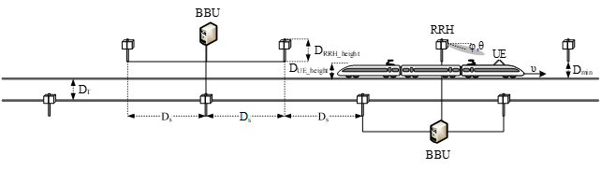

Figure 5.1-1 Illustration of the D-values used on RAN4 work.

General deployment parameters:

RAN4 will at least consider the following general deployment for open-space scenarios:

- Ds and Dmin: Take the 5 scenarios in table 5.1-1 as basic assumption; and

- Scenario 1 and 4 shall be considered with high priority; and

- Dmin for [5m, 20, 30 and 50 meters] if found to be necessary; and

- DRRH_height: 15m as basic assumption, [10,20m] if found to be necessary; and

- DUE_height: 5m.

|  |  |  |
| --- | --- | --- |
| Scenario | Ds (meter) | Dmin (meter) |
| 1 | 800 | 10 |
| 2 | 700 | 10 |
| 3 | 500 | 10 |
| 4 | 700 | 150 |
| 5 | 200 | 30 |

RAN4 will at least consider the following assumptions for the deployment in the tunnel scenario:

- Ds and DUE_height are considered similar as in open-space deployment in Scenario 2 and 4, i.e., Ds=700m and DUE_height =5m; and

- Dmin and DRRH_height are constrained by the tunnel (e.g, dimension, shape, etc), and shall be smaller than values for open space scenario;

- Dmin: 1m; and

- DRRH_height: 5.3m for one-track tunnel and 7.4m for two-track tunnel as the baseline assumption. The one-track tunnel shall be considered with higher priority.

Sub-Carrier Spacing (SCS):

It is still open which SCS options to consider. The options are:

- Option-1: SCS = 120kHz; and

- Option-2: Consider both SCS = 120kHz and 60kHz.

Concerning the transmissions schemes following schemes were discussed in distinguished:

- JT: Joint Transmission scheme applied for all channel (SSB, TRS, PDCCH, PDSCH) – Full SFN; and

- DPS: Dynamic Point Selection based on the Rel-15 beam management (BM) principles; and

- Multi-DCI based Multi-TRP transmission based on the Rel-15 eMIMO principles.

Among these the following down selection has been agreed:

- For Rel-17 WI discussion, FR2 HST transmission schemes which are not compatible with Rel-15/16 NR are precluded; and

- For Rel-17 WI discussion, Joint transmission (JT) used for FR2 HST, only full SFN is considered; and

- For Rel-17 WI discussion, Multi-DCI based multi-TRP transmission is precluded.

RAN4 primarily consider HST FR2 deployment with

- One train moving over one railway track in one direction. RAN4 focuses on 1 direction 1 train. If this opposite direction is completely symmetric, the 1 direction study can apply directly; and

- RRHs are located on one side of the track.

Dedicated network for roof-mounted CPE:

- RAN4 to assume that in HST FR2 Scenario A, only high-speed CPEs installed on the roof of the train can be present in the network.

RAN4 did comparison between unidirectional and bi-directional RRH deployments for Scenario-A and concluded that from signal strength and beam coverage perspective the bi-directional deployment will not provide significant throughput improvement compared to unidirectional deployment. This conclusion is based on the deployment scenario analysis. RAN4 will only consider unidirectional deployments for Scenario-A. Bi-directional deployment can be considered if the feasibility issue of unidirectional deployment is identified.

RAN4 assume that FR2 HST with CPEs is operated as dedicated network. Hence, assumption in RAN4 is that in HST FR2 Scenario A and B, only high-speed CPEs installed on the roof of the train can be present in the network. There is no need to differentiate roof-mounted CPE from other FR2 UEs in HST FR2 scenario.

RAN4 will not consider curvature when defining the requirements.

RAN4 assumed that uni-directional and bi-directional RRH deployments can be considered for tunnel scenario, in which single-panel reception UE and DPS transition scheme shall have higher priority. RAN4 also agreed that multi-panel reception may also be considered in the HST FR2 tunnel scenario to alleviate potential mobility issues that may occur inside the tunnel.

## 5.2 HST scenario and RRH parameters

RAN4 will investigate both unidirectional and bidirectional deployment scenarios for FR2 HST.

The exact understanding and definition of HST still needs further discussion based on the following interpretations:

- HST Interpretation-1: All RRHs under one BBU transmit the same signal (SFN).

- Selected RRH(s) for TX, depending on DPS Tx mode is used or not.

- HST Interpretation-2: All RRHs under one BBU in the same cell ID, but for different TCI.

- Other interpretation is not precluded.

For full SFN JT and unidirectional RRH deployment, only consider following scenario:

- The setting with only one TCI state transmission.

The value of Ds_offset implicitly limit the RRH beam direction, so there is no need to introduce additional restriction on RRH beam’s possible range of angle on azimuthal plane.

### 5.2.1 Unidirectional deployments

For the unidirectional scenario RAN4 will consider SFN scenario. Hence, one panel per RRH pointed to the same direction for all RRHs (figure 5.2.1-1).

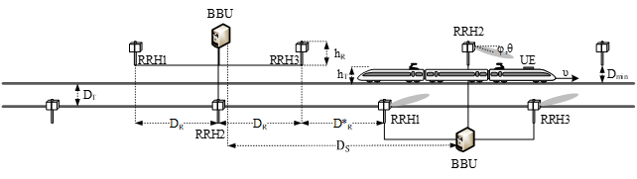

Figure 5.2.1-1 HST scenario with one panel per RRH pointing to the same direction for all RRHs

For the unidirectional scenario the following unidirectional deployment scenario in table 5.2-1 will be prioritized:

Table 5.2-1: Assumed deployment parameters for unidirectional scenario.

|  |  |
| --- | --- |
| Parameter | Value |
| Ds and Dmin | Scenario 2: Ds = 700m and Dmin = 10m  Scenario 4: Ds = 700m and Dmin = 150m  Tunnel scenario: Ds=700m and Dmin = 1m |
| RRH height | Scenario 2 and 4: 15m  Tunnel Scenario: 5.3m Note 1 |
| Number of RRH sites per BBU | 4 |
| Number of RRH panels per RRH sites | 1 (i.e. unidirectional) Note 2 |
| Number of analog beams per RRH panel | 1 or 2 Note 3 |
| RRH panel orientation | Option 1: RRH panel boresight pointed to the railway at the direction of Ds (projection of the neighboring RRH on the railway).  Option 2: other options not precluded |
| Analog beam orientation | Based on companies’ selection for better performance |
| Note 1: RRH height for single track railway tunnel. For two-track railway tunnel, RRH height is 7.4m  Note 2: For JT for all channels, 1 beam per RRH panel is considered.  Note 3: For DPS, 1 or 2 analog beams per RRH panel can be considered. | |

Number of Beam for unidirectional RRH deployment, Scenario 2:

- For scenario 2, unidirectional, RRH parameter: 1 beam per RRH panel; and

- For scenario 2, unidirectional, UE parameter:

a) 1 beam per panel; and

b) 2 panels assumed to be implemented in the UE side; and

c) Only the one active panel per UE can be used for Tx and Rx; and FFS whether another panel can be used for beam search

RRH switching point for unidirectional RRH deployment, Scenario 2, figure 5.2.1-2:

- RRH switching point is where the UE switches from the source RRH beam to the target RRH beam based on maximizing SNR among detected beams.

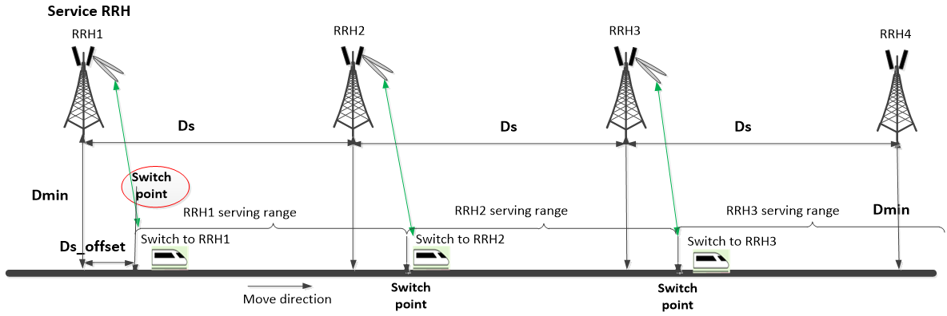

Figure 5.2.1-2: RRH switching point for unidirectional RRH deployment.

Number of Beam for unidirectional RRH deployment, Scenario 4:

- For scenario 4, unidirectional, RRH parameter:

a) 1 beam per RRH panel; or

b) 2 beams per RRH panel; or

c) 3 beams per RRH panel; or

d) 4 beams per RRH panel.

Note that uneven separation between beams can be considered.

RAN4 agreed that at least 2 beams per RRH panel is considered. Other options are not precluded, and it is FFS whether there are benefits of implementing more beams per RRH panel.

- For scenario 4, unidirectional, UE parameter:

a) 1 beam per UE panel; or

b) 2 beams per UE panel; or

c) 7 beams per UE panel.

RAN4 assumes 2 panels to be implemented in the UE side. Only the one active panel per UE can be used for Tx and Rx; and FFS whether another panel can be used for beam search.

RAN4 decided that at least option a) of having 1 beam per panel is considered. Other options are not precluded, and it is FFS whether there are benefits of implementing more beams per UE panel.

Number of Beam for unidirectional RRH deployment in Tunnel scenario shall follow similar setting as in Scenario 2:

- For Tunnel scenario, unidirectional, RRH parameter: 1 beam per RRH panel; and

- For Tunnel scenario, unidirectional, UE parameter:

a) 1 beam per panel; and

b) 2 panels assumed to be implemented in the UE side; and

c) Only the one active panel per UE can be used for Tx and Rx; and FFS whether another panel can be used for beam search

RRH switching point for unidirectional RRH deployment, Tunnel scenario, Figure 5.2.1-2 with Ds_offset could be shorter than that in Scenario 2.

### 5.2.2 Bidirectional deployment

For the bidirectional scenario RAN4 will consider SFN scenario where there is one panel per RRH with signals to opposite directions along the track (figure 5.2.2-1).

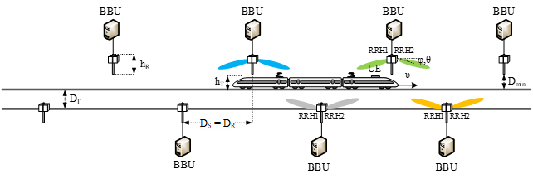

Figure 5.2.2-1 HST scenario with one panel per RRH

Additionally, also SFN scenario where there are two panels per RRH (figure 5.2.2-2).

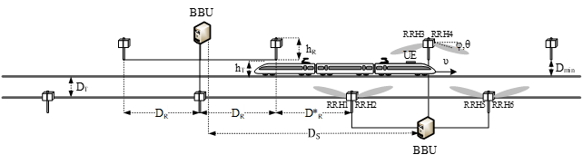

Figure 5.2.2-2 HST scenario with two panels per RRH

For the bi-directional scenario the following bi-directional deployment scenario in table 5.2-2 will be studied:

Table 5.2-2: Assumed deployment parameters for bi-directional scenario.

|  |  |
| --- | --- |
| Parameter | Value |
| Ds and Dmin | Scenario 2: Ds = 700m and Dmin = 10m  Scenario 4: Ds = 700m and Dmin = 150m  Tunnel scenario: Ds=700m and Dmin=1m |
| RRH height | Scenario 2 and 4: 15m  Tunnel Scenario: 5.3m |
| Number of RRH sites per BBU | 4 |
| Number of RRH panels per RRH sites | 2 (i.e. bi-directional) |
| Number of analog beams per RRH panel | 1, 2 or 4 |
| RRH panel orientation | Option 1: RRH panel boresight pointed to the railway in the middle point between 2 RRHs.  Option 2: RRH panel boresight pointed to the railway at the distance of Ds (projection of the neighboring RRH on the railway). Other options not precluded. |
| Analog beam orientation | Based on companies’ selection for better performance |

Candidate schemes for bi-directional deployment for further analysis, scenario 2:

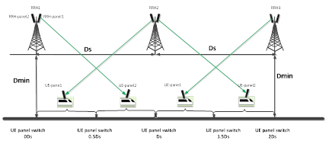

Figure 5.2.2-3: Connecting to 2nd-Nearest RRH

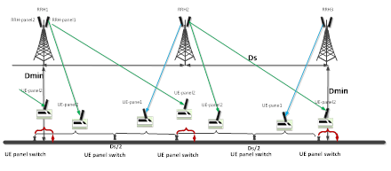

Figure 5.2.2-4: Scheme-2: Connecting to Nearest RRH except Coverage Hole

For Scenario 2 bi-directional RRH deployment:

- [Scheme 1 under bi-directional scenario is feasible without coverage hole issue, and no propagation delay jump between switching points];

- Scheme-2 can be used as starting points for further analysis.

Number of beams for bi-directional RRH deployment, Scenario 2:

- For scenario 2, bi-directional, RRH parameter: 1 beam per RRH panel, two panels in opposite directions; and

- For scenario 2, bi-directional, UE parameter: 1 beam per UE panel (i.e., 2 beams per UE).

Candidate schemes for bi-directional deployment for further analysis, for scenario 4:



Figure 5.2.2-5: Connecting to 2nd-Nearest RRH



Figure 5.2.2-67: Scheme-2: Connecting to Nearest RRH except Coverage Hole

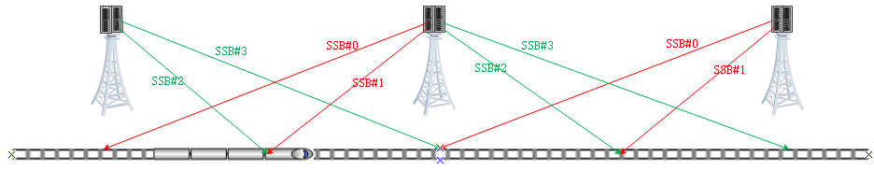

Figure 5.2.2-7: Scheme-3: Connecting to Nearest RRH except the area under the RRH

For Scenario 4 bi-directional RRH deployment: the schemes above can be used as starting points for further analysis.

Number of beams for bi-directional RRH deployment, Scenario 4:

- For scenario B, bi-directional, RRH parameter:

a) 1 beam per RRH panel; or

b) 2 beams per RRH panel; or

c) 3 beams per RRH panel; or

d) 4 beams per RRH panel.

Note that uneven separation between beams can be considered.

RAN4 agreed that at least 2 beams per RRH panel is considered. Other options are not precluded, and it is FFS whether there are benefits of implementing more beams per RRH panel.

- For scenario 4, bi-directional, UE parameter:

a) 1 beam per UE panel; or

b) 2 beams per UE panel; or

c) 7 beams per UE panel.

RAN4 assumes 2 panels to be implemented in the UE side. Only the one active panel per UE can be used for Tx and Rx; and FFS whether another panel can be used for beam search.

RAN4 decided that at least option a) of having 1 beam per panel is considered. Other options are not precluded, and it is FFS whether there are benefits of implementing more beams per UE panel.

Number of beams for bi-directional RRH deployment in Tunnel scenario shall be similar to Scenario 2 setting:

- For Tunnel scenario, bi-directional, RRH parameter: 1 beam per RRH panel, two panels in opposite directions; and

- For Tunnel scenario, bi-directional, UE parameter: 1 beam per UE panel (i.e., 2 beams per UE).

For bi-directional RRH deployment, DPS transmission scheme shall be considered.

### 5.2.3 RRH Parameters

The detailed RRH parameters are still under discussion in RAN4 and following options have been agreed for potential down selection:

Number of RRH sites per BBU:

- [1 to 4] RRHs sites per BBU; and

- Other values are not precluded.

Number of Analog Beams per panel in RRH:

- [1,2,4] analogue beam(s) per panel in RRH; and

- Other values are not precluded.

SSB index to Beam Mapping. The impact of following options for SSB index to Beam mapping is FFS:

1) Option 1:

a) All RRHs (connected to one BBU with fiber) share the same cell ID; and

b) All RRHs under the same cell use the same set of SSB indexes, e.g., all RRHs use SSB-0 to SSB-3.

2) Option 2:

a) All RRHs (connected to one BBU with fiber) share the same cell ID; and

b) RRHs under the same cell use the different sets of SSB indexes, e.g., RRH-1 uses SSB-0 to SSB-3, RRH-2 uses SSB-4 to SSB-7.

When DPS is used as transmission scheme, SSB index to Beam Mapping used in the discussion for this WI is as follows:

RRHs under the same cell use different sets of SSB indexes, e.g., RRH-1 uses SSB-0 to SSB-3, RRH-2 uses SSB-4 to SSB-7, etc.

RAN4 discussed the aspect of potential handover problem due to sudden RX signal increase of the target cell. RAN4 thinks that this can be alleviated by DPS transmission scheme with carefully allocated SSB-index among neighboring cells to avoid inter-cell interference.

Concerning RRH antenna array orientation the impact of following options for RRH antenna array orientation is FFS:

- Option 1: RRH panel boresight pointed to the railway in the middle point between 2 RRHs; or

- Option 2: RRH panel boresight pointed to the railway at the distance of Ds (projection of the neighbouring RRH on the railway); or

- Other option is not precluded.

Related to RRH/UE boresight direction of Antenna Panel and beam direction, RAN4 may not need to specify RRH/UE boresight direction of antenna panel and beam direction for deployment scenario study, but left for companies’ choice:

- RRH/UE boresight direction of antenna panel and beam direction information can be provided by individual company to accompany their deployment scenario analysis result, which can be captured in TR.

## 5.3 Train roof-mounted high-power CPE parameters

### 5.3.0 Introduction

NOTE: Single panel, i.e. only one active antenna panel at a time, as baseline antenna assumption

### 5.3.1 Number of panels per CPE

The number of panels per CPE was open and for discussion. Concerning the number of panels per CPE following will be considered:

- 2 panels per CPE each for both for TX and RX. Each panel points in opposite directions.

For the bi-directional Operation for Two Panels in the CPE following is considered:

- Follow the Rel-15/16 principle of “only one active Rx/Tx panel at a time”.

### 5.3.2 Placement of CPE panel(s)

UE antenna panel(s) for forward and backward directions:

- RAN4 to consider CPE to be equipped with two panels pointed forward and backward along the track.

UE boresight direction of Antenna Panel and beam direction, RAN4 may not need to specify RRH/UE boresight direction of antenna panel and beam direction for deployment scenario study, but left for companies’ choice:

- RRH/UE boresight direction of antenna panel and beam direction information can be provided by individual company to accompany their deployment scenario analysis result, which can be captured in TR.

### 5.3.3 Number of CPE devices

Number of CPE devices per train/carriage:

- RAN4 requirement can be defined based on the baseline of 1 CPE device per train.

# 6 FR2 high speed feasibility evaluation

This section will include the evaluation parameters and channel model used in the FR2 HST and used for evaluating the feasibility FR2 HST.

## 6.1 Evaluation Parameters

### 6.1.1 RRH antenna array parameters for evaluation

RAN4 will perform FR2 HST feasibility study based on following RRH antenna array parameters in table 6.1.1.1 for evaluation:

Table 6.1.1.1

|  |  |
| --- | --- |
| Parameter | Urban Macro 30 GHz |
| Am | 30 |
| SLAy | 30 |
| j3dB | 90 |
| q3dB | 90 |
| Ge,max | 5.5 |
| LE | 1.8 |
| P | 2 |
| dy | 0.5l |
| dh | 0.5l |

Antenna array configuration options were considered:

- Option-1: [Mg, Ng, M, N, P] = [1, 1, 4, 8, 2]; and

- Option-2: [Mg, Ng, M, N, P] = [1, 1, 8, 8, 2]; and

- Option-3: [Mg, Ng, M, N, P] = [1, 1, 8, 16, 2].

RAN4 also agreed that other options are not precluded. RRH Antenna Element Assumption for RRH side following option is assumed:

- Option-2: [Mg, Ng, M, N, P] = [1, 1, 8, 8, 2].

RF session can trigger relevant discussion on RF requirements taking above agreements into account.

### 6.1.2 RRH antenna element parameters for evaluation

RAN4 agreed to use the following RAN1 assumptions in table 6.1.2.1 for BS evaluation as baseline, while other assumptions are not precluded:

Table 6.1.2.1: BS evaluation parameters.

|  |  |  |
| --- | --- | --- |
| Radiation power pattern of a single antenna element for TRP | Vertical cut of the radiation power pattern (dB) |  |
| Horizontal cut of the radiation power pattern (dB) |  |
| 3D radiation power pattern (dB) |  |
| Maximum directional gain of an antenna element GE,max | [8] dBi |

### 6.1.3 CPE antenna array parameters for evaluation

RAN4 will perform the FR2 HST feasibility study based on following CPE antenna array parameters for evaluation:

- RAN1 assumption: 2 ports: [Mg, Ng, M, N, P] = [1, 1, 2, 4, 2]; and

- PC4 assumption: 2 ports: [Mg, Ng, M, N, P] = [1, 1, 4, 4, 2].

RAN4 also agreed that other options are not precluded.

UE Antenna Element Assumption: on UE side:

- Option 1: N=4, M=4 with 2 polarizations as starting point, and other options not precluded pending on further discussion.

RF session can trigger relevant discussion on RF requirements taking above agreements into account.

### 6.1.4 CPE antenna element parameters for evaluation

RAN4 use the following RAN1 assumption for CPE antenna element parameters evaluation in table 6.1.4.1 as baseline:

Table 6.1.4.1: CPE antenna element parameters.

|  |  |
| --- | --- |
| Parameter | Values |
| Antenna element radiation pattern in θ’’ dim (dB) |  |
| Antenna element radiation pattern in ϕ’’ dim (dB) |  |
| Combining method for 3D antenna element pattern (dB) |  |
| Maximum directional gain of an antenna element GE,max | 5dBi |

## 6.2 Channel model for FR2 HST

This section collects the channel model information used for FR2 HST feasibility evaluation and provides the analysis on channel modelling for performance requirements.

### 6.2.1 Pathloss model used for link budget evaluation

**Pathloss model for open-space deployments:**

To have the link budget analysis for the proposed FR2 HST deployment scenarios, the accurate large-scale pathloss model is one of the prerequisites. The following large scale pathloss models are proposed to be considered as candidate options:

- Option-1: TR38.901 RMa LoS (baseline option); or

- Option-2: free space model; or

- Option-3: TR38.901 UMa LoS.

TS38.901 RMa LoS pathloss model will be used for link budget evaluation at least for scenario 2 in table 5.1-1.

RAN4 to choose TS38.901 RMa LoS pathloss model also for the evaluation of Scenario 4 in table 5.1-1.

For the purpose of demonstrating and validating which large scale channel modeling is suitable for FR2 HST, the analysis has been provided based on the practical field measurement. Specifically, based upon the conditions provided in the Table 6.2.1-1, the practical field testing on a trait along a typical railway has been conducted to obtain measurement data at the frequency of 28GHz, as illustrated in the Figure 6.2.1-1.

Table 6.2.1-1 Parameters for practical field measurement for typical high speed train scenario

|  |  |
| --- | --- |
| Parameter name | Configuration value |
| Minimum TX-RX distance | 60 m |
| Maximum TX-RX distance | 550 m |
| Distance granularity | 1 m |
| Center frequency | 28 GHz |
| TX antenna height | 5 m |
| RX antenna height | 3 m |
| Parameter *h*E in 3GPP | 1 m |

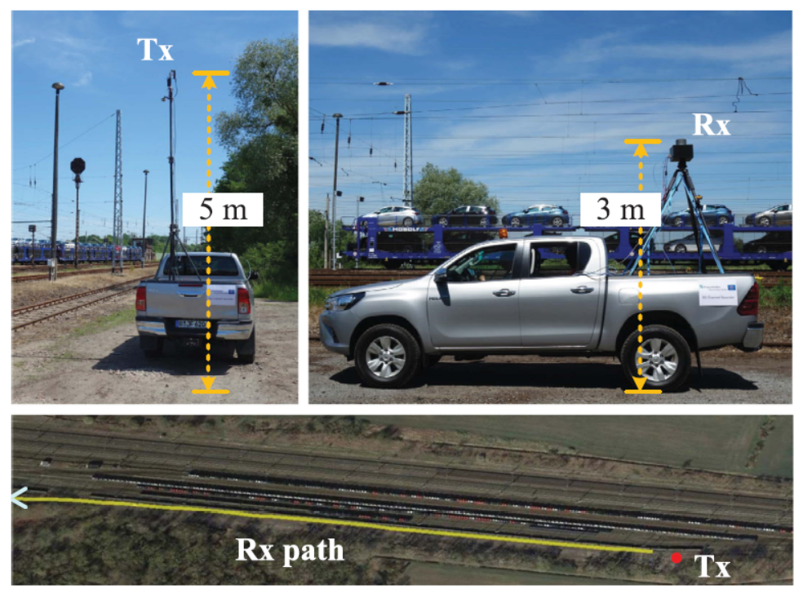

Figure 6.2.1-1 Illustration of practical field measurement conducted for typical high speed train scenario

By having the analysis based on the measurement data obtained from the measurement campaign as above described, the comparison among measurement results and pathloss models (i.e., the three options of RMa LOS, UMa LOS and free space model) is demonstrated in Figure 6.2.1-2 and accompanying Table 6.2.1-2 in which the numerical results are contained.



Figure 6.2.1-2 Comparison of measurement data and pathloss models for FR2 HST

By leveraging the numerical results in terms of the root mean square error (RMSE), mean error and standard deviation (Std), it has been demonstrated that for the evaluated range there is no significant difference from three different pathloss LoS models, and the field measurement also validate that LoS model can reflect the practical FR2 HST channel condition compared with NLoS models. By further investigating three LoS models’ similarity from measurement data, it has been demonstrated that RMa LoS model can achieve the lowest value of RMSE and best mean error with reasonable standard deviation.

Table 6.2.1-2 Numerical comparison of measurement data and pathloss models for FR2 HST

|  |  |  |  |
| --- | --- | --- | --- |
|  | RMSE | Mean Error | Std |
| Free space model | 4.5212 | -0.74819 | 4.4634 |
| RMa LoS model | 4.4716 | 0.13552 | 4.4741 |
| UMa LoS model | 4.4974 | -0.3428 | 4.4889 |
| RMa NLoS model | 35.1499 | 34.4667 | 6.9036 |
| UMa NLoS model | 26.5 | 25.692 | 6.5006 |

Based upon the above analysis on the measurement data from the typical railway environment for 28GHz, it has been demonstrated that TS38.901 RMa LoS model is an accurate large-scale pathloss model and it is agreed that TS38.901 RMa LoS pathloss model is adopted to be used for link budget evaluation at least for Scenario-A.

Editor Note: FFS pathloss model and Scenario-B.

**Pathloss and channel model for tunnel deployments**

If DRRH_height > DUE_height and assuming that there are no obstacles between the RRH and CPE, then LoS paths should always exist for the propagation inside the tunnel. Note that, different to open-space scenarios, contribution of the scattering and reflection paths in the received signal power are expected to be more significant in the tunnel propagation due to the impact of waveguiding effects. Nevertheless, since the beamforming is used in HST FR2 deployment, and in addition to the fact that the LoS path has shortest travel distance compared to scattering and reflection, the strong LoS path assumption should remain valid in the HST FR2 tunnel deployment scenario, and thus the LoS pathloss model can be used for the link budget analysis.

TS38.901 RMa LoS model, which is considered in open-space link budget analysis, can be reused in tunnel scenario. On the other hand, it is also worth noting that RMa LoS model does not capture the effects of rich reflection and scattering that likely exist in the tunnel propagation. From this viewpoint, other pathloss model such as TS38.901 UMa LoS and UMi street cayon LoS channel model might be more relevant for link budget study in the tunnel scenario as those models somewhat included the impact of reflection and scattering propagation in the pathloss.

As mentioned above, the LoS condition can be considered for most of the areas between the serving RRH and neighboring ones. However, there may be exception in the area under the serving RRH where the serving beam cannot provide coverage directly. Different to the open space scenarios, channel condition w.r.t. the serving RRH in its shadow area is likely NLoS in tunnel due to the rich of the diffuse reflection paths. Nevertheless, from the mobility performance perspective, the impact of such NLoS condition on the HST FR2 deployments may be minor. More specifically, the signal level of the NLoS paths may be rather low as the result of high-order reflections. In addition, the shadow area under the RRH is small in tunnel scenario, which is few meters from the RRH since DRRH_height is close to DUE_height. For example, given the deployment parameters for single-track railway, the NLoS region could be within the radius of 5 meters from the BS, for which the train takes 50 ms to travel. This means that network may not be able to react timely to the measurement report, if available, for this NLoS area. Therefore, the impact of NLoS propagation under the RRH on the mobility performance, if exists, can be negligible.

Ray-tracing simulation results conducted in RAN4 studies [R4-2219289] and [R4-2302152] demonstrated that pathloss model in tunnel might have similar characteristics compared to urban open space scenarios; and pathloss at locations under the Tx is lower than that in open-space scenario; and multi-path components (MPCs) extensively exist but delay spread is small making MPCs indistinguishable from each other. These observations confirm the analysis that LoS propagation model can be used in the tunnel.

### 6.2.2 Channel modelling for performance requirements

Based on WID as follows, RAN4 is tasked to further study the channel model for FR2 HST, where the key question needs to be answer:

- Whether or not single-tap per RRH channel model is assumed in UL direction; and

- Whether single- or multi-tap model is assumed in DL direction.

Compared with the FR1 counterpart, the major difference of having analog beamforming in FR2 should be considered in determining channel model for performance requirement. Depending on whether or not joint transmission is allowed for FR2 HST, it could be possible to have multiple taps from neighboring RRHs, while if only DPS is allowed single tap model should be employed.

Furthermore, whether or not the single tap is accurate enough for a single TX-RX link in FR2 HST scenario has been studied. Specifically, a measurement-data-calibrated FR2 HST ray-tracing model is used to simulate various paths of LoS and reflected path for a practical railway scenario. As required by WID, the UE is mounted on top of the driver’s cabin of the train in the simulation. And the traveling length is 2000 m, with a sampling distance of 20 m, thus making 200 snapshots (UE locations) be simulated.

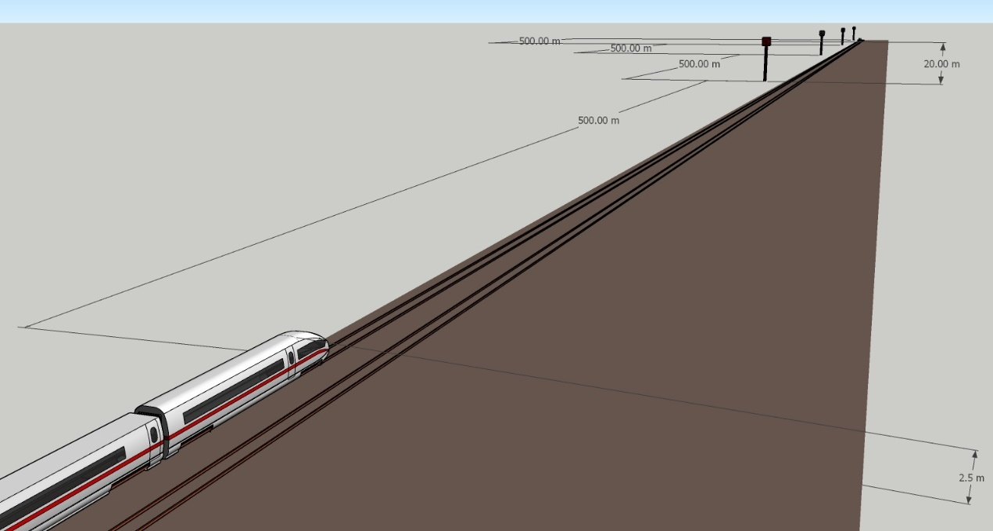

**UE moving direction**

**The entire length is 2000 m**

**RRH1**

**RRH2**

**RRH3**

**RRH4**

**UE**

**(Initial position)**

Figure 6.2.2-1 Illustrative of the setup for FR2 HST ray-tracing simulation

For each given UE location, the received signals from 4 RRHs are simulated by using the ray-tracing model. Numerically, it has been demonstrated that all simulated snap shots have the ratio of received non-first-tap power over total received power smaller than 0.01, or in other words, in all snap shots, the first tap can contain more than 99% of the energy, which validate the single-tap assumption from a single TX-RX link in FR2 HST.



Figure 6.2.2-2 CDF of the ratio of non-first-tap power over total power

Based on measurement-data-calibrated ray-tracing modeling at 28GHz for typical railway environment, it has been validated that the single-tap is accurate enough to represent a single TX-RX link for FR2 HST. Therefore, it is agreed that for channel modelling for performance requirement, the single-tap can be assumed for a single TX-RX link at least for Scenario-A.

Editor Note: FFS multi-tap models are needed for SFN and other scenarios and FFS channel model for Scenario-B.

For channel modelling for performance requirement evaluation:

- Single-tap can be assumed for a single TX-RX link at least for scenario 2 in table 5.1-1.

RAN4 agreed that for both uplink and downlink the cosine of angle θ(t) used in Doppler shift in channel model is applied. This applies for:

- A particular uni-directional deployment scenario; and

- A particular bi-directional deployment scenario.

The single tap propagation model can be assumed for each single Tx-Rx link for both scenario 2 and scenario 4 in table 5.1-1

RAN4 agreed that the uplink and downlink channel model in uni-directional deployments one channel model (either toward to serving beam or away from serving beam) is applied for demodulation requirement even if UE can travel in two directions in practice.

RAN4 will use the following HST-DPS channel model as a starting point for FR2 HST uni-directional RRH deployment:

- UE is moving towards the serving beam

- The cosine of angle θ(t) used in Doppler shift $f_{s}\left(t\right)=f_{d} cos{θ\left(t\right)}$ is provided as

- (1)

- (2)

Where:

- (3)

The Ds_offset value for introducing performance requirements is 10m and 100m for Scenarios A and B, respectively. The Ds_offset value has no restriction concerning deployments and the value is only used for developing the demodulation requirements. The Ds_offset is derived from the worst case based on analysis of deployment scenarios. Note, demodulation simulation assumptions should cover at least one Doppler shift jump region.

RAN4 decided regarding the HST FR2 channel model in bi-directional deployment to use option 2 with DPS based channel model as starting point and based on this RAN4 agreed to use the following cosine values for the different schemes 2a – 2c below. Of the options RAN4 agreed to apply channel modelling as option 2a for FR2 HST Bi-directional RRH deployment:

Option 2(a): To match Bi-directional deployment Scheme-1: UE connect to 2nd-nearest RRH):

- (4)

- (5)

- (6)

Option 2(b): based on Scheme-2 for Bidirectional RRH Deployment:

- , , (7)

- , (8)

- , (9)

- , (10)

- (The Ds_offset is derived from the worst case based on analysis of deployment scenarios)

Option 2(c): based on Scheme-3 for Bidirectional RRH Deployment:

- (11)

- (12)

- (13)

- (14)

- (15)

- (16)

RAN4 agrees to use DPS channel model for both uni-directional and bi-directional for performance requirements.

It was agreed that TCI switching belongs RRM scope, and there is no need to model and consider this in demodulation requirements. Demodulation requirements will not verify the PDSCH performance during TCI switching period. No propagation delay and delay jump modelling in channel model for DL PDSCH demodulation.

## 6.3 FR2 Feasibility Evaluation

RAN4 perform feasibility study on FR2 HST scenario, by at least considering following aspects:

1) The feasibility of a deployment based the beam dwelling time and measurement period framework:

a) How many beams/SSBs per RRH can be deployed (given other deployment parameters such as Dmin, Ds, speed etc) while maintain mobility performance with FR2 BM mechanism?; and

b) How much beam refinement is needed to achieve coverage and mobility?

- How much beam overlapping area is needed (given other deployment parameters such as Dmin, Ds, speed etc.) to ensure beam refinement procedure can be executed successfully?

2) Study throughput performance and mobility performance:

a) More number of analogue beams and sharper beam may provide better link budget performance but more challenging on mobility performance.

3) Receive timing difference.

4) Maximum supported Doppler shift for both UL and DL and maximum supported UE speed.

Other feasibility study is not precluded.

For evaluating the maximum supported speed following numerology will be considered:

- For FR2 HST evaluations and possible performance requirements definition, RAN4 only consider 120kHz SCS as baseline assumption.

### 6.3.1 Idle/inactive mode

### 6.3.2 Connected mode

#### 6.3.2.1 Number of Rx beams

RAN4 discussed the Rx beam number for RRM requirements definition and agreed to define two sets of enhanced RRM requirements in terms of the number of Rx beams (i.e., Rx beam sweeping scaling factor) per UE:

- Set 1: 2 Rx beams

- Set 2: 6 Rx beams

Set 1 is more relevant to the deployments where the RRHs are located next to the railway track, e.g., like in Scenario-A with Dmin = 10m. Whereases, Set 2 can be used in the scenarios where RRHs are further away from the track, e.g., like Scenario-B with Dmin=150m.

The analysis below is based on the system-level simulations carried out following the assumptions and parameters from Table 6.3.8.1-1.

It was found out that in priority scenarios additional beams oriented upwards (i.e., up from the horizontal plane parallel to the railways track) do not provide meaningful pefromance gains. Therefore, the analysis below is focusing only on the beams with different orientations in the horizontal plane.

Following the antenna panel parameters from the Section 6.1, the half-power width for the RRH boresight beam is around 12.6 degrees (8x8 panel). Whereas the half-power width of the UE boresight beam is around 26 degrees (4x4 panel).

##### 6.3.2.1.1 Scenario-A

The considered deployment is uni-directional Scenario-A where the train is traveling in the direction opposite to the serving beam as presented in Figure 6.3.2.1.1-1. It is assumed that the RRH panel is oriented towards the projection of the following RRH on the railway track, and only one beam is used per RRH panel. The UE panel boresight is parallel to the railway track.



Figure 6.3.2.1.1-1: HST FR2 Uni-directional deployment, the train is moving towards the serving beam.

In Figure 6.3.2.1.1-2, simulation results (cumulative distribution function of SINR) are shown when only one Rx beam with fixed orientation is configured at the UE. It can be seen that the beam co-oriented with the UE panel’s boresight (RxBeams1-90) provides the highest SINR.

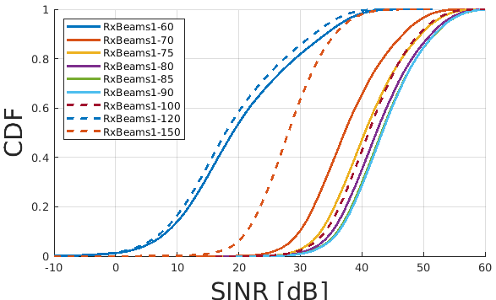

Figure 6.3.2.1.1-2: CDF of SINR for different orientations of a single Rx beam.

Next, a scenario where multiple Rx beams can be used at the UE side is considered. In Figure 6.3.2.1.1-3, it is demonstrated that no gain from using more than one boresight beam (i.e., the beam 90) is observed even if all of the additional beams are oriented towards the RRH.

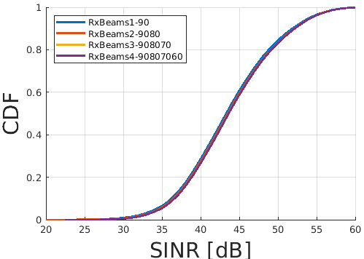

Figure 6.3.2.1.1-3: CDF of SINR for different number of Rx beams.

#### 6.3.2.1.2 Scenario-B

A scheme of uni-directional deployments in HST FR2 Scenario-B is shown in Figure 6.3.2.1.2-1. We also indicate the orientation of Tx beams at RRH and Rx beams at CPE used in the simulations.



Figure 6.3.2.1.2-1: The schemes of uni- and bi-directional deployments in HST FR2 Scenario-B with the orientation of Tx and Rx beams.

From Figure 6.3.2.1.2-2 it can be noticed that increasing the number of Tx beams on RRH side provides very minor gain in HST FR2 uni-directional Scenario-B if only one Rx beam is used. Indeed, in this case, the CPE stays mostly in the coverage area of the boresight Tx beam, and additional beams are not used much.

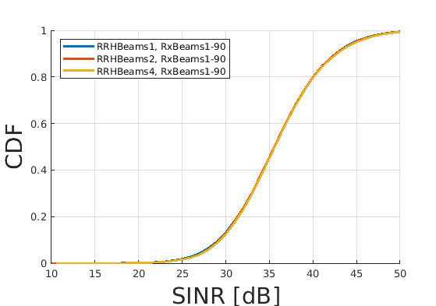

Figure 6.3.2.1.2-2: SINR CDF in uni-directional Scenario-B for different number of Tx beams when only one Rx beam parallel to the track is used.

Firstly, the scenario where one boresight Tx beam is used at the RRH and one Rx beam is used at the UE is considered. Different UE Rx beams directions are compared in Figure 6.3.2.1.2-3. The results demonstrate that Rx beam orientation has a significant impact on performance. For example, wrong orientation of Rx beam (e.g., to the other side from the RRH) results in the significant loss of performance. It was also found that Rx beam oriented 10-15 degrees from the UE panel boresight towards the RRH (i.e., RxBeams1-80, RxBeams1-75) provide best performance in Scenario-B.

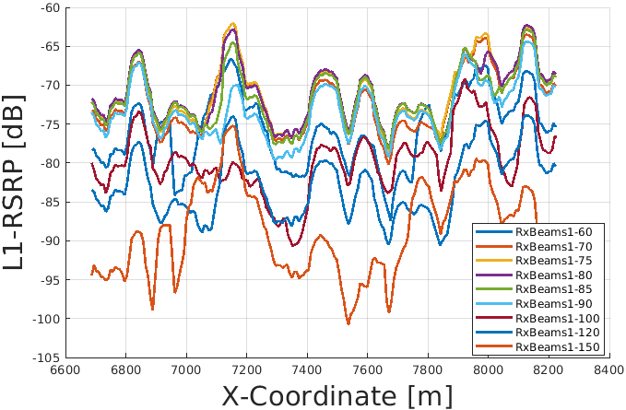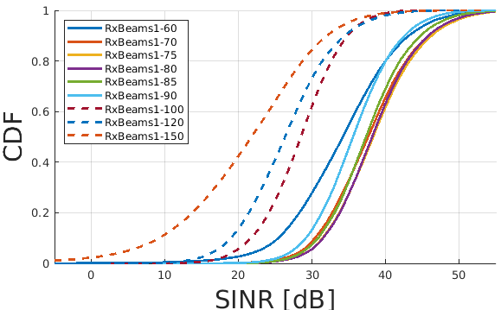

Figure 6.3.2.1.2-3: L1-RSRP traces of serving RRH (top) and SINR CDFs (bottom) in uni-directional Scenario-B for different orientations of Rx beams.

Next, it is studied how the performance depends on the orientation of one Rx beam when multiple Tx beams are used. These results are shown in Figure 6.3.2.1.2-4. Like in Figure 6.3.2.1.2-2, one can observe that adding more Tx beams when only one Rx beam parallel to the track is used does not provide significant gain. However, if we orient the Rx beam more towards the RRH, then in the areas next to the RRH the received signal power can be significantly increased.

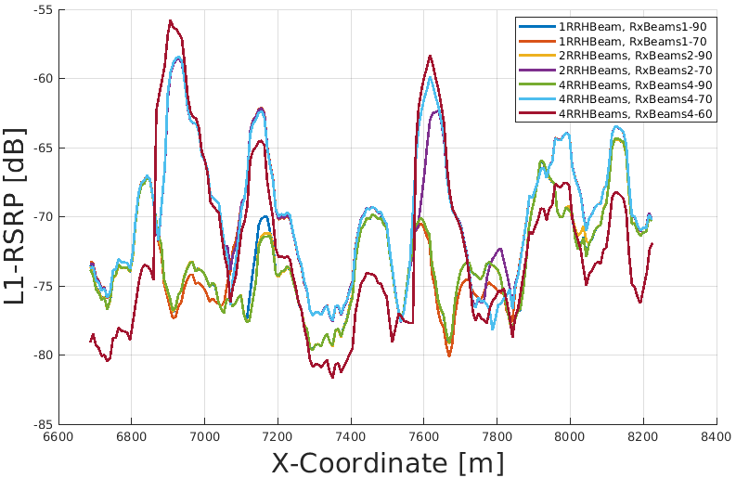

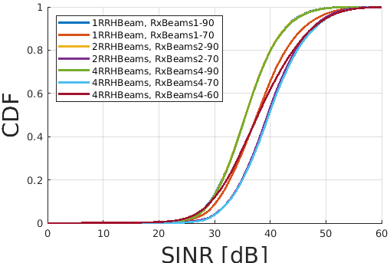

Figure 6.3.2.1.2-4: L1-RSRP traces of serving RRH (top) and SINR CDFs (bottom) in uni-directional Scenario-B with multiple Tx beams and for different orientations of Rx beam.

Finally, the scenario where multiple (four) Tx and multiple (up to four) Rx beams are configured together is analyzed (Figure 6.3.2.1.2-5). It is shown that the correct choice of Rx beams improves the received signal strength in the areas where the coverage of additional Tx beams is present. The median value of the SINR can be increased for around 4 dB. One can also notice that the use of 2 and 3 Rx beams provide significant gains, whereases the gain from more additional beams (e.g., 4 in total) is not significant.

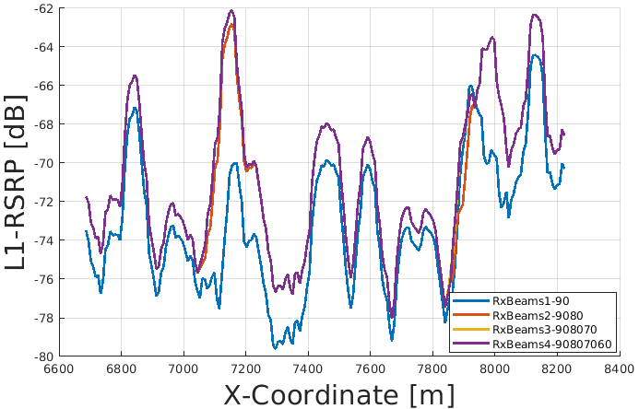

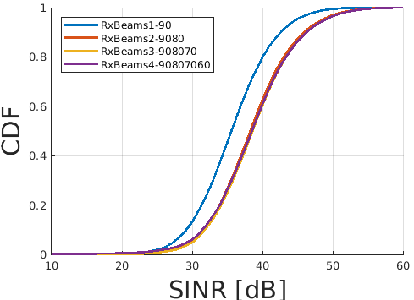

Figure 6.3.2.1.2-5: L1-RSRP traces of serving RRH (top) and SINR CDFs (bottom) in uni-directional Scenario-B with four Tx and multiple Rx beams.

### 6.3.3 Link Performance and Throughput Performance

Based on the evaluation parameters provided in clause 6.1 and channel modeling provided in clause 6.2, companies are provided evaluation results by examining the link performance and throughput performance. In the following sub-section, companies’ evaluation results are provided for information, which are used as the technical basis to derive the conclusion.

#### 6.3.3.1 Link Performance Evaluation from Samsung

For Scenario-A, uni-directional and bi-directional deployment, Samsung provide the evaluation in the contributions R4-2110234 and R4-2113170 respectively.

##### 6.3.3.1.1 Scenario-A, Uni-directional RRH Deployment

As provided in clause 6.2 for the detailed simulation assumption and the detailed beam configuration in Table 6.3.3.1.1-1, it has been shown that with 1 beam per RRH panel and 1 beam per UE panel, the link budget performance is satisfactory, in terms of at least ~30dB margin over FR2 PC4 REFSENS requirement and at least ~21dB margin over FR2 PC4 spherical coverage requirement, as illustrated in following figure. Even considering 31dBm for TX power is a bit optimistic assumption for 8x8 panel configuration (e.g., with per element P_out = 12dBm and 3dB polarization gain, 8x8 panel can achieve 12 + 10log(64) + 3 = 34dBm without considering any implementation margin), the cellular coverage should still be satisfactory with implementation margin considered.



Figure 6.3.3.1.1-1 RX power without UE RX beamforming, Scenario-A, Uni-directional

Next, we take UE RX beamforming gain into account, and assume 1 beam per panel (which is existing agreement in R4-2106100). For simplicity, it is assumed that UE boresight direction is opposite to RRH boresight direction (i.e., the largest UE beamforming gain is achieved when UE is located at the projection point of the neighboring RRH on the railway). It is shown in the following figure, with UE RX beamforming gain into account, the received signal power after RX beamforming is no less than -50dBm even for the nearest coverage point (which is corresponding to least RX beamforming gain around 15dB), which also should be regarded as satisfactory link performance.



Figure 6.3.3.1.1-2 RX power with UE RX beamforming, Scenario-A, Uni-directional

The evaluation and analysis above is based on the parameters provided in clause 6.1, while some of additional used assumptions are summarized in the below Table:

Table 6.3.3.1.1-1 Additional Assumptions for Uni-directional RRH Deployment Link Performance Evaluation

|  |  |
| --- | --- |
| Parameter | Value |
| **Channel parameters** | |
| Carrier frequency | 30 GHz |
| Propagation model | RMa LoS |
| RRH parameters | |
| RRH Tx Power | 31 dBm |
| RRH antenna array model | [Mg, Ng, M, N, P]=[1, 1, 8, 8, 2] |
| RRH panel orientation | Option-1: RRH panel boresight pointed to the railway at the distance of Ds (projection of the neighboring RRH on the railway)  - Azimuth angle: 0.8 degree  - Down-titling: 1.2 degree |
| Number of RRH panels per RRH sites | 1 (i.e., uni-directional) |
| Number of Analog Beams per RRH | 1 |
| Analog Beam orientation | boresight direction as RRH panel orientation |
| UE parameters | |
| UE antenna array model | [Mg, Ng, M, N, P]=[1, 1, 4, 4, 2]  5dBi per element antenna gain |
| UE panel orientation | Direction is opposite to RRH boresight direction  (Note: RRH boresight direction for Scenario-A:Azimuth angle: 0.8 degree  Down-titling: 1.2 degree) |
| Number of Beams per UE panel | 1 |

##### 6.3.3.1.2 Scenario-A, Bi-directional RRH Deployment

Two candidate schemes for Bi-directional deployment for Scenario-A are discussed, and the illustration of two scheme are captured in WF R4-2106100 for information, i.e.,

- Scheme-1: Connecting to 2nd-Nearest RRH;

- Scheme-2: Connecting to Nearest RRH except Coverage Hole.

 

Scheme-1: Connecting to 2nd-Nearest RRH Scheme-2: Connecting to Nearest RRH except Coverage Hole

Figure 6.3.3.1.2-1 Illustration of Scheme-1 and 2 for bi-directional deployment

Accordingly the link performance of scheme-1 and scheme-2 are provided in the following two figures respectively.



Figure 6.3.3.1.2-2 RX power with UE RX beamforming for Scheme-1, Scenario-A, Bi-directional



Figure 6.3.3.1.2-3 RX power with UE RX beamforming for Scheme-2, Scenario-A, Bi-directional

The evaluation and analysis above is based on the parameters provided in clause 6.1, while some of additional used assumptions and the detailed beam configuration in Table 6.3.3.1.2-1 are summarized in the below Table:

Table 6.3.3.1.2-1 Additional Assumptions for Bi-directional RRH Deployment Link Performance Evaluation

|  |  |
| --- | --- |
| Parameter | Value |
| Channel parameters | |
| Carrier frequency | 30 GHz |
| Propagation model | RMa LoS |
| RRH parameters | |
| RRH Tx Power | 31 dBm |
| RRH antenna array model | [Mg, Ng, M, N, P]=[1, 1, 8, 8, 2] |
| RRH panel orientation | Option-1: RRH panel boresight pointed to the railway in the middle point between 2 RRHs  Scenario-A:Azimuth angle: 1.6 degree  Down-titling: 2.5 degree |
| Number of RRH panels per RRH sites | 2 (i.e., Bi-directional) |
| Number of Analog Beams per RRH | 1 |
| Analog Beam orientation | boresight direction as RRH panel orientation |
| UE parameters | |
| UE antenna array model | [Mg, Ng, M, N, P]=[1, 1, 4, 4, 2]  5dBi per element antenna gain |
| UE panel orientation | Direction is opposite to RRH boresight direction  (Note: RRH boresight direction for Scenario-A:Azimuth angle: 1.6 degreeDown-titling: 2.5 degree) |
| Number of Beams per UE panel | 1 |

##### 6.3.3.1.3 Scenario-B, Uni-directional RRH Deployment

*Editor Notes: TBA.*

##### 6.3.3.1.4 Scenario-B, Bi-directional RRH Deployment

*Editor Notes: TBA.*

#### 6.3.3.2 Link performance Evaluation from Huawei

##### 6.3.3.2.1 Scenario A

For Scenario-A, uni-directional and bi-directional deployment, Huawei provide the evaluation in the contributions R4-2119021 based on simulation assumption as shown in clause 6.1 and Table 6.3.3.2.1-1.

Table 6.3.3.2.1-1 Simulation assumption for Scenario-A

|  |  |
| --- | --- |
| Parameter | Value |
| Carrier frequency | 30GHz |
| Ds | 700m |
| Dmin | 10m |
| RRH Tx power | 47dBm |
| RRH height | 15m |
| RRH antenna array | [Mg, Ng, M, N, P]=[1, 1, 8, 8, 2] |
| Path Loss | RMa LoS |
| UE antenna height | 5m |
| UE antenna array | [Mg, Ng, M, N, P]=[1, 1, 4, 4, 2] |
| UE noise figure | 10dB |
| ILs | 13 dB |
| SNR | 18.6dB (i.e. FR2 Test 2-6, 64QAM CR=0.43 and Rank2 in TS 38.101-4) |

###### 6.3.3.2.1.1 Scenario A, Bi-directional

There are two schemes for Bi-directional deployment. Considering very small Dmin, the angle between RRH-UE line and the railway can be negligible, so only Scheme-1 is for further analysis.



Figure 6.3.3.2.1.1-1 Scheme-1 for Bi-directional deployment

For Scheme-1, 1 beam per RRH panel and 6 beam per UE panel is selected. Note that a single RRH panel or UE panel refers to the antenna configuration in Table 6.3.3.2.1-1. The RRH panel boresight is pointed to the railway at the distance of Ds, the beam is pointed to the railway at the distance of Ds. When the UE is at the distance of Ds, the UE panel boresight is point to RRH panel boresight rightly. The link budget analysis is shown as Figure 6.3.3.2.1.1-2 below.

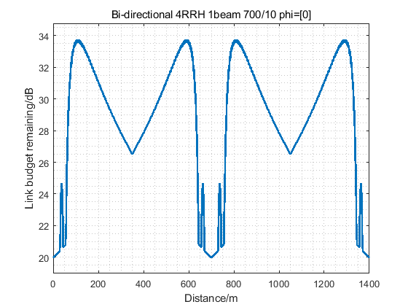

Figure 6.3.3.2.1.1-2 Link budget for Scheme-1

For Scheme-1, the power of side-lobes for different beams change rapidly when UE is near to the RRH and the minimum time duration for the best beam with same beam index can be far less than 160 ms that is the L1-RSRP measurement period for HST FR2 scenario. It is a great challenge for the UE to ensure the performance not to degrade in such location. UE can use different strategy by implementation, such as select the best beam as per RSRP measurement result or directly switch the UE beam point to the main-lobe beam transmission from the next RRH. For the former one, the best beam may be unavailable with high probability once UE beam switching has been performed.

###### 6.3.3.2.1.2 Scenario A, Uni-directional

For Uni-directional deployment, 1 beam per RRH panel and 2 beam per UE panel is selected. Note that a single RRH panel or UE panel refers to the antenna configuration in Table 6.3.3.2.1-1. The RRH panel boresight is pointed to the railway at the distance of Ds, the beam is pointed to 0 degrees. When the UE is at the distance of Ds, the UE panel boresight is point to RRH panel boresight rightly. The link budget analysis is shown as Figure 6.3.3.2.1.2-1 below.

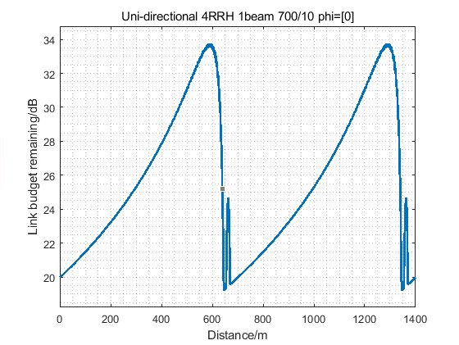

Figure 6.3.3.2.1.2-1 Link budget for Uni-directional deployment

The link budget remaining and the minimum beam dwelling time for Uni-directional deployment is shown as Table 6.3.3.2.1.2-1 below.

Table 6.3.3.2.1.2-1 Link budget remaining and minimum beam dwelling time

|  |  |  |
| --- | --- | --- |
| link budget remaining[dB] | minimum beam dwelling time[s] | Beam switching point[m] |
| 19.2 | 7.20 | 50 |

##### 6.3.3.2.2 Scenario B

For Scenario-B, uni-directional and bi-directional deployment, Huawei provide the evaluation in the contributions R4-2119022 based on simulation assumption as shown in clause 6.1 and Table 6.3.3.2.2-1.

Table 6.3.3.2.2-1 Simulation assumption for Scenario-B

|  |  |
| --- | --- |
| Parameter | Value |
| Carrier frequency | 30GHz |
| Ds | 700m |
| Dmin | 150m |
| RRH Tx power | 47dBm |
| RRH height | 15m |
| RRH antenna array | [Mg, Ng, M, N, P]=[1, 1, 8, 8, 2] |
| Path Loss | RMa LoS |
| UE antenna height | 5m |
| UE antenna array | [Mg, Ng, M, N, P]=[1, 1, 4, 4, 2] |
| UE noise figure | 10dB |
| ILs | 13 dB |
| SNR | 18.6dB (i.e. FR2 Test 2-6, 64QAM CR=0.43 and Rank2 in TS 38.101-4) |

###### 6.3.3.2.2.1 Scenario B, Bi-directional

There are four schemes for Bi-directional deployment are for further analysis.



a) Scheme-1 b) Scheme-2



c) Scheme-3

Figure 6.3.3.2.2.1-1 Candidate schemes for Bi-directional deployment

For Scheme-1, 1 beam per RRH panel and 6 beam per UE panel is selected. Note that a single RRH panel or UE panel refers to the antenna configuration in Table 6.3.3.2.2-1. The RRH panel boresight is pointed to the railway at the distance of Ds, the beam is pointed to the railway at the distance of Ds. When the UE is at the distance of Ds, the UE panel boresight is point to RRH panel boresight rightly. The link budget analysis is shown as Figure 6.3.3.2.2.1-2 below.

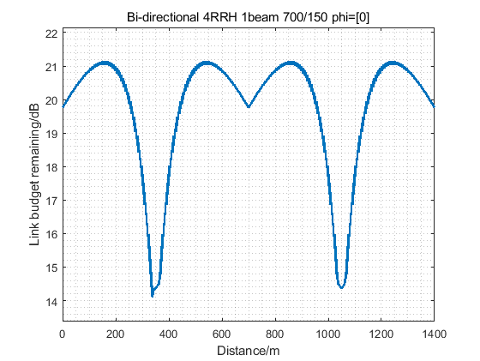

Figure 6.3.3.2.2.1-2 Link budget for Scheme-1

For Scheme-2, 1 beam for one RRH panel and 2 beams for another RRH panel and 6 beam per UE panel is selected. Note that a single RRH panel or UE panel refers to the antenna configuration in Table 6.3.3.2.2-1. The RRH panel boresight is pointed to the railway at the distance of Ds, the beam is pointed to 0 and 10 degrees. When the UE is at the distance of Ds, the UE panel boresight is point to RRH panel boresight rightly. The link budget analysis is shown as Figure 6.3.3.2.2.1-3 below.

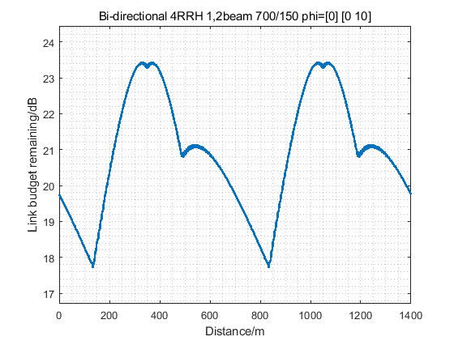

Figure 6.3.3.2.2.1-3 Link budget for Scheme-2

For Scheme-3, 2 beam per RRH panel and 6 beam per UE panel is selected. The RRH panel boresight is pointed to the railway at the distance of Ds, the beam is pointed to 0 and 10 degrees. When the UE is at the distance of Ds, the UE panel boresight is point to RRH panel boresight rightly. The link budget analysis is shown as Figure 6.3.3.2.2.1-4 below.

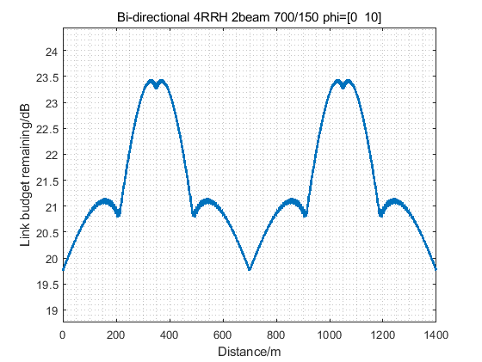

Figure 6.3.3.2.2.1-4 Link budget for Scheme-3

The link budget remaining and the minimum beam dwelling time for three schemes are shown as Table 6.3.3.2.2.1-1 below.

Table 6.3.3.2.2.1-1 Link budget remaining and minimum beam dwelling time

|  |  |  |  |
| --- | --- | --- | --- |
|  | link budget remaining[dB] | Minimum beam dwelling time[s] | Beam switching point[m] |
| Scheme-1 | 14.3 | 3.60 | [0,350] |
| Scheme-2 | 17.7 | 2.06 | [150, 350, 500] |
| Scheme-3 | 19.8 | 1.54 | [0, 200, 350, 500] |

###### 6.3.3.2.2.2 Scenario B, Uni-directional

For Uni-directional deployment, 2 beams per RRH panel and 6 beam per UE panel is selected. The RRH panel boresight is pointed to the railway at the distance of Ds, the beam is pointed to 0 and 10 degrees. When the UE is at the distance of Ds, the UE panel boresight is point to RRH panel boresight rightly. The link budget analysis is shown as Figure 6.3.3.2.2.2-1 below.

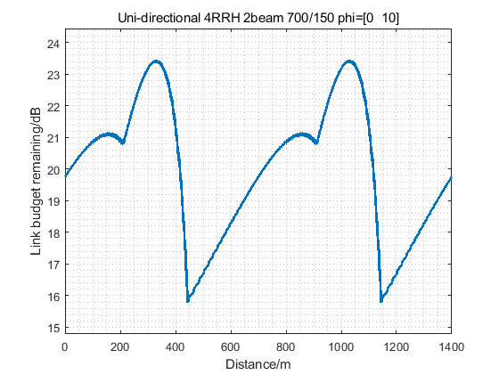

Figure 6.3.3.2.2.2-1 Link budget for Uni-directional deployment

The link budget remaining and the minimum beam dwelling time for Uni-directional deployment is shown as Table 6.3.3.2.2.2-1 below.

Table 6.3.3.2.2.2-1 Link budget remaining and minimum beam dwelling time

|  |  |  |
| --- | --- | --- |
| link budget remaining[dB] | minimum beam dwelling time[s] | Beam switching point[m] |
| 15.8 | 2.57 | [200, 450] |

#### 6.3.3.3 Link level performance from Ericsson

For scenario A and B, uni- and bi-directional scenarios, Ericsson provided evaluation in contributions R4-2104679 and R4-2104680. The analysis has been performed using the antenna array configurations in sections 6.1.1 and 6.1.3.

##### 6.3.3.3.1 Scenario-A, Uni-directional RRH Deployment

For this scenario, it was assumed that the RRHis positioned such that the antenna(s) face directly along the track; i.e. a zero degree steered beam is parallel to the track (in both azimuth and elevation). The UE on the train is positioned such that it’s antenna(s) point directly along the track.

Zero beam steering was assumed, and so the RRHbeam points along the track (but is 10m away from the track) and the UE beam points along the track.

These assumptions are not fully optimal, but they are sufficient to demonstrate that a single TX and a single RX beam is sufficient.

The antenna radiation patterns in azimuth for the UE and RRHare depicted in figure 6.3.3.3.1-1. The array is symmetrical in both axes, so the elevation patterns are the same as the azimuth patterns.

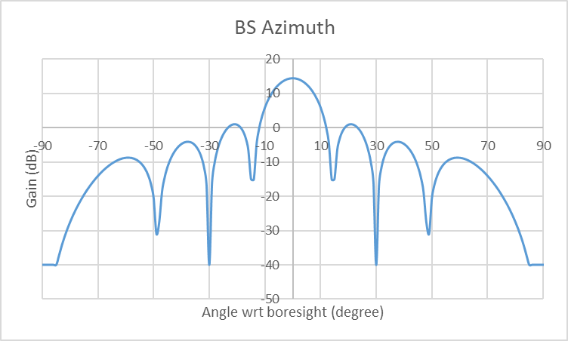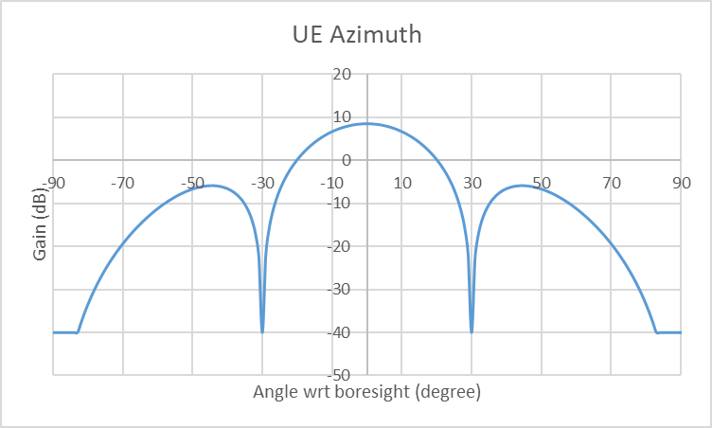

Figure 6.3.3.3.1-1: RRH and UE antenna radiation patterns in azimuth (Elevation patterns are the same)

The most critical link for coverage is the uplink. Thus, the uplink was modelled considering 23dBm transmitter power for the UE. For a train mounted UE, this may be an underestimate for the power.

The coverage pattern for the single TX / RX beam is depicted in figure 6.3.3.3.1-3. A uni-directional deployment is considered in which the RRHantenna is pointing in the direction of movement of the train and the UE antenna away from the direction of movement of the train. The x axis represents the distance along the track from the point on the track that is closest to the RRH. (That implies, at zero on the x axis the UE on the side is parallel to the RRH which is 10m away from the side of the track). The y axis represents UL SNR assuming 10dB noise figure at the RRH

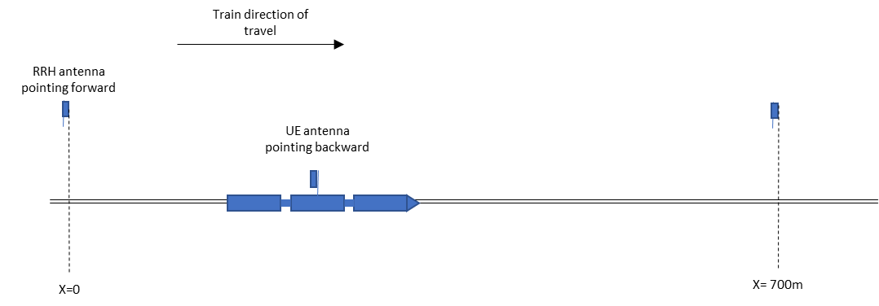

Figure 6.3.3.3.1-2: Unidirectional deployment scenario

As can be seen in the figure, good coverage is obtained when the train is further than 60-70m along the track from the RRH. Furthermore, the SNR remains good from 700-800m; i.e. the SNR from the RRHat position zero on the track is still good as the UE passes the next RRH (located at 700m along the track)

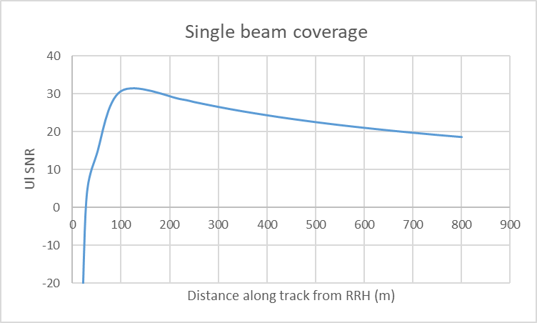

Figure 6.3.3.3.1-3: UL SNR for single TX and single RX beam

Using DPS, the UE can switch RRH after travelling around 60-70m along the track from RRH2 in the figure. Assuming that this is the case, then the SNR observed when travelling along the track is as depicted in figure 4. For downlink, the SNR will be greater.

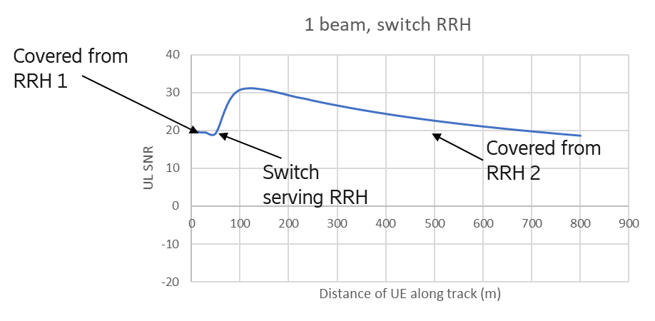

Figure 6.3.3.3.1-4: UL SNR assuming single TX/RX beam and DPS switching between RRH

Based on this analysis, we observe that in scenario 1, in a uni-directional deployment it is sufficient to operate with a single TX beam and a single RX beam.

##### 6.3.3.3.2 Scenario-A, Bi-directional RRH Deployment

Uni-directional deployment in Scenario A provides very good coverage. Bi-directional deployment would require connection to the second nearest basestation when the UE would be within around 50m from a basestation due to the large azimuth angle to the nearest RRH at that point. Thus, bi-directional deployment would require double the antenna infrastructure at basestations with no coverage or capacity gain.

If RRH are equipped with two antenna, improved throughput can be obtained by operating each direction as an independent uni-directional UE. In a future release, multi-antenna single UE operation may also be introduced.

##### 6.3.3.3.3 Scenario-B, Uni-directional RRH Deployment

To consider the number of beams and coverage, a deployment has been analyzed considering scenario B. The RRH antennas are rotated by 13 degrees towards the track, whilst the UE antenna points parallel to the track. Up to 3 RRH beams and up to 2 UE beams are considered. Uplink SNR is considered for depicting the coverage of the beams, since UL SNR is the most critical scenario. DL SNR will be larger than UL SNR.

The x axis represents the distance along the track from the point on the track that is closest to the RRH. (That implies, at zero on the x axis the UE on the side is parallel to the RRH, which is 150m away from the side of the track). The y axis represents UL SNR assuming 10dB noise figure at the RRH and 23dBm UE TRP.

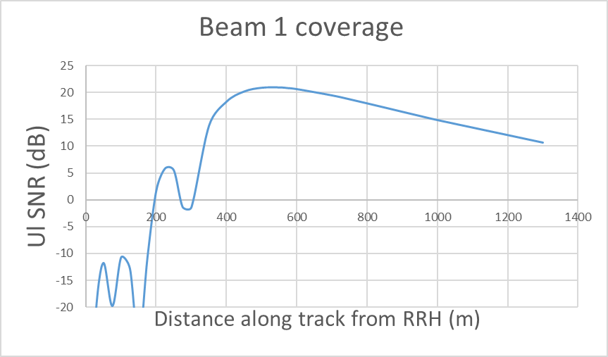

Figure 6.3.3.3.3-1: Coverage of RRH beam 1 + UE beam 1

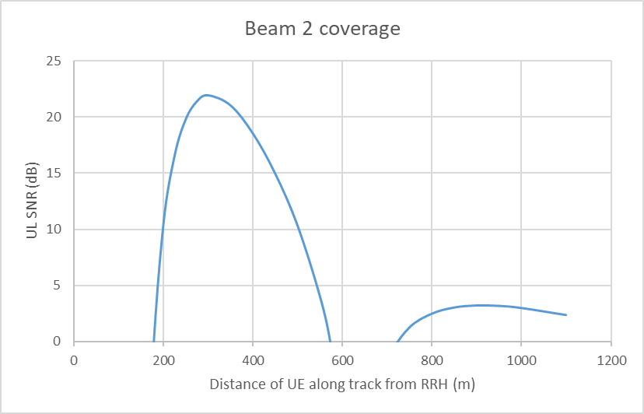

Figure 6.3.3.3.3-2: Coverage of RRH beam 2 + UE beam 1

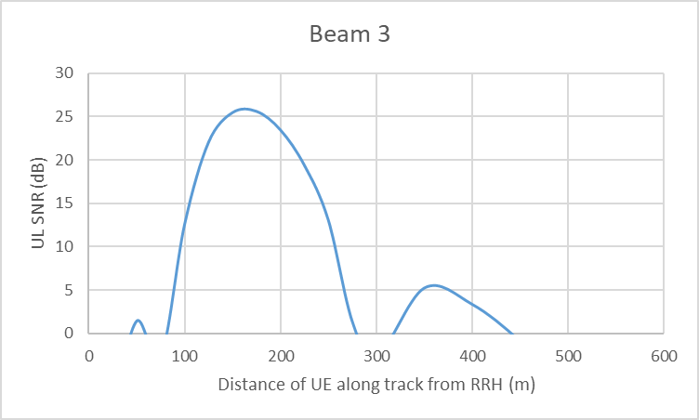

Figure 6.3.3.3.3-3: Coverage of RRH beam 3 + UE beam 2

Figure 6.3.3.3.3-1 indicates that the first RRH beam can provide coverage from around 300-400m along the track to around 1km along the track. This means that the RRH can provide coverage to a point well beyond the following RRH. Figures 6.3.3.3.3-2 and 6.3.3.3.3-3 indicate that the remaining beams can provide coverage closer to the RRH.

There is little point in providing more beams. Beam 3 provides coverage from around 100-150m from the RRH. Closer to the RRH, beam 1 from the previous RRH is able to provide coverage. Further beams closer to the RRH would be narrow in coverage and do not improve SNR.

Figure 6.3.3.3.3-4 indicates the SNR if a single TX/RX beam (beam 1) is used and coverage close to the RRH is provided from the previous/next RRH. The figure indicates that good UL SNR of above 15dB (DL SNR will be larger than this) can be provided along the length of the track with one TX and one RX beam.

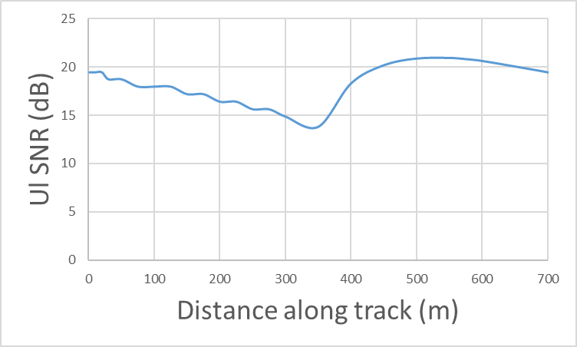

Figure 6.3.3.3.3-4: Coverage provided from next and previous RRH with 1 beam per RRH and UE antenna.

Figure 6.3.3.3.3-5 depicts the coverage obtained with 3 beams per RRH antenna and 2 beams per UE antenna, considering both the current and previous RRH. The figure shows that the lowest SNR level can be improved a few dB compared to the single beam case.

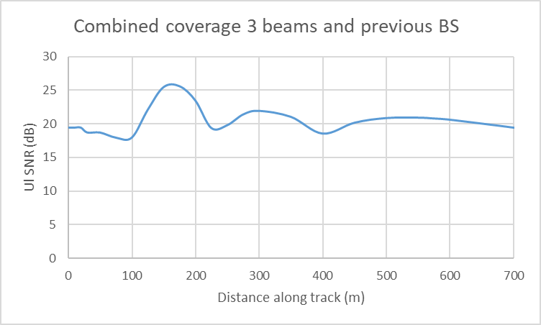

Figure 6.3.3.3.3-5: Coverage provided from next and previous RRH with 3 beams per RRH antenna and 2 beams per UE antenna.

Thus, we observe that it is perfectly feasible to assume just on beam per antenna also for scenario B as long as the RRH antenna is oriented slightly towards the track. There is some scope for further optimization if 3 RRH / 2 UE beams are considered. Also, allowing for more beams offers more robustness for covering track curves.

##### 6.3.3.3.4 Scenario-B, Bi-directional RRH Deployment

For bi-directional deployment, half of the distance along the track would be covered by one RRH and the other half by the following RRH

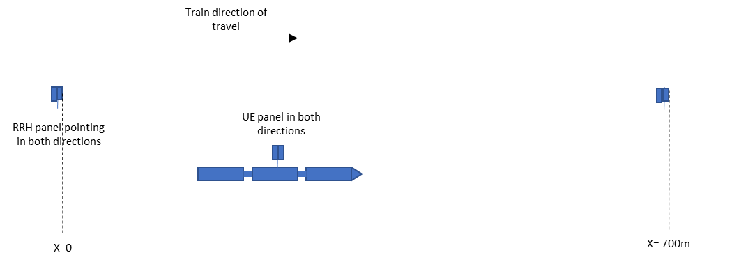

Figure 6.3.3.3.4-1: Bi-directional deployment scenario

The figure below depicts the achievable coverage using 3 beams at the RRH and 3 beams at the UE, with the RRH and UE antennas pointed parallel to the track. After 350m along the track, coverage would be provided by the next RRH. To avoid a break in coverage close to the RRH, the next nearest RRH should be used to serve the UE when it is close in to a RRH.

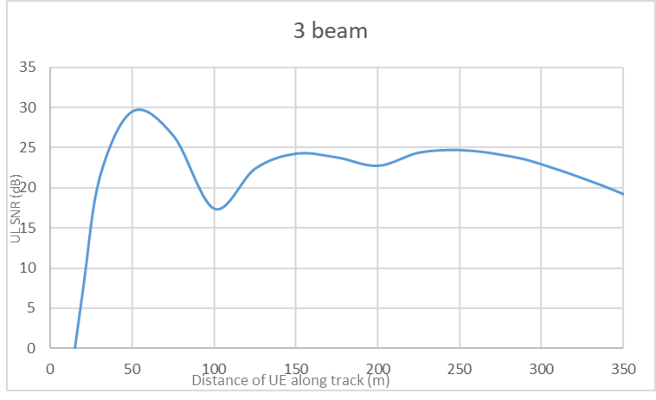

Figure 6.3.3.3.4-2: UL SNR with 3 beams per UE and RRH in each direction with DPS switching between beams and RRH

#### 6.3.3.4 Throughput Performance from Nokia

The throughput CDFs are obtained from fully dynamic system-level simulations, which were carried out to evaluate RRM requirements and mobility performance under high-speed train scenarios in FR2. Simulations were performed with train speed 350 km/h in both uni-directional Scenario-A and -B. In bi-directional case only throughput results for Scenario-B are covered. 50MHz channel bandwidth is assumed.

The results include “non-SFN and non-DPS” (i.e., without DPS) transmission scheme analysis corresponding to L3-mobility based on the traditional HO procedure. In these simulations, it is assumed that each BBU has only one RRH corresponding to a more challenging mobility scenario due to longer delays. Alternatively, simulation results for Dynamic Point Selection (DPS) deployments assume that all RRHs are connected to the same BBU, i.e., the mobility is based on L1 measurements and is provided by beam management procedures instead of HO.

On the RRH side, the number of Tx beams is chosen according to the deployment, i.e., only 1 Tx beam in Scenario-A, and 1 or 2 Tx beams in Scenario-B.

The simulation assumptions and parameters for the evaluation of mobility performance are shown in Table 6.3.8.1-1 6.3.4.1.1-1 and 6.3.4.1.2-1 without DRX.

Throughput statistics are shown in figures 6.3.3.4-1, 6.3.3.4-2, 6.3.3.4-3, 6.3.3.4-4, 6.3.3.4-5, 6.3.3.4-6, 6.3.3.4-7 and 6.3.3.4-8. The used metric is windowed user (CPE) throughput where each sample represents average throughput over 100 ms window of the CPE. The maximum achievable CPE throughput in this scenario setting with 50 MHz and maximum modulation 64QAM is about 300 Mbps when there is only one CPE served by a cell at a time. Both the performance with enhanced RRM requirements (Req: Enhanced) and legacy RRM requirements (Req: Legacy) are shown in the figures.

The results demostrate that in the investigated uni-directional scenarios maximum throughput is achieved over 90% of the time. The reason for such a high performance is that there is only one CPE in the simulated area at a time creating very favorable interference conditions. Propagation condition is fully LOS, which causes the coverage area of a RRH to be long along the track. Also, mobility performance (see 6.3.4.1) in non-DRX case is sufficient to keep CPE most of the time in the cell and beam with good signal conditions. In the uni-directional scenario where train is traveling to opposite direction than RRH beams are pointing to the throughput performance tends to be lower than in the cases where train is traveling to the same direction as RRH beams are pointing to. The reason for this is in the mobility performance that is clearly better in the same direction case. However, enhanced requirements clearly also improve the throughput performance of the opposite direction case. The throughputs in DPS deployment are higher than without DPS in all uni-directional cases.

In the bi-directional scenarios maximum throughputs are achieved more seldom i.e., 40-60% of the window samples. One reason, why throughput in bi-directional Scenario-B is not optimal might be because UE is not connected to the closest RRH but to the next closest one, e.g., like it is shown in Figure 5.2.2-3. Bi-directional scenarios are also affected by more frequent handovers and beam switches compared to uni-directional scenarios, which can cause small breaks in data transmission affecting throughput for some of the sampled windows. However, also bi-directional scenario throughput performance gets better when enhanced RRM requirements are applied, despite the lower number of Rx beam options in use compared to legacy RRM requirements. The delay in switching to a better cell or beam gets lower with enhanced requirements. The throughputs in DPS deployment are higher than without DPS in all bi-directional cases.

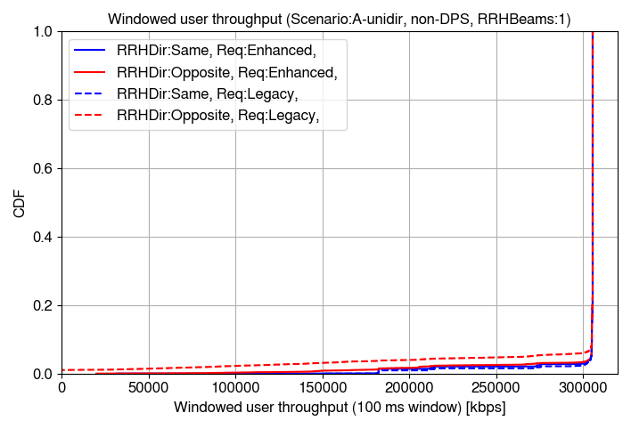

Figure 6.3.3.4-1: Windowed user throughput in uni-directional Scenario-A without DPS

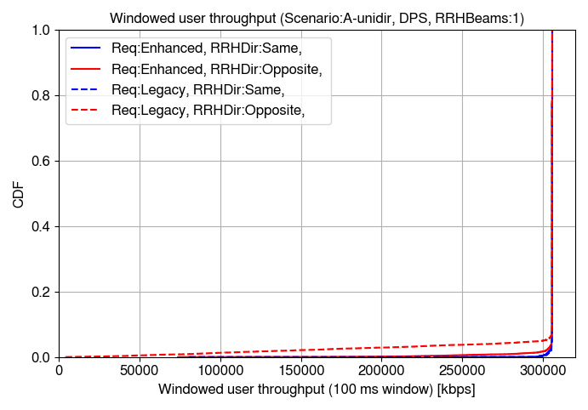

Figure 6.3.3.4-2: Windowed user throughput in uni-directional Scenario-A with DPS

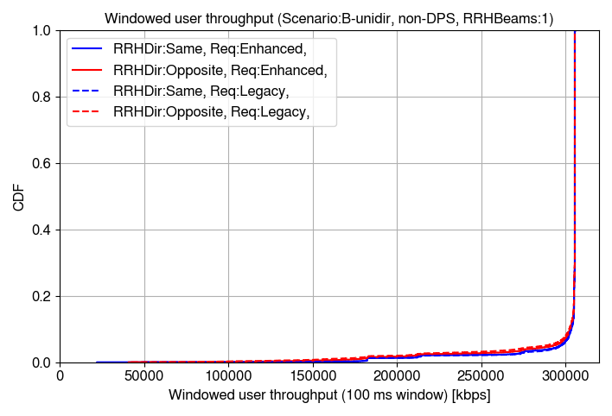

Figure 6.3.3.4-3: Windowed user throughput in uni-directional Scenario-B without DPS (RRHBeams:1)

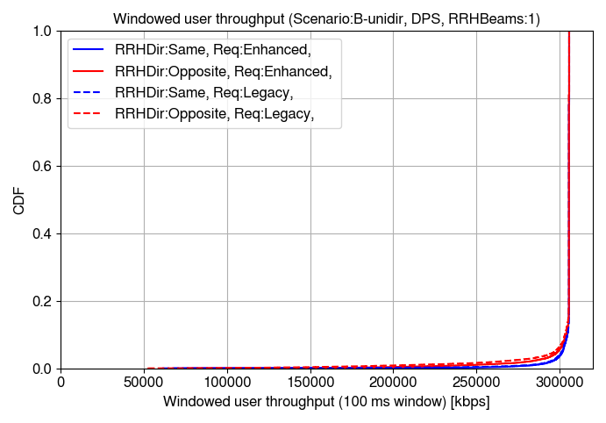

Figure 6.3.3.4-4: Windowed user throughput in uni-directional Scenario-B with DPS (RRHBeams:1)

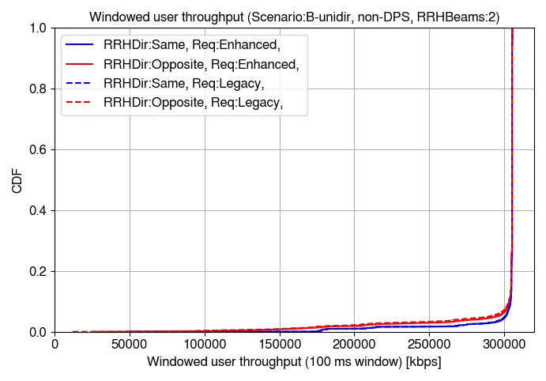

Figure 6.3.3.4-5: Windowed user throughput in uni-directional Scenario-B without DPS (RRHBeams:2)

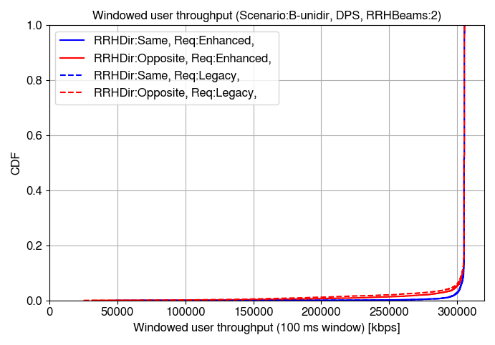

Figure 6.3.3.4-6: Windowed user throughput in uni-directional Scenario-B with DPS (RRHBeams:2)

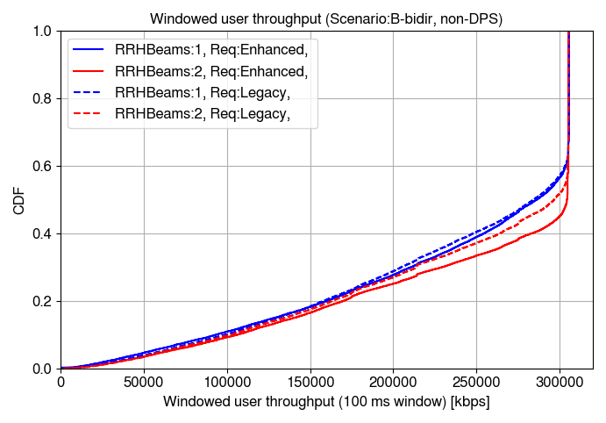

Figure 6.3.3.4-7: Windowed user throughput in bi-directional Scenario-B without DPS

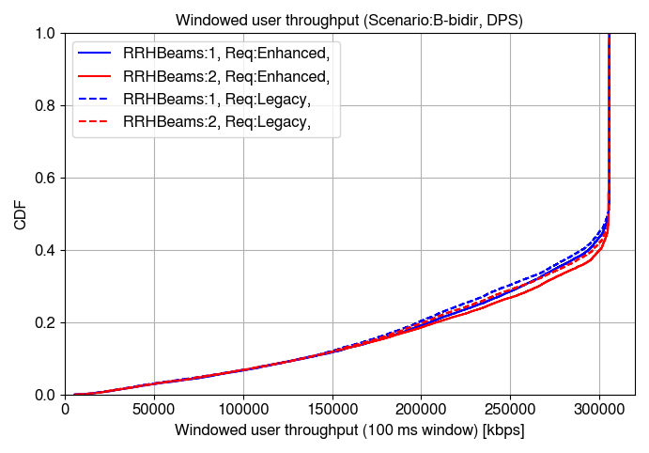

Figure 6.3.3.4-8: Windowed user throughput in bi-directional Scenario-B with DPS

### 6.3.4 Mobility Performance

RAN4 discussed the RX beam number for RRM requirements definition and agreed to define two set of requirements for Scenario A and Scenario B in terms of number of RX beams per UE:

- Scenario A: [2] RX beams for all scenarios.

- Scenario B: [6] RX beams for all scenarios.

NOTE: if there is insignificant difference between Scenario A and B requirements, then further discussion on unified requirements can take place

For RRC CONNECTED mode requirements for DRX (based on GtW):

- Define requirements for the short DRX configurations (≤ [80] ms).

Handover:

- Existing FR2 requirement should be applicable to the HST FR2 deployments when the target cell is known.

Requirements on inter-frequency measurements:

- Do not define inter-frequency measurements requirements for FR2 HST.

Requirements on inter-RAT measurements:

- Do not define inter-RAT measurements requirements for FR2 HST.

Measurement procedures:

1) Cell identification - PSS/SSS detection:

- Option1: The Cell identification - PSS/SSS detection requirements shall be enhanced.

2) Cell identification - Intra-frequency measurements:

- Option 1: The intra-frequency measurement requirement shall be enhanced.

3) Restriction on SMTC periodicity:

- Restriction on SMTC periodicity configuration are preferred in FR2 HST.

4) CSI-RS based L3 measurements:

- The analysis of the requirements to be de-prioritized.

L1 measurements:

- The L1 measurements shall be enhanced.

#### 6.3.4.1 System-level evaluation of mobility performance by Nokia

The simulation results are obtained from fully dynamic system-level simulations, which were carried out to evaluate RRM requirements and mobility performance under high-speed train scenarios in FR2. Simulations were performed with train speed 350 km/h in both uni- and bi-directional Scenario-A and -B.

The results include “non-SFN and non-DPS” (i.e., without DPS) transmission scheme analysis corresponding to L3-mobility based on the traditional HO procedure. In these simulations, it is assumed that each BBU has only one RRH creating a more challenging mobility scenario due to longer delays. Alternatively, simulation results for Dynamic Point Selection (DPS) deployments assume that all RRHs are connected to the same BBU, i.e., the mobility is based on L1 measurements and is provided by beam management procedures instead of HO.

Additionally, different settings are considered for DRX configurations in CONNECTED mode, including DRX disabled and DRX cycles of 40, 80, and 160 ms.

On the RRH side, the number of Tx beams is chosen according to the deployment, i.e., only 1 Tx beam in Scenario-A, and 1 or 2 Tx beams in Scenario-B.

Non-ideal PDCCH model is used with Aggregation Level (AL) 16.

The simulation assumptions and parameters for the evaluation of mobility performance are shown in Table 6.3.8.1-1. The differences from these parameters are explicitly described in the sections below.

##### 6.3.4.1.1 Legacy RRM requirement mobility performance

In the sub-sections below the mobility performance results in HST FR2 deployments based on legacy, i.e., not enhanced, FR2 requirements are presented.

In Table 6.3.4.1.1-1, we show parameters that are different from the ones presented in Table 6.3.8.1-1.

Table 6.3.4.1.1-1: Legacy simulation assumptions for mobility performance evaluation.

|  |  |
| --- | --- |
| Parameter | Value |
| Number of beams per CPE panel | Enhanced requirements:  Uni-directional Scenario-A:  1 Rx beam (scaling factor 8 is assumed for RRC measurements, L1 measurements and cell detection delays in simulations)  Rx beam is oriented parallel to the railway track towards the serving Tx beam.  Uni-directional Scenario-B:  8 Rx beams (scaling factor 8 is assumed for RRC measurements, L1 measurements and cell detection delays in simulations)  Rx beam orientations (90 degrees is boresight of antenna panel): 55, 65, 75, 85, 95, 105, 115, 125 degrees (only first three are usable for RRHs north from track to be comparable with bi-directional case)  Bi-directional Scenario-B:  4 Rx beams (scaling factor 8 is assumed for RRC measurements, L1 measurements and cell detection delays in simulations)  Rx beam orientations (90 degrees is boresight of antenna panel): 55, 65, 75, 85 degrees  Bi-directional Scenario-A:  1 Rx beam per panel (scaling factor 8 is assumed for RRC measurements, L1 measurements and cell detection delays in simulations)  Two Rx beams of the CPE are oriented parallel to the railway track in opposite directions. |
| DRX | DRX disabled (DRX 0), 40, 80, 160 ms cycles |
| RRC measurement period  L1 RSRP measurement period | N=8 assumed in scaling  DRX 0: 480 ms  DRX 40: 1440 ms  DRX 80: 2880 ms  DRX 160: 5760 ms |
| Cell detection delay  (TPSS/SSS_sync_intra) | N = 8 is assumed in scaling  DRX 0: 600 ms  DRX 40: 1440 ms  DRX 80: 2880 ms  DRX 160: 5760 ms |
| RLM assumptions | N=8 assumed in scaling  TEvaluate_out_CSI-RS: 600, 3600, 7200, 14400 ms (DRX 0, 40, 80, 160)  TEvaluate_in_CSI-RS: 300, 1800, 3600, 7200 ms (DRX 0, 40, 80, 160) |
| BFD assumptions | N=8 assumed in scaling  TEvaluate_BFD_CSI-RS: 300, 1800, 3600, 7200 ms (DRX 0, 40, 80, 160) |
| PDCCH model | Non-ideal PDCCH model with AL16 |

###### 6.3.4.1.1.1 Uni-directional Scenario-A without DPS

This section shows system level simulation mobility performance results for uni-directional Scenario-A without DPS for both the case when train is traveling into same direction (Dir:Same in legends) as RRH beam are pointing to and into opposite direction (Dir:Opposite in legends). Figure 6.3.4.1.1.1-1 shows successful handover rate per CPE per second and ping-pong rate as percentage of ping-pong handovers per all handovers. Ping-pong handover is observed when two handovers happen back and forth between two same cells in one second. It is observed that handover and ping-pong rates are the highest without DRX and gradually decrease when DRX cycle is increased. Significant drop in successful handovers is observed when train travels to opposite direction than RRH beams are pointed to and DRX is used. Ping-pongs are not observed in the cases with DRX configured.

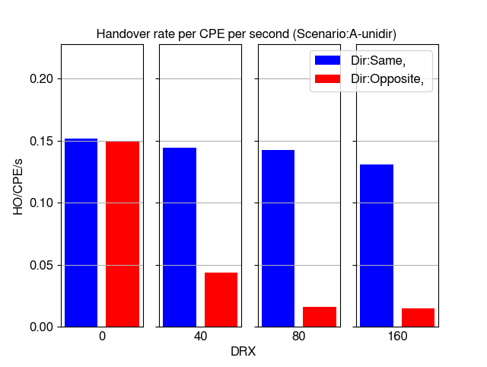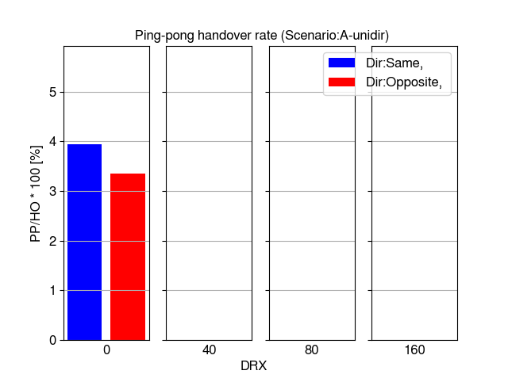

Figure 6.3.4.1.1.1-1 Handover and ping-pong handover rates

Figure 6.3.4.1.1.1-2 shows average time-of-stay in cell (RRH). It is observed that without DRX the time-of-stay in RRH is slightly lower than the time train with 350 km/h speed takes to travel the distance of one Ds of 700 meters (about 7.2 seconds). This result is due to ping-pongs observed in Figure 6.3.4.1.1.1-1. With DRX cycles 80-160 ms the time-of-stay increases to over 7 seconds.

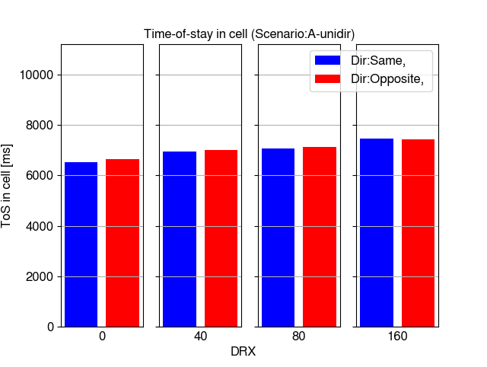

Figure 6.3.4.1.1.1-2 Time-of-stay in cell

Figure 6.3.4.1.1.1-3 shows time-of-outage percentage per call (existence of CPE in the simulation) and average time-of-outage duration due to low SINR (below -8 dB) conditions. Time-of-outage percentage per call includes all the sources of outage combined. This consists of handover execution time, the time it takes to perform radio link failure related procedures from observing radio link problem until re-establishment of connection and the time below -8 dB SINR conditions are observed in the simulation even prior to radio link problem can be detected based on filtering. It is observed from the results that significant outage is detected only in case train travels to opposite direction than RRHs are pointing to and DRX is used.

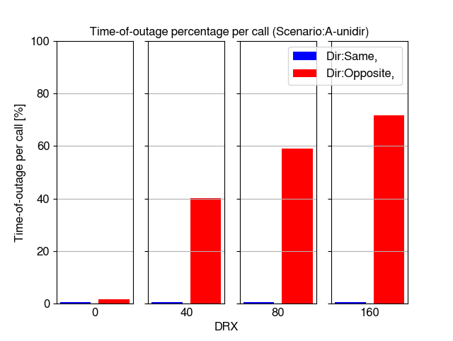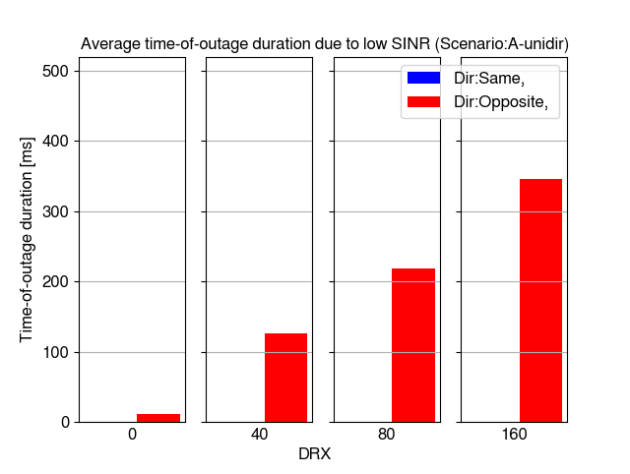

Figure 6.3.4.1.1.1-3 Time-of-outage per call and time-of-outage duration due to low SINR

Figure 6.3.4.1.1.1-4 shows inter-cell mobility failure rate (RLF + HOF percentage of all handover and failure events). The results show that failure rate is very high in case train is traveling to opposite direction than RRH beams are pointing to and DRX is used in case of legacy RRM requirements. DRX 40 ms causes about 70% failure rate and DRX 80-160 ms causes even higher number of problems with over 80% failure rate in this scenario. No failures are observed when train is traveling into same direct as RRH beams are pointing to.

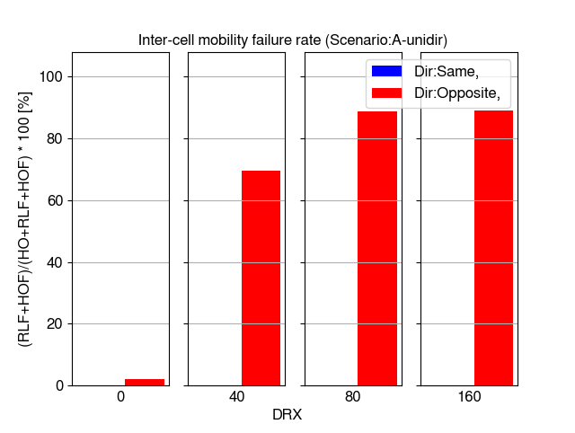

Figure 6.3.4.1.1.1-4 Mobility failure rate

Figure 6.3.4.1.2.1-5 shows distribution of raw SINR values taken from the CQI measurements and it is observed that SINR level is high and clearly sufficient to support high mobility performance except in the cases with DRX 40-160 ms and train traveling to opposite direction.

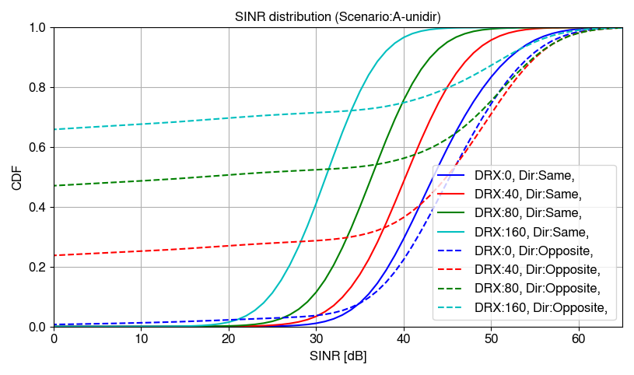

Figure 6.3.4.1.1.1-5 SINR distributions

###### 6.3.4.1.1.2 Uni-directional Scenario-A with DPS

This section shows system level simulation mobility performance results for uni-directional Scenario-A with DPS. Some of the observed statistics are of different type than in the section without DPS. Figure 6.3.4.1.1.2-1 shows successful beam switch rate per CPE per second and ping-pong rate as percentage of ping-pong beam switches per all beam switches. Beam ping-pong is observed when two beam switches happen back and forth between two same beams in one second. Practically in Scenario-A with just one Tx beam per RRH this means ping-pongs between RRHs. In DPS case the same trend is observed in beam switches as with handovers in non-DPS case, without DRX the rates are the highest and gradually rates decrease when longer DRX cycles are used. The differences between the rates in train travel direction are rather low except in the case with DRX cycle 160 ms where beam switch rate drops significantly when train in traveling to opposite direction.

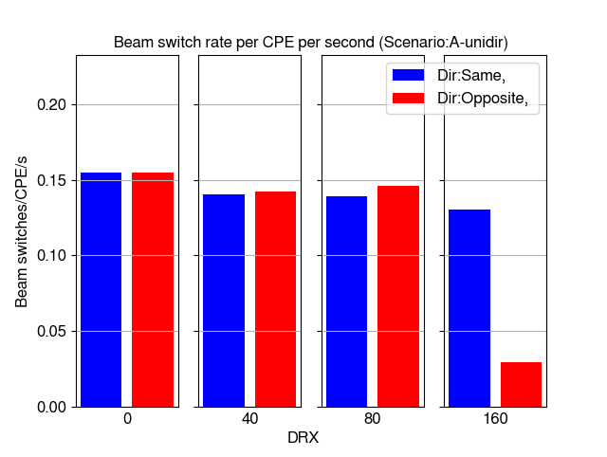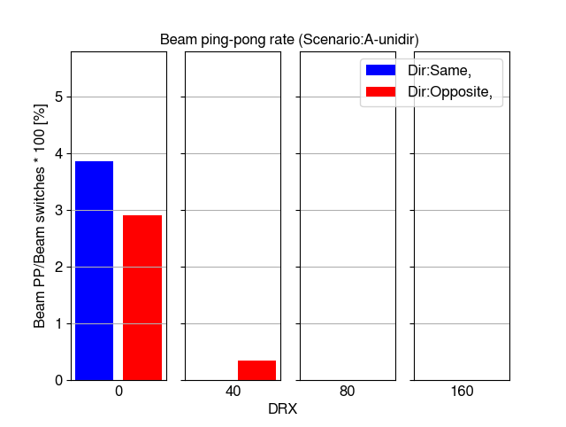

Figure 6.3.4.1.1.2-1 Beam switch and beam ping-pong rates

Figure 6.3.4.1.1.2-2 shows time-of-outage percentage per call (existence of CPE in the simulation) and average time-of-outage duration due to low SINR (below -8 dB) conditions. Similar trend is observed here as without DPS that the time-of-outage rates are very low when train is traveling to the same direction as RRH beams are pointing to and none of the outages are caused by low SINR. In the opposite direction time-of-outage starts to increase significantly when DRX cycles are 40 ms or longer. However, time-of-outage is significantly lower than without DPS due to lower delay when switching to different RRH location. Regardless of this the case of DRX cycle 160 ms has very significant time-of-outage in the opposite direction.

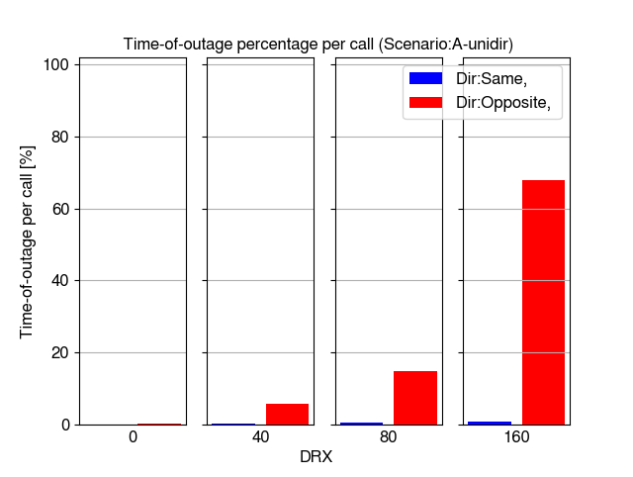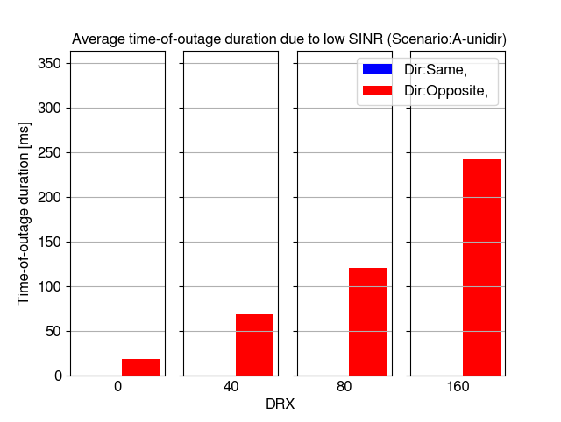

Figure 6.3.4.1.1.2-2 Time-of-outage per call and time-of-outage duration due to low SINR

Figure 6.3.4.1.1.2-3 shows beam failure indication rate as percentage of BFIs per beam switches. Similar trend is observed without DPS that no failures happen among the studied DRX cycles when train is traveling to same direction as RRH beams are pointing to. In case of opposite direction, the failure indication rates are very high even with short DRX when legacy performance requirements are used with scaling factor 8.

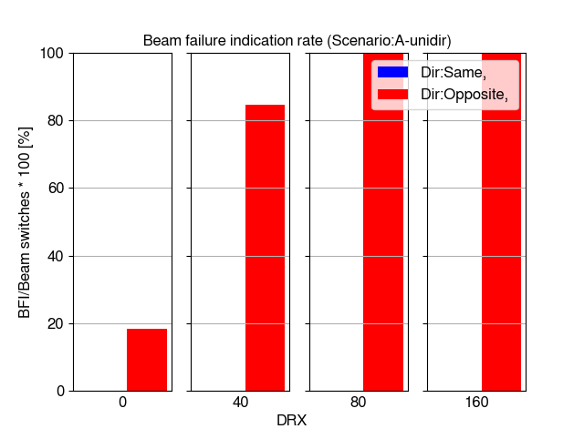

Figure 6.3.4.1.1.2-3 Beam failure indication rate

Figure 6.3.4.1.1.2-4 shows distribution of raw SINR values taken from the CQI measurements and it is observed that SINR level is high and clearly sufficient to support high mobility performance except in the cases with DRX 40-160 ms and train traveling to opposite direction. However, the amount of low SINR samples below 0 dB are less common in cases of DRX 40-80 ms when DPS is used.

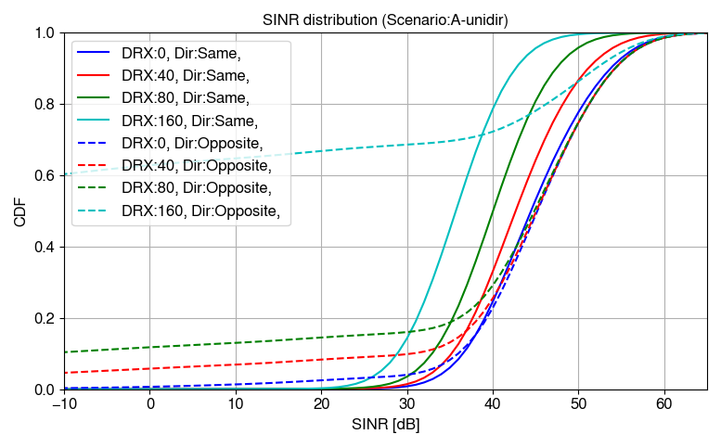

Figure 6.3.4.1.1.2-4 SINR distributions

###### 6.3.4.1.1.3 Uni-directional Scenario-B without DPS

This section shows system level simulation mobility performance results for uni-directional Scenario-B without DPS. Also, comparison between 1 and 2 beams per RRH is included in this section. Figure 6.3.4.1.1.3-1 shows successful handover rate per CPE per second and ping-pong rate as percentage of ping-pong handovers per all handovers. It is observed that without DRX the handover rate is the highest and it drops when DRX cycle 40 ms is used but remains at approximately same level with all simulated DRX cycles. This indicates that there is more time to perform handover in Scenario-B than in Scenario-A particularly when comparing the cases when train is traveling to opposite direction than the RRH beams are pointing to. It is also observed that without DRX there are higher handover and ping-pong rates with 1 beam per RRH than 2 beams per RRH.

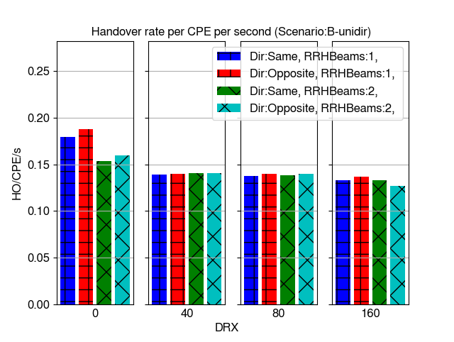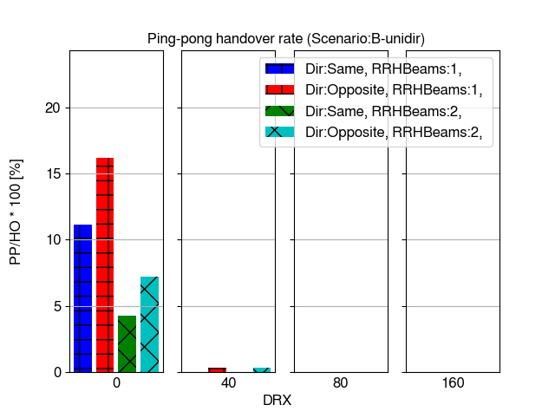

Figure 6.3.4.1.1.3-1 Handover and ping-pong handover rates

Figure 6.3.4.1.1.3-2 shows average time-of-stay in cell (RRH). It is observed that without DRX the time-of-stay in RRH is significantly lower than the time train with 350 km/h speed takes to travel the distance of one Ds of 700 meters (about 7.2 seconds) particularly with 1 Tx beam per RRH. This result is due to ping-pongs observed in Figure 6.3.4.1.1.3-1 in similar way as in Scenario A. Time-of-stay is relatively close among all studied DRX cycles in this scenario and close to the expected time-of-stay based on Ds.

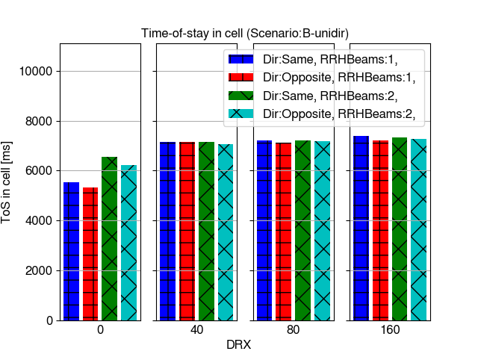

Figure 6.3.4.1.1.3-2 Time-of-stay in cell

Figure 6.3.4.1.1.3-3 shows time-of-outage percentage per call (existence of CPE in the simulation) and average time-of-outage duration due to low SINR (below -8 dB) conditions. It is observed that in Scenario-B the outage rates are very low compared to Scenario-A in case where train is traveling to opposite direction. Only in case of DRX cycle 160 ms there is significant increase in time-of-outage particularly with 2 RRH beams. Beam management becomes more challenging with long DRX and scaling factor 8.

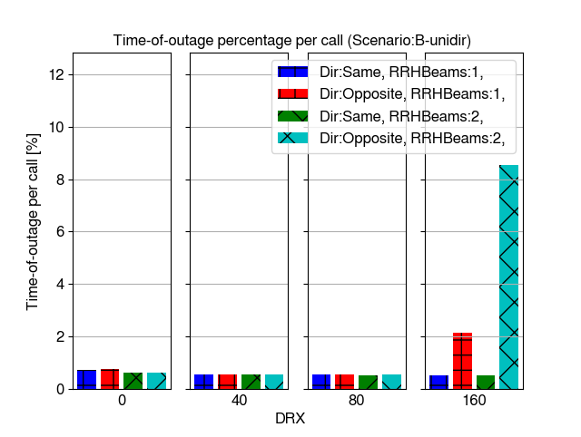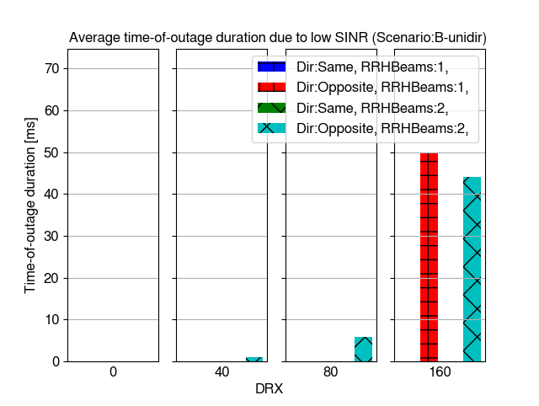

Figure 6.3.4.1.1.3-3 Time-of-outage per call and time-of-outage duration due to low SINR

Figure 6.3.4.1.1.3-4 shows inter-cell mobility failure rate (RLF + HOF percentage of all handover and failure events). There are no failures in Scenario-B except with DRX 160 ms and train traveling to opposite direction where about 2-8 % failure rate is observed. This is very significantly lower rate of failures than in the corresponding Scenario-A case.

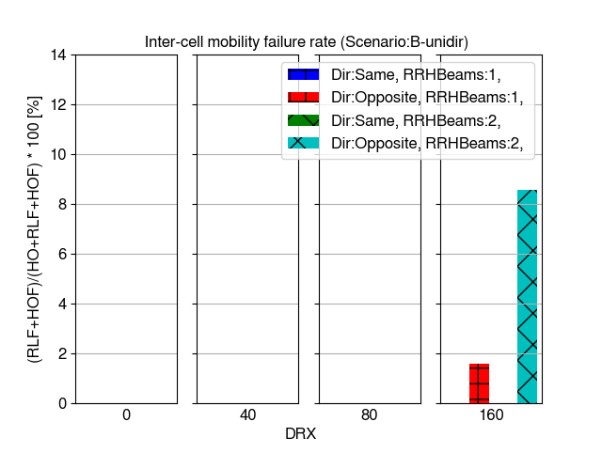

Figure 6.3.4.1.1.3-4 Mobility failure rate

Figure 6.3.4.1.1.3-5 shows distribution of raw SINR values taken from the CQI measurements and it is observed that SINR level is high and clearly sufficient to support always high mobility performance in all cases except DRX 160 ms and train traveling to opposite direction. It is also observed than without DRX and DRX 40 ms there is clear gain in SINR from having 2 beams per RRH compared to 1 beam per RRH, but when longer DRX is applied the gain is no longer observed. This is caused by the delays in selecting optimal beams with longer DRX.

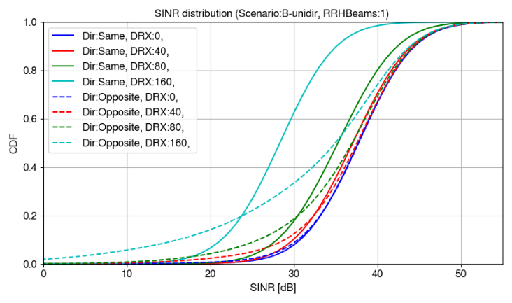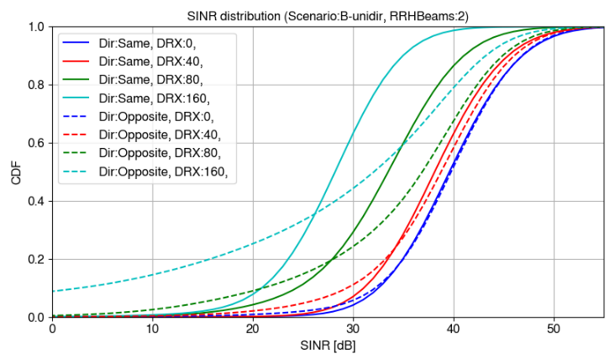

Figure 6.3.4.1.1.3-5 SINR distributions

###### 6.3.4.1.1.4 Uni-directional Scenario-B with DPS

This section shows system level simulation mobility performance results for uni-directional Scenario-B with DPS. Figure 6.3.4.1.1.4-1 shows successful beam switch rate per CPE per second and ping-pong rate as percentage of ping-pong beam switches per all beam switches. It is observed that there are clearly more beam switches with 2 beams per RRH than 1 beam per RRH. However, beam ping-pongs are less common in case of 2 beams per RRH. As observed in previous scenarios beam switch and ping-pong rates gradually decrease when DRX in used.

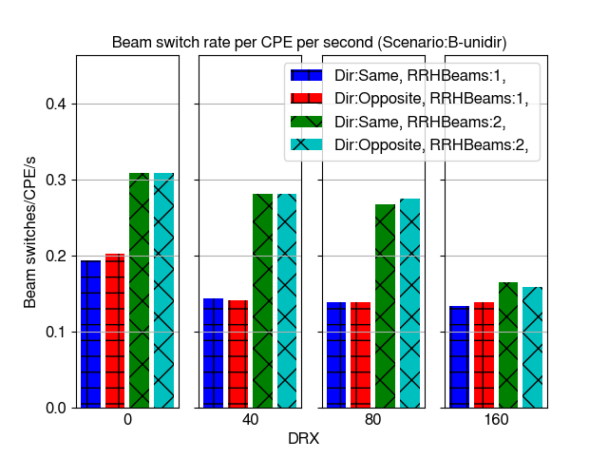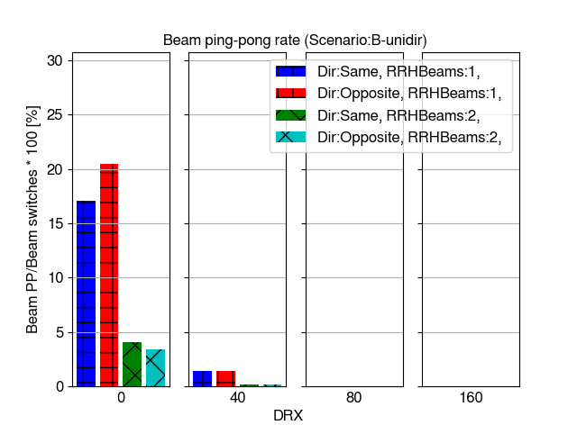

Figure 6.3.4.1.1.4-1 Beam switch and beam ping-pong rates

Figure 6.3.4.1.1.4-2 shows time-of-outage percentage per call (existence of CPE in the simulation) and average time-of-outage duration due to low SINR (below -8 dB) conditions. It is observed that time-of-outage rates are very low without DRX and DRX up to 80 ms. Particularly in cases where train is traveling to opposite direction than RRHs are pointing to the time-of-outage rates increase when DRX cycle 160 ms is applied.

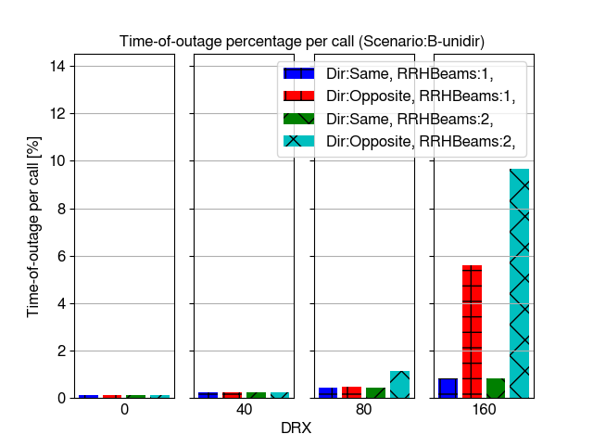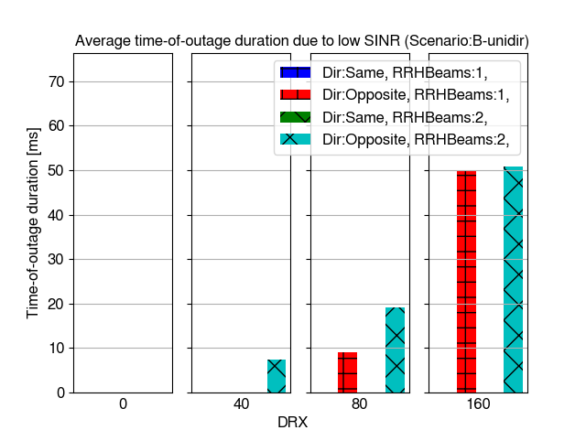

Figure 6.3.4.1.1.4-2 Time-of-outage per call and time-of-outage duration due to low SINR

Figure 6.3.4.1.1.4-3 shows beam failure indication rate as percentage of BFIs per beam switches. It is observed that failure indications only happen in significant rate with DRX 160 ms and when train is traveling to opposite direction. Also, in this case the failure rate is lower than in Scenario-A.

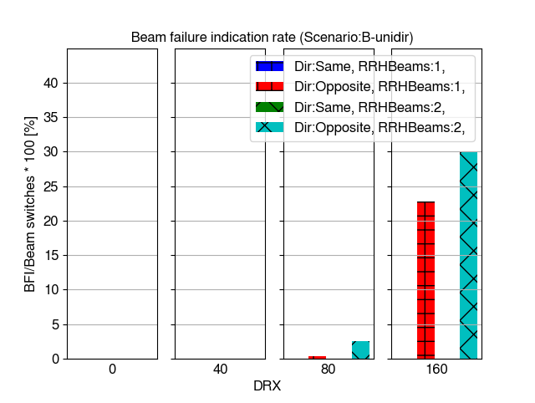

Figure 6.3.4.1.1.4-3 Beam failure indication rate

Figure 6.3.4.1.1.4-4 shows distribution of raw SINR values taken from the CQI measurements and it is observed that SINR level is high and clearly sufficient to support high mobility performance except it the cases with DRX 160 ms and train traveling to opposite direction. Also, DRX 80 ms causes some significant degradation in SINR in the opposite direction, but as observed from failure rates it does not cause high number of problems.

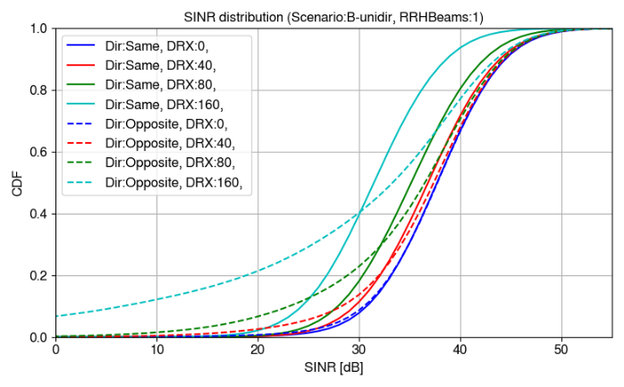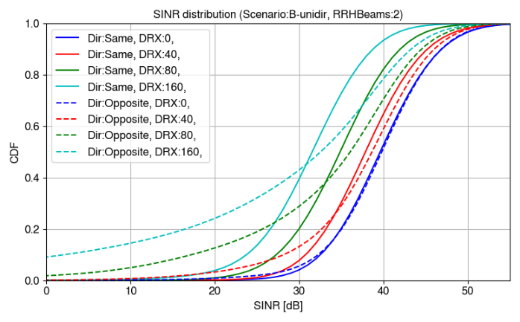

Figure 6.3.4.1.1.4-4 SINR distributions

###### 6.3.4.1.1.5 Bi-directional Scenario-B without DPS

This section shows system level simulation mobility performance results for bi-directional Scenario-B without DPS. Figure 6.3.4.1.1.5-1 shows successful handover rate per CPE per second and ping-pong rate as percentage of ping-pong handovers per all handovers. It is observed that general levels of handover and ping-pong rates are clearly higher in bi-directional scenario than in uni-directional scenario. Uni-directional Scenario-B has maximum of about 0.2 HO/CPE/s and bi-directional has over 0.8 HO/CPE/s. Ping-pongs are much more common even with DRX in bi-directional scenario.

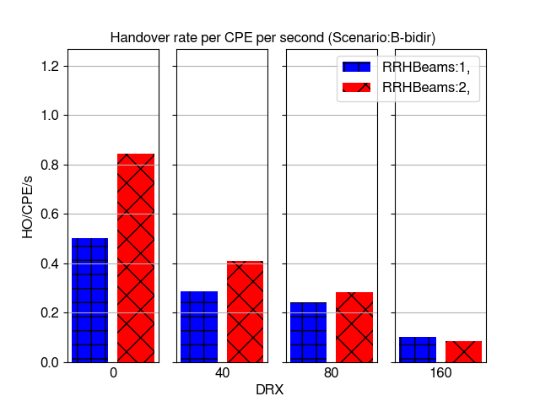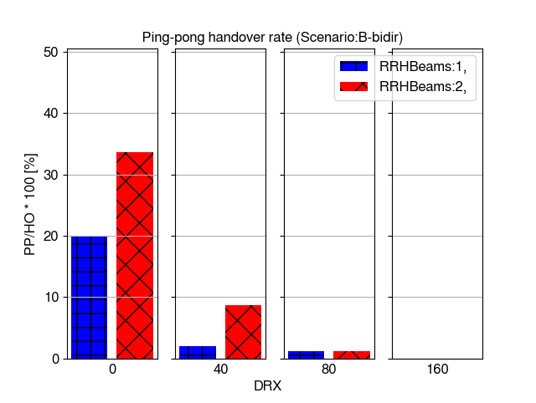

Figure 6.3.4.1.1.5-1 Handover and ping-pong handover rates

Figure 6.3.4.1.1.5-2 shows average time-of-stay in cell (RRH). It is observed that time-of-stay is significantly affected by DRX cycle and the number of beams per RRH. Generally, time-of-stay times in bi-directional scenario are about half of the times or lower in comparison to uni-directional scenario.

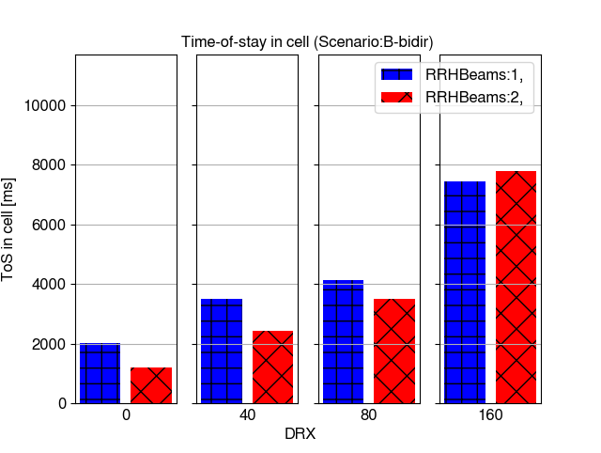

Figure 6.3.4.1.1.5-2 Time-of-stay in cell

Figure 6.3.4.1.1.5-3 shows time-of-outage percentage per call (existence of CPE in the simulation) and average time-of-outage duration due to low SINR (below -8 dB) conditions. It is observed that time-of-outage percentage per call is higher in bi-directional scenario than in uni-directional scenario mainly due to increased handovers. However, also in bi-directional Scenario-B clearly increased outage is only seen when DRX cycle is set to 160 ms.

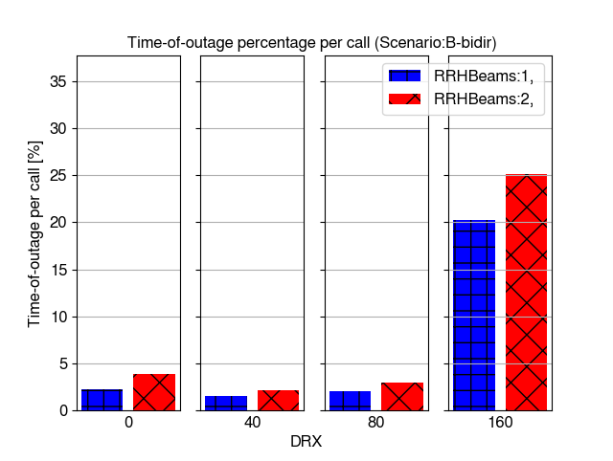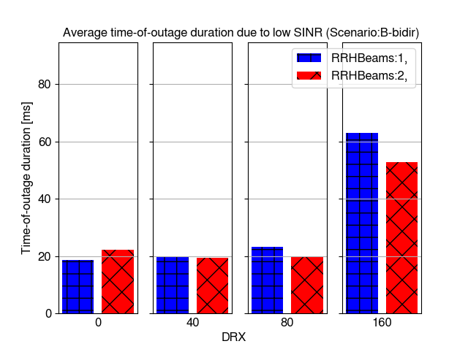

Figure 6.3.4.1.1.5-3 Time-of-outage per call and time-of-outage duration due to low SINR

Figure 6.3.4.1.1.5-4 shows inter-cell mobility failure rate (RLF + HOF percentage of all handover and failure events). It is observed that significant number of failures happen only with DRX cycle 160 ms.

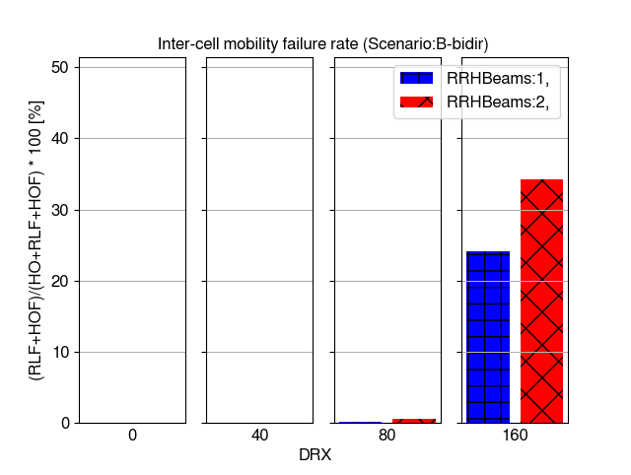

Figure 6.3.4.1.1.5-4 Mobility failure rate

Figure 6.3.4.1.1.5-5 shows distribution of raw SINR values taken from the CQI measurements and it is observed that SINR level is high and clearly sufficient to support always high mobility performance in all cases except DRX 160 ms. It is also observed than without DRX and DRX 40 ms there is clear gain in SINR from having 2 beams per RRH compared to 1 beam per RRH, but when longer DRX is applied the gain is no longer observed. This is caused by the delays in selecting optimal beams with longer DRX. It is noted that SINR level in low SINR percentiles is lower in bi-directional scenario than uni-directional Scenario-B. Possible reasons for this include using multi-panel UE assumption 1 in bi-directional scenario where two panels per CPE are used. With this assumption only one panel can be activated at the time and used for measurements causing some additional delays in mobility and beam management.

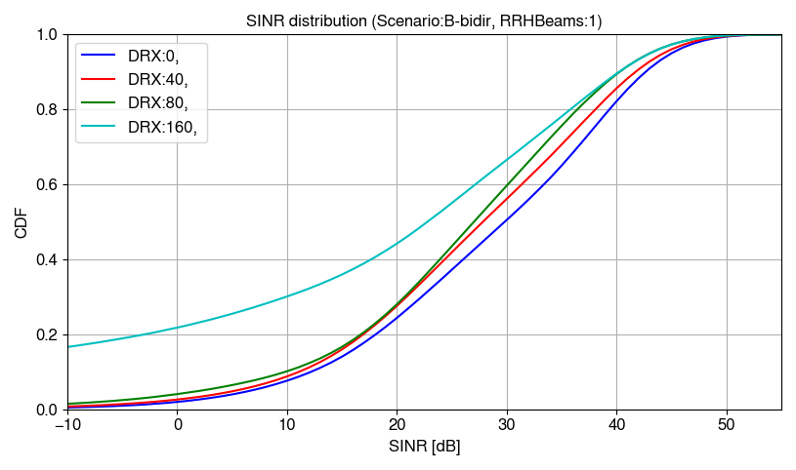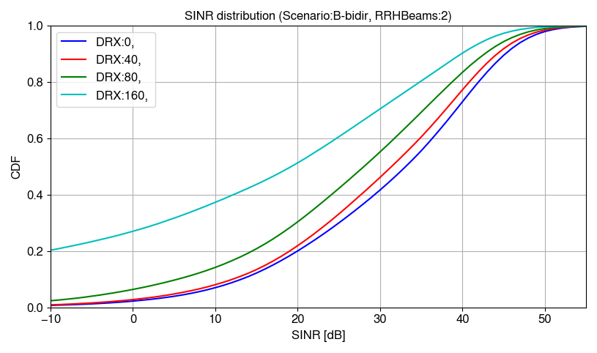

Figure 6.3.4.1.1.5-5 SINR distributions

###### 6.3.4.1.1.6 Bi-directional Scenario-B with DPS

This section shows system level simulation mobility performance results for bi-directional Scenario-B with DPS. Figure 6.3.4.1.1.6-1 shows successful beam switch rate per CPE per second and ping-pong rate as percentage of ping-pong beam switches per all beam switches. It is observed that DRX cycle and the number of beams per RRH have significant impact on beam switch rate by decreasing rate when DRX cycle increases. There are more beam switches with 2 beams per RRH than 1 beam per RRH as would be expected in DPS scenario.

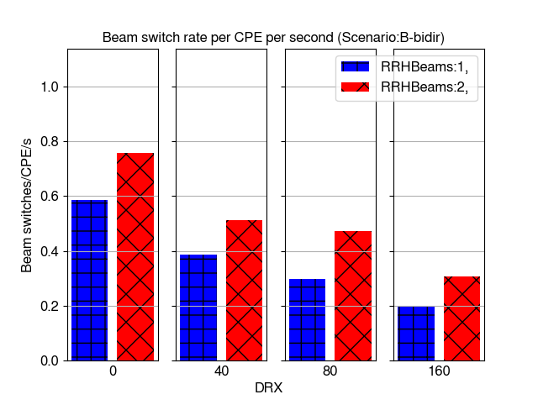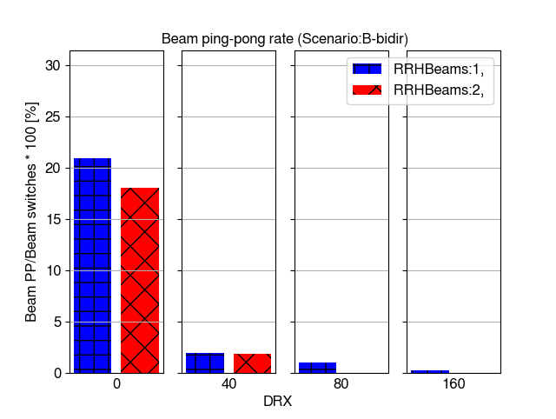

Figure 6.3.4.1.1.6-1 Beam switch and beam ping-pong rates

Figure 6.3.4.1.1.6-2 shows time-of-outage percentage per call (existence of CPE in the simulation) and average time-of-outage duration due to low SINR (below -8 dB) conditions. It is observed that the outage percentage per call is lower in DPS scenario than without DPS. This is caused by lower outage time in beam switch than handover. Only with DRX 160 ms the outage rate significantly increases from the level without DRX. This can be caused by less optimal beam selection.

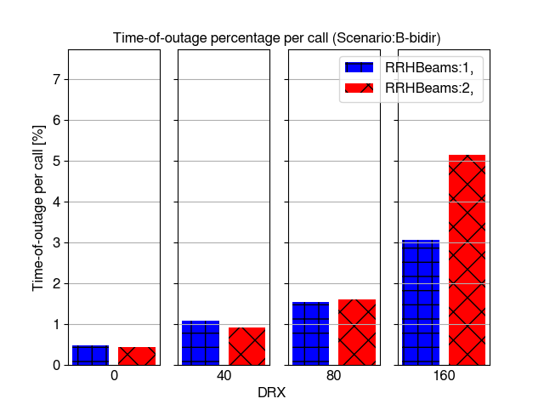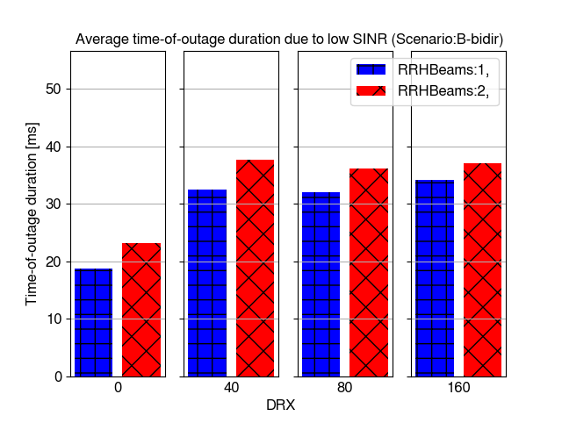

Figure 6.3.4.1.1.6-2 Time-of-outage per call and time-of-outage duration due to low SINR

Figure 6.3.4.1.1.6-3 shows beam failure indication rate as percentage of BFIs per beam switches. Beam failure indication are only observed with DRX with generally more problems in the case with 1 beam per RRH.

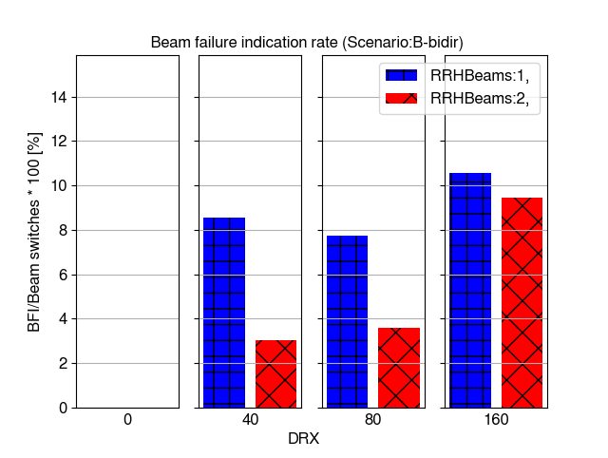

Figure 6.3.4.1.1.6-3 Beam failure indication rate

Figure 6.3.4.1.1.6-4 shows distribution of raw SINR values taken from the CQI measurements and it is observed that SINR level is high and clearly sufficient to support high mobility performance in the most cases. It is also observed that 2 beams per RRH only bring gain in cases where DRX cycle is lower than 80 ms. There is loss when the highest DRX cycle is used due to the least optimal beam management when longest delays are observed.

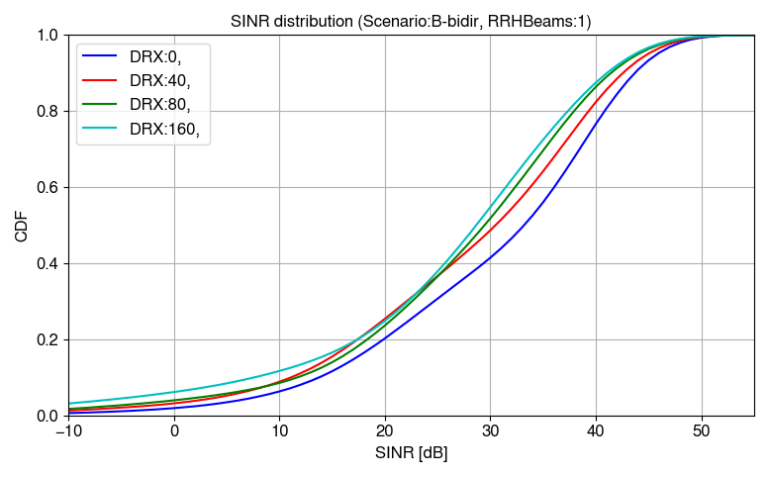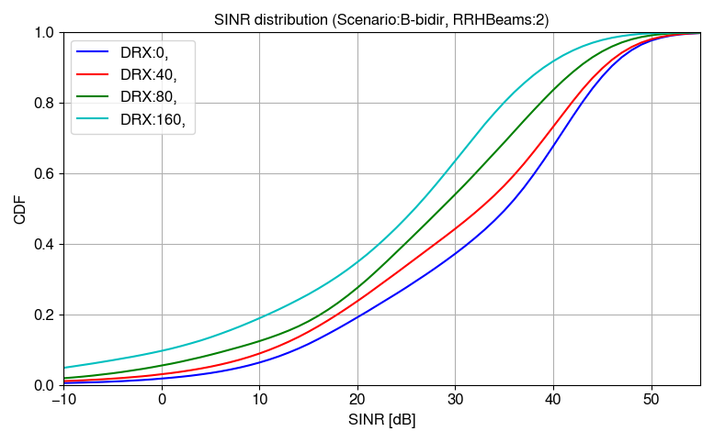

Figure 6.3.4.1.1.6-4 SINR distributions

###### 6.3.4.1.1.7 Bi-directional Scenario-A without DPS

This section shows system-level mobility performance simulation results for bi-directional Scenario-A without DPS with legacy RRM requirements. In addition to other parameters varied in the rest of the scenarios, the results with both multi-panel assumption 1 (MPUEAssumption:as1) and 3 (MPUEAssumption:as3) are shown here. With assumption 1, only one panel at a time can perform measurements and with assumption 3 both panels can measure at the same time.

Figure 6.3.4.1.1.7-1 shows handover rate per CPE per second and ping-pong handover rate relative to all handovers. It is observed that assumption 3 increases the number of handovers, but not always the number of ping-pongs in this scenario. When measuring with both panels at the same time the measurements are more up to date, which may reduce back-and-forth ping-pong handovers. As seen in other scenarios, longer DRX cycles significantly reduce the number of handovers.

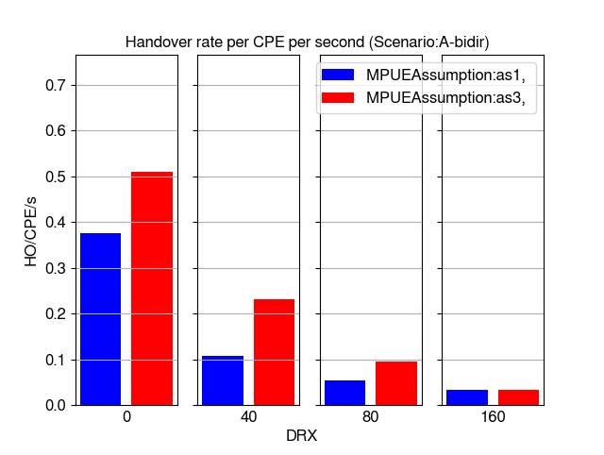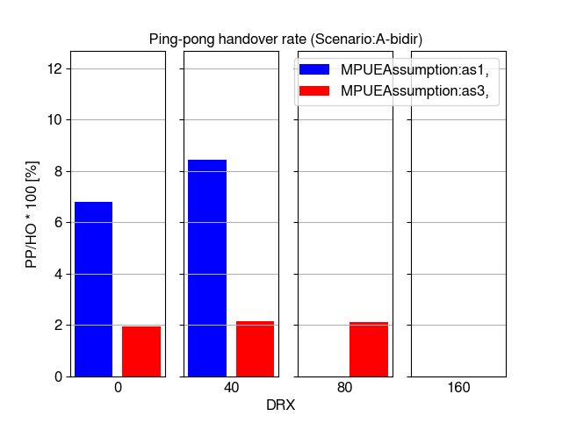

Figure 6.3.4.1.1.7-1 Handover and ping-pong handover rates

Figure 6.3.4.1.1.7-2 shows average time-of-stay in a cell. In bi-directional scenario, time-of-stay is very short without DRX due to frequent handovers. The time-of-stay is generally longer with assumption 1 due to more delays in following the best radio conditions, causing less handover to occur. Also, longer DRX cycles increase the average time-of-stay in a cell.

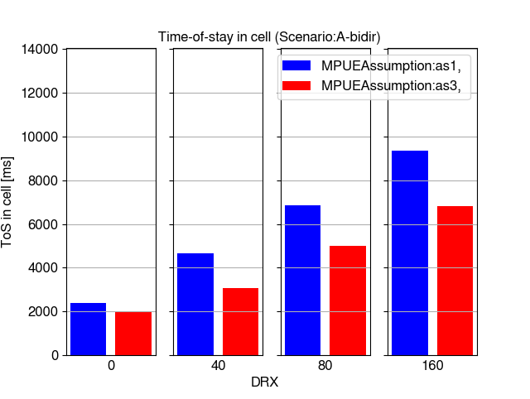

Figure 6.3.4.1.1.7-2 Time-of-stay in cell

Figure 6.3.4.1.1.7-3 shows time-of-outage statistics for both the total percentage of outage conditions relative to call length and average durations of outage due to low SINR level. With legacy requirements, the time-of-outage is very significant even without DRX and when multi-panel UE assumption 1 is configured. This is caused by the long delays due to legacy scaling factor 8 particularly when train is traveling towards the serving beam and quickly passing through the RRH location.

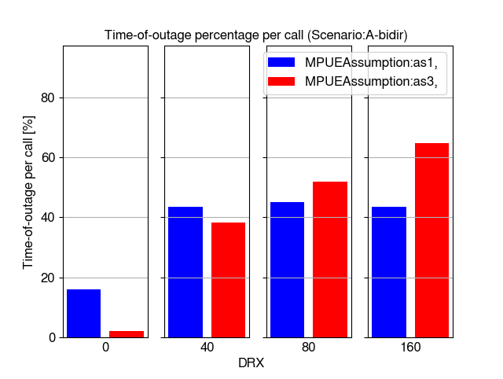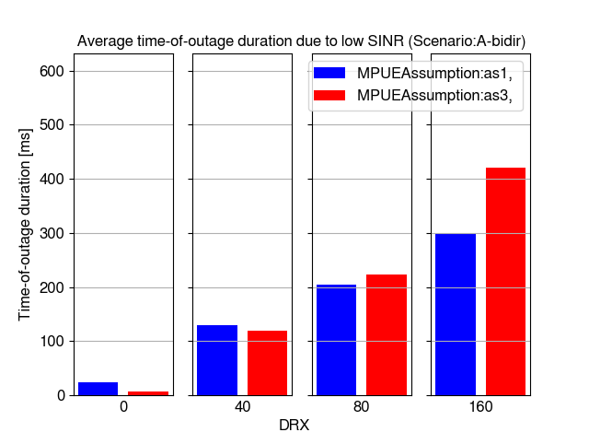

Figure 6.3.4.1.1.7-3 Time-of-outage per call and time-of-outage duration due to low SINR

Figure 6.3.4.1.1.7-4 shows mobility failure rates, and it behaves in the similar way as time-of-outage. The failure rate is high particularly with DRX, but also without DRX in cases where assumption 1 is configured.

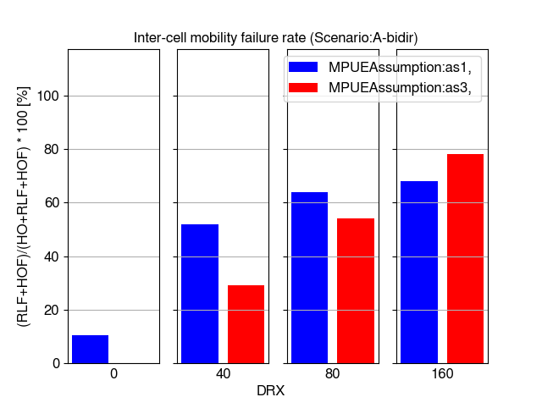

Figure 6.3.4.1.1.7-4 Mobility failure rate

Figure 6.3.4.1.1.7-5 shows SINR distributions for all simulated DRX cycles and multi-panel assumptions. It is observed that with legacy requirements only cases without DRX can provide fast enough mobility procedures to maintain good SINR level. However, with assumption 1, also the case without DRX has significantly degraded SINR for over 5% of the samples.

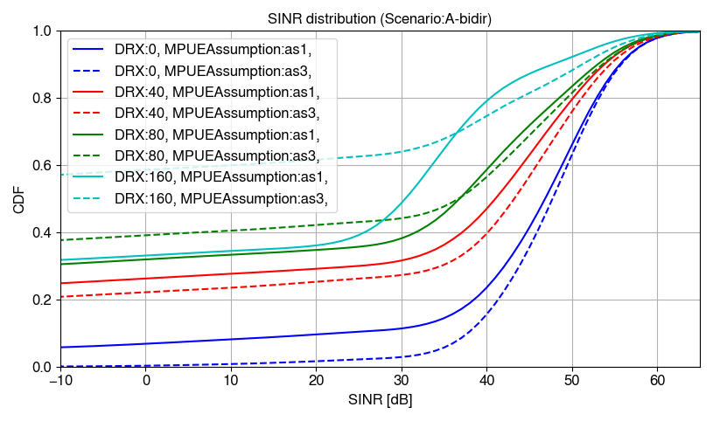

Figure 6.3.4.1.1.7-5 SINR distributions

###### 6.3.4.1.1.8 Bi-directional Scenario-A with DPS

This section shows system-level mobility performance simulation results for bi-directional Scenario-A with DPS with legacy requirements.

Figure 6.3.4.1.1.8-1 shows beam switch and beam ping-pong rates. The results show that the beam switch rate is significantly higher with multi-panel assumption 3, which is inline with the results seen in 6.3.4.1.1.7 for handovers in non-DPS case. Also, longer DRX cycles decrease the number of beam switches. Ping-pong rates are much more variant depending on DRX cycle where multi-panel assumptions are rather equal except in DRX 80 ms case, where there is higher ping-pong rate with assumption 3.

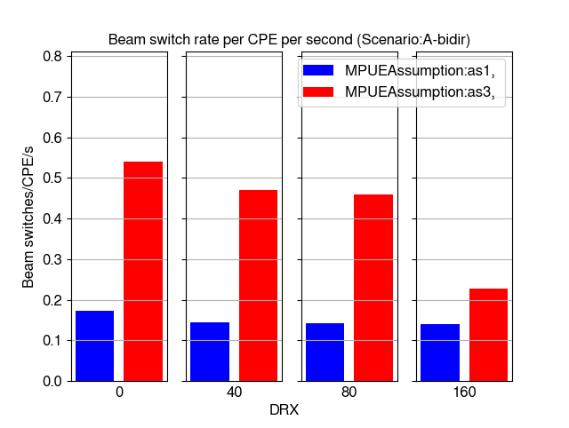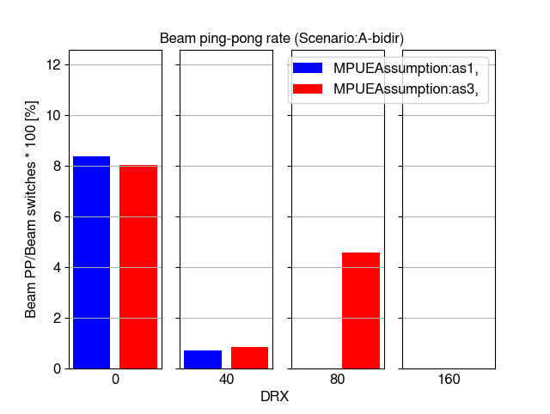

Figure 6.3.4.1.1.8-1 Beam switch and beam ping-pong rates

Figure 6.3.4.1.1.8-2 shows time-of-outage statistics with DPS. The results show that the rates generally increase with longer DRX but are lower than in non-DPS case in 6.3.4.1.1.7. Non-DRX case does not cause significant outages with either assumption 1 or 3. Due to high delays caused by legacy requirements and DRX, the time-of-outage can be high with both multi-panel assumptions when the longest DRX cycle is used.

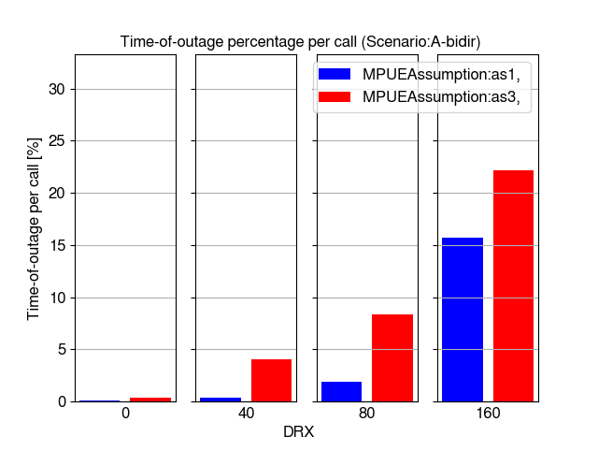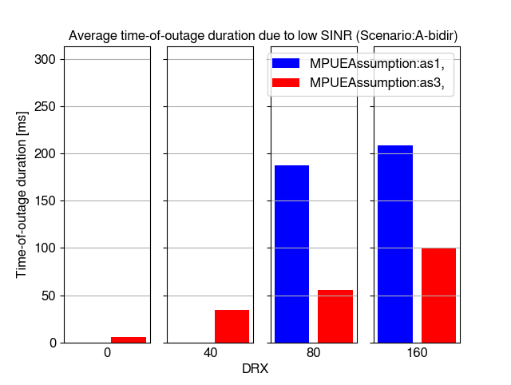

Figure 6.3.4.1.1.8-2 Time-of-outage per call and time-of-outage duration due to low SINR

Figure 6.3.4.1.1.8-3 shows beam failure indication rates in DPS scenario. It is observed that beam failures are either not observed at all or almost zero without DRX depending on the multi-panel assumption. However, when DRX cycle increases the failure indication rates become high with both assumptions.

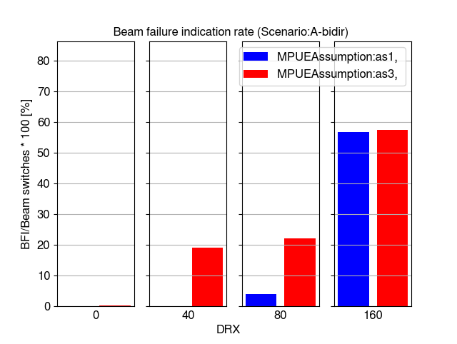

Figure 6.3.4.1.1.8-3 Beam failure indication rate

Figure 6.3.4.1.1.8-4 shows SINR distributions for all simulated DRX cycles and multi-panel assumptions. It is observed that SINR significantly degrades when mobility delays are increased with DRX cycles. The SINR difference between multi-panel assumptions is not so clear as in non-DPS case in 6.3.4.1.1.7. Assumption 3 gives gain in median and peak percentiles of the CDF particularly without DRX, but assumption 1 can be better in low percentiles of the CDF.

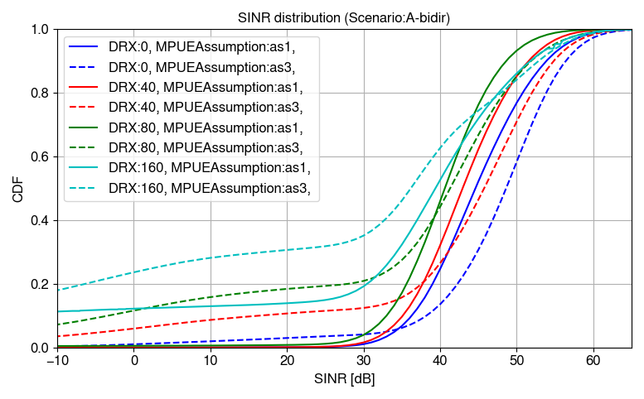

Figure 6.3.4.1.1.8-4 SINR distributions

##### 6.3.4.1.2 Enhanced RRM requirement mobility performance

In the sub-sections below the mobility performance results in HST FR2 deployments with enhanced requirements selected according to the number of Rx beams are presented, i.e., with scaling factors 2 for Scenario-A and 6 for Scenario-B.

In Table 6.3.4.1.2-1, we are introducing the parameters that are different in between the baseline legacy FR2 RRM requirements (assuming scaling factor 8) and enhanced HST FR2 requirements.

Table 6.3.4.1.2-1: Enhanced simulation assumptions for mobility performance evaluation.

|  |  |
| --- | --- |
| Parameter | Value |
| Number of beams per CPE panel | Enhanced requirements:  Uni-directional Scenario-A:  - 1 Rx beam (scaling factor 2 is assumed for RRC measurements, L1 measurements and cell detection delays in simulations)  - Rx beam is oriented parallel to the railway track towards the serving Tx beam.  Uni-directional Scenario-B:  - 6 Rx beams (scaling factor 6 is assumed for RRC measurements, L1 measurements and cell detection delays in simulations)  - Rx beam orientations (90 degrees is boresight of antenna panel): 65, 75, 85, 95, 105, 115 degrees (only first three are usable for RRHs north from track to be comparable with bi-directional case)  Bi-directional Scenario-B:  - 3 Rx beams (scaling factor 6 is assumed for RRC measurements, L1 measurements and cell detection delays in simulations)  - Rx beam orientations (90 degrees is boresight of antenna panel): 65, 75, 85 degrees  Bi-directional Scenario-A:  - 1 Rx beam per panel (scaling factor 2 is assumed for RRC measurements, L1 measurements and cell detection delays in simulations)  - Two Rx beams of CPE are oriented parallel to the railway in opposite directions |
| DRX | DRX disabled (DRX 0), 40, 80, 160 ms cycles |
| RRC measurement period  L1 RSRP measurement period | Scaling factor N=2:  DRX 0: 120 ms  DRX 40: 360 ms  DRX 80: 720 ms  DRX 160: 1440 ms  Scaling factor N = 6:  DRX 0: 360 ms  DRX 40: 1080 ms  DRX 80: 2160 ms  DRX 160: 4320 ms |
| Cell detection delay  (TPSS/SSS_sync_intra) | Scaling factor N=2:  DRX 0: 600 ms  DRX 40: 600 ms  DRX 80: 720 ms  DRX 160: 1440 ms  Scaling factor N = 6:  DRX 0: 600 ms  DRX 40: 1080 ms  DRX 80: 2160 ms  DRX 160: 4320 ms |
| RLM assumptions | Scaling factor N=2:  TEvaluate_out_CSI-RS: 600, 3600, 720, 14400 ms (DRX 0, 40, 80, 160)  Scaling factor N = 6:  TEvaluate_out_CSI-RS: 600, 3600, 720, 14400 ms (DRX 0, 40, 80, 160)  N310: 2 samples  N311: 2 samples  Qout threshold SINR: -8 dB  Qin threshold SINR: -6 dB |
| BFD assumptions | Scaling factor N=2:  TEvaluate_BFD_CSI-RS: 300, 1800, 3600, 7200 ms (DRX 0, 40, 80, 160)  Scaling factor N = 6:  TEvaluate_BFD_CSI-RS: 300, 1800, 3600, 7200 ms (DRX 0, 40, 80, 160) |
| PDCCH model | Non-ideal PDCCH model with AL16 |

###### 6.3.4.1.2.1 Uni-directional Scenario-A without DPS

This section shows system level simulation mobility performance results for uni-directional Scenario-A without DPS for both the case when train is traveling into same direction (Dir:Same in legends) as RRH beam are pointing to and into opposite direction (Dir:Opposite in legends). Figure 6.3.4.1.2.1-1 shows successful handover rate per CPE per second and ping-pong rate as percentage of ping-pong handovers per all handovers. Ping-pong handover is observed when two handovers happen back and forth between two same cells in one second. It is observed that handover and ping-pong rates are the highest without DRX and gradually decrease when DRX cycle is increased. Significant drop in successful handovers is observed when train travels to opposite direction than RRH beams are pointed to and DRX cycle is increased to 160 ms.

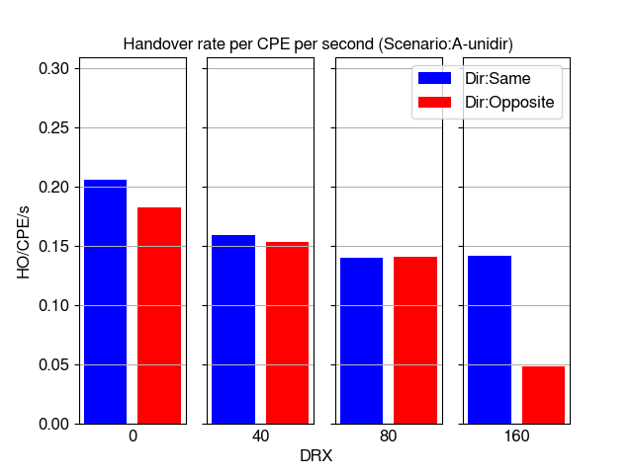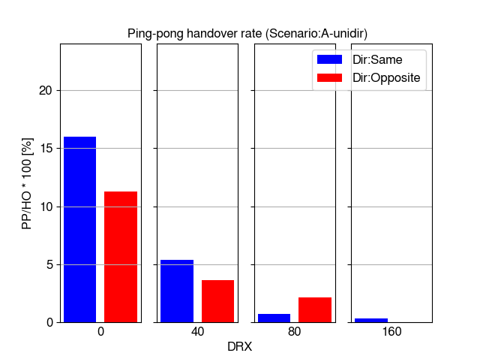

Figure 6.3.4.1.2.1-1 Handover and ping-pong handover rates

Figure 6.3.4.1.2.1-2 shows average time-of-stay in cell (RRH). It is observed that without DRX the time-of-stay in RRH is significantly lower than the time train with 350 km/h speed takes to travel the distance of one Ds of 700 meters (about 7.2 seconds). This result is due to ping-pongs observed in Figure 6.3.4.1.2.1-1. With DRX cycles 80-160 ms the time-of-stay increases to about 7 seconds.

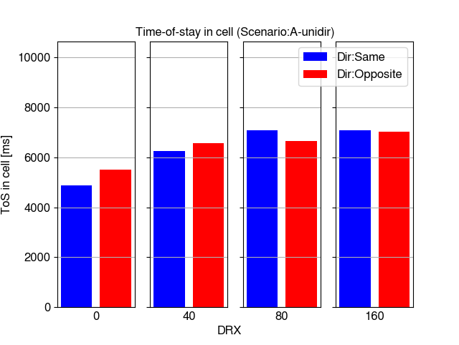

Figure 6.3.4.1.2.1-2 Time-of-stay in cell

Figure 6.3.4.1.2.1-3 shows time-of-outage percentage per call (existence of CPE in the simulation) and average time-of-outage duration due to low SINR (below -8 dB) conditions. Time-of-outage percentage per call includes all the sources of outage combined. This consists of handover execution time, the time it takes to perform radio link failure related procedures from observing radio link problem until re-establishment of connection and the time below -8 dB SINR conditions are observed in the simulation even prior to radio link problem can be detected based on filtering. It is observed from the results that significant outage is detected only in case train travels to opposite direction than RRHs are pointing to and DRX cycles are 80 ms or longer.

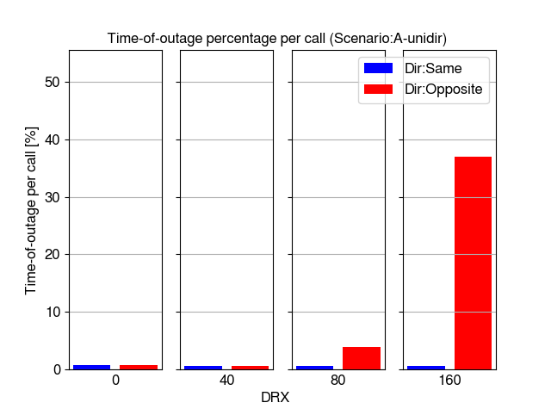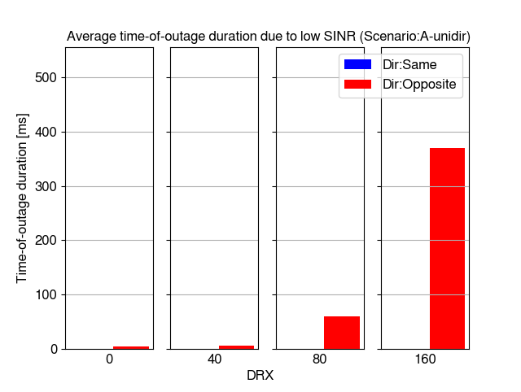

Figure 6.3.4.1.2.1-3 Time-of-outage per call and time-of-outage duration due to low SINR

Figure 6.3.4.1.2.1-4 shows inter-cell mobility failure rate (RLF + HOF percentage of all handover and failure events). It is seen that similarly as significant time-of-outage rates are observed only scenario where train travels to opposite direction than RRHs are pointing to causes mobility failures among the simulated DRX cycles. DRX 80 ms causes about 7% failure rate and DRX 160 ms causes very significant problems with over 60% failure rate in this scenario. No failures are observed when train is traveling into same direct as RRH beams are pointing to.

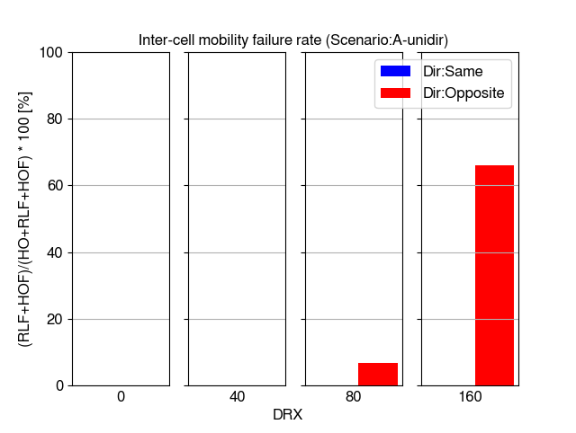

Figure 6.3.4.1.2.1-4 Mobility failure rate

Figure 6.3.4.1.2.1-5 shows distribution of raw SINR values taken from the CQI measurements and it is observed that SINR level is high and clearly sufficient to support high mobility performance except it the cases with DRX 80-160 ms and train traveling to opposite direction.

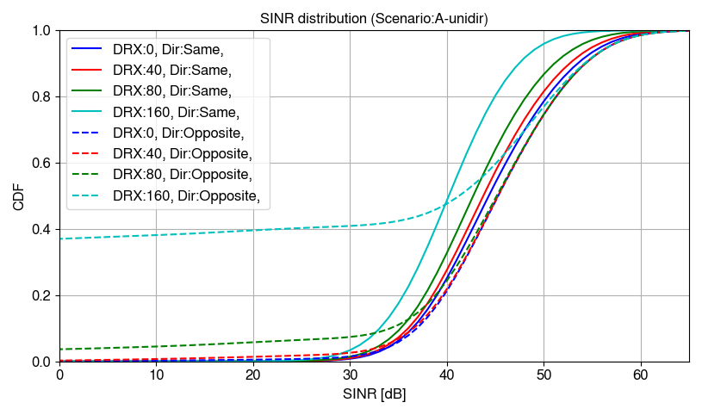

Figure 6.3.4.1.2.1-5 SINR distributions

###### 6.3.4.1.2.2 Uni-directional Scenario-A with DPS

This section shows system level simulation mobility performance results for uni-directional Scenario-A with DPS. Some of the observed statistics are of different type than in the section without DPS. Figure 6.3.4.1.2.2-1 shows successful beam switch rate per CPE per second and ping-pong rate as percentage of ping-pong beam switches per all beam switches. Beam ping-pong is observed when two beam switches happen back and forth between two same beams in one second. Practically in Scenario-A with just one Tx beam per RRH this means ping-pongs between RRHs. In DPS case the same trend is observed in beam switches as with handovers in non-DPS case, without DRX the rates are the highest and gradually rates decrease when longer DRX cycles are used. The differences between the rates in train travel direction are rather low.

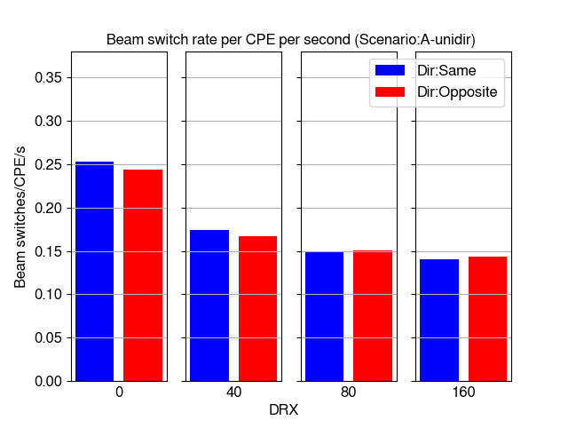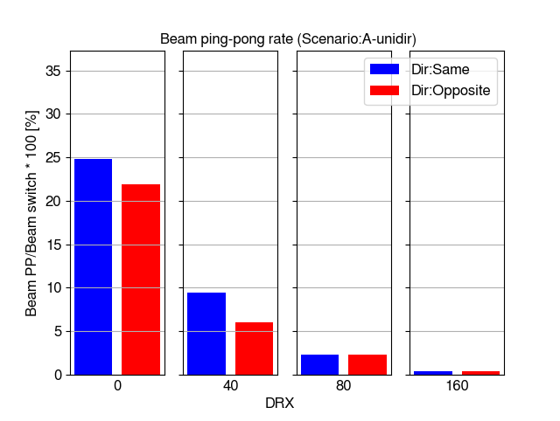

Figure 6.3.4.1.2.2-1 Beam switch and beam ping-pong rates

Figure 6.3.4.1.2.2-2 shows time-of-outage percentage per call (existence of CPE in the simulation) and average time-of-outage duration due to low SINR (below -8 dB) conditions. Similar trend is observed here as without DPS that the time-of-outage rates are very low when train is traveling to the same direction as RRH beams are pointing to and none of the outages are caused by low SINR. In the opposite direction time-of-outage starts to increase significantly when DRX cycles are 80 ms or longer. However, time-of-outage is significantly lower than without DPS due to lower delay when switching to different RRH location.

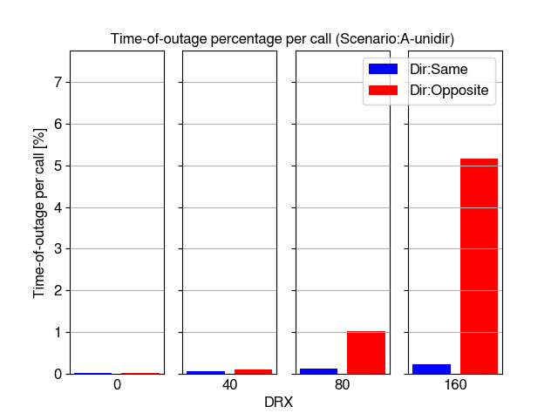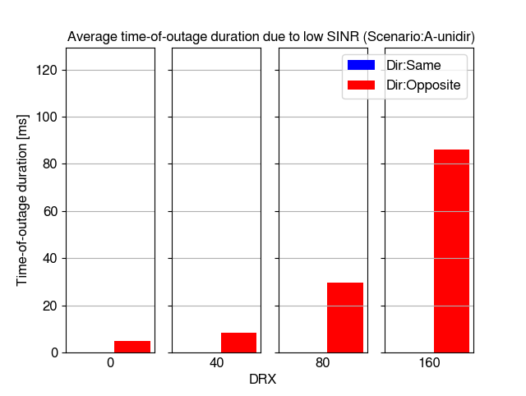

Figure 6.3.4.1.2.2-2 Time-of-outage per call and time-of-outage duration due to low SINR

Figure 6.3.4.1.2.2-3 shows beam failure indication rate as percentage of BFIs per beam switches. Similar trend is observed without DPS that no failures happen among the studied DRX cycles when train is traveling to same direction as RRH beams are pointing to. Only in case of DRX cycle 80 ms or more failures are observed with train traveling to opposite direction.

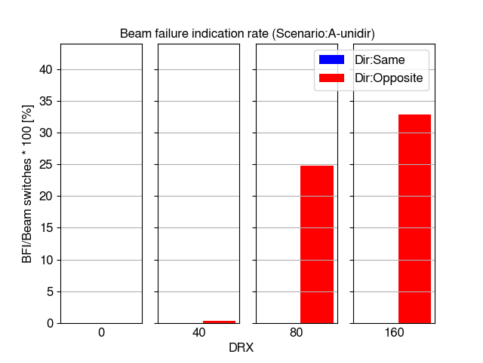

Figure 6.3.4.1.2.2-3 Beam failure indication rate

Figure 6.3.4.1.2.2-4 shows distribution of raw SINR values taken from the CQI measurements and it is observed that SINR level is high and clearly sufficient to support high mobility performance except in the cases with DRX 80-160 ms and train traveling to opposite direction. However, the amount of low SINR samples below 0 dB are less common even in these cases when DPS is used.

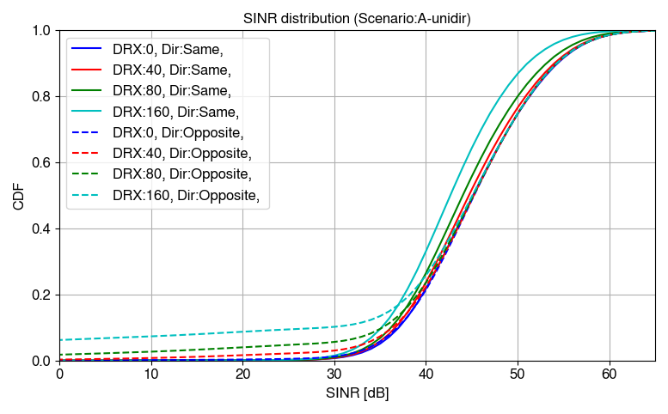

Figure 6.3.4.1.2.2-4 SINR distributions

###### 6.3.4.1.2.3 Uni-directional Scenario-B without DPS

This section shows system level simulation mobility performance results for uni-directional Scenario-B without DPS. Also, comparison between 1 and 2 beams per RRH is included in this section. Figure 6.3.4.1.2.3-1 shows successful handover rate per CPE per second and ping-pong rate as percentage of ping-pong handovers per all handovers. It is observed that without DRX the handover rate is the highest and it drops when DRX cycle 40 ms is used but remains at approximately same level with all simulated DRX cycles. This indicates that there is more time to perform handover in Scenario-B than in Scenario-A particularly when comparing the cases when train is traveling to opposite direction than the RRH beams are pointing to. It is also observed that without DRX there are higher handover and ping-pong rates with 1 beam per RRH than 2 beams per RRH.

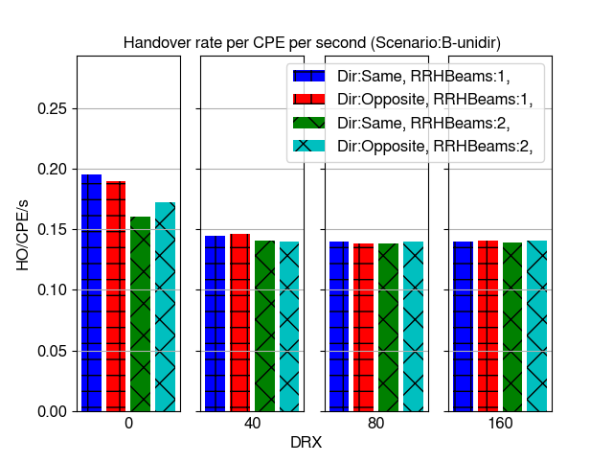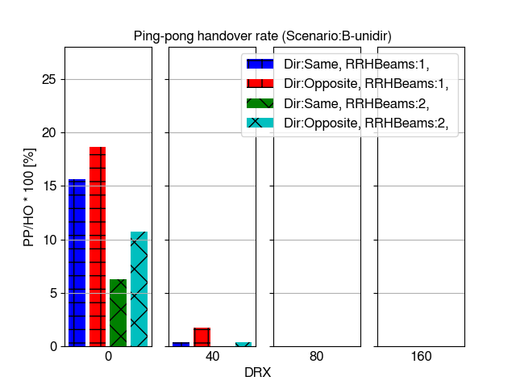

Figure 6.3.4.1.2.3-1 Handover and ping-pong handover rates

Figure 6.3.4.1.2.3-2 shows average time-of-stay in cell (RRH). It is observed that without DRX the time-of-stay in RRH is significantly lower than the time train with 350 km/h speed takes to travel the distance of one Ds of 700 meters (about 7.2 seconds) particularly with 1 Tx beam per RRH. This result is due to ping-pongs observed in Figure 6.3.4.1.2.3-1 in similar way as in Scenario A. Time-of-stay is relatively close with all studied DRX cycles in this scenario.

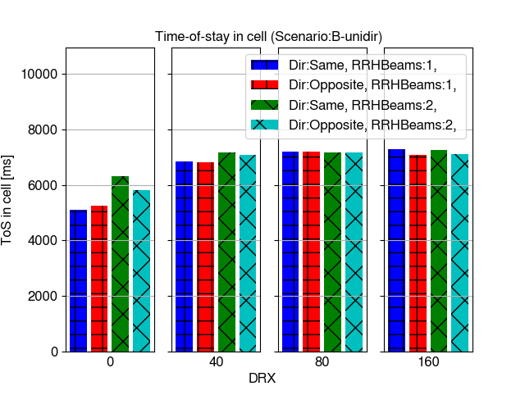

Figure 6.3.4.1.2.3-2 Time-of-stay in cell

Figure 6.3.4.1.2.3-3 shows time-of-outage percentage per call (existence of CPE in the simulation) and average time-of-outage duration due to low SINR (below -8 dB) conditions. It is observed that in Scenario-B the outage rates are very low compared to Scenario-A in case where train is traveling to opposite direction.

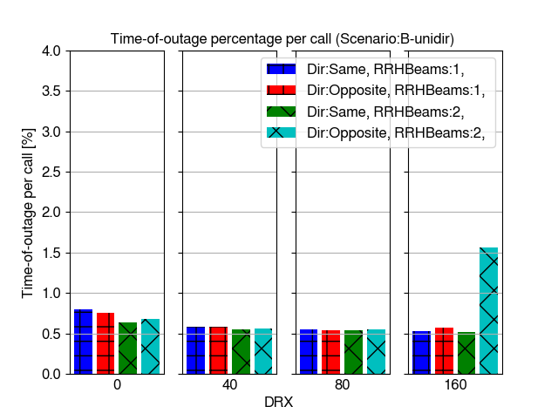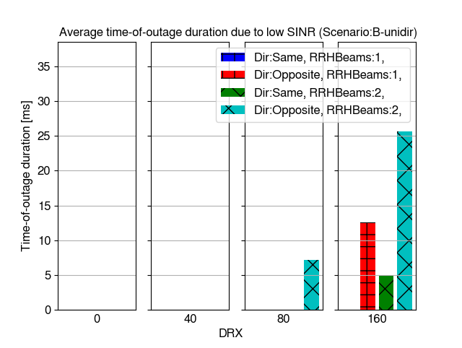

Figure 6.3.4.1.2.3-3 Time-of-outage per call and time-of-outage duration due to low SINR

Figure 6.3.4.1.2.3-4 shows inter-cell mobility failure rate (RLF + HOF percentage of all handover and failure events). There are no failures in Scenario-B except with DRX 160 ms, train traveling to opposite direction and 2 beams per RRH where about 1 % failure rate is observed. This is very significantly lower rate of failures than in the corresponding Scenario-A case.

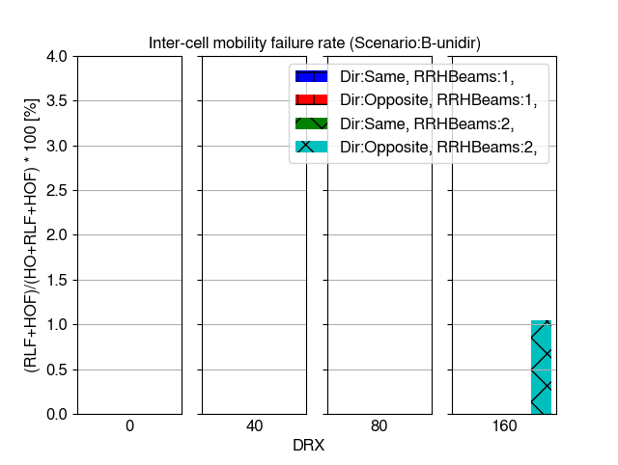

Figure 6.3.4.1.2.3-4 Mobility failure rate

Figure 6.3.4.1.2.3-5 shows distribution of raw SINR values taken from the CQI measurements and it is observed that SINR level is high and clearly sufficient to support always high mobility performance in all cases except DRX 160 ms and train traveling to opposite direction. It is also observed than without DRX and DRX 40 ms there is clear gain in SINR from having 2 beams per RRH compared to 1 beam per RRH, but when longer DRX is applied the gain is no longer observed. This is caused by the delays in selecting optimal beams for longer DRX.

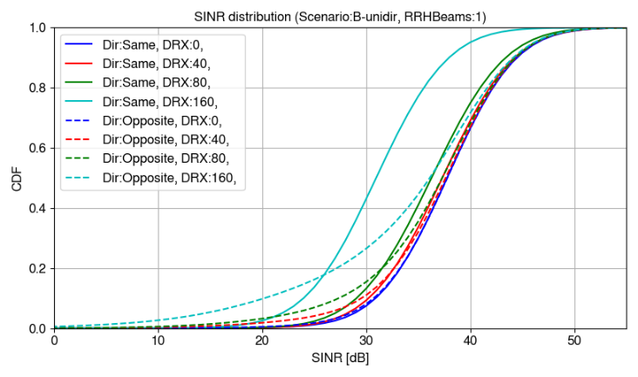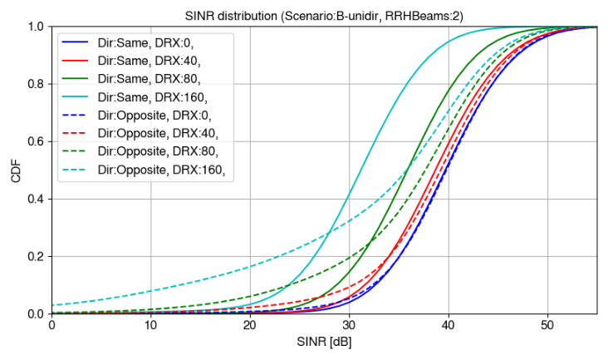

Figure 6.3.4.1.2.3-5 SINR distributions

###### 6.3.4.1.2.4 Uni-directional Scenario-B with DPS

This section shows system level simulation mobility performance results for uni-directional Scenario-B with DPS. Figure 6.3.4.1.2.4-1 shows successful beam switch rate per CPE per second and ping-pong rate as percentage of ping-pong beam switches per all beam switches. It is observed that there are clearly more beam switches with 2 beams per RRH than 1 beam per RRH. However, beam ping-pongs are less common is case of 2 beams per RRH. As observed in previous scenarios beam switch and ping-pong rates gradually decrease when DRX in used.

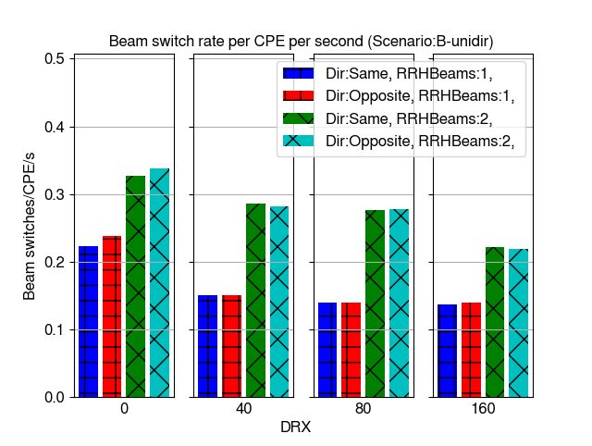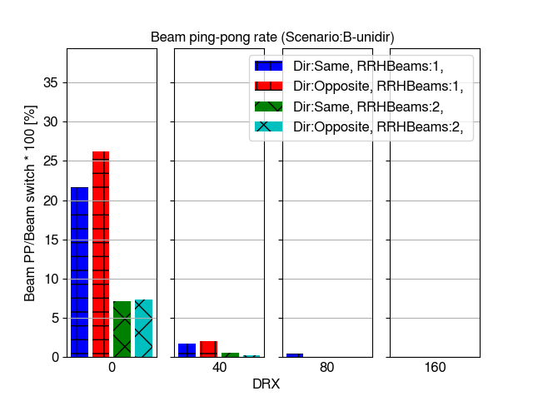

Figure 6.3.4.1.2.4-1 Beam switch and beam ping-pong rates

Figure 6.3.4.1.2.4-2 shows time-of-outage percentage per call (existence of CPE in the simulation) and average time-of-outage duration due to low SINR (below -8 dB) conditions. It is observed that time-of-outage rates are very low without DRX and DRX up to 80 ms. Particularly in cases where train is traveling to opposite direction than RRHs are pointing to the time-of-outage rates increase when DRX cycle 160 ms is applied.

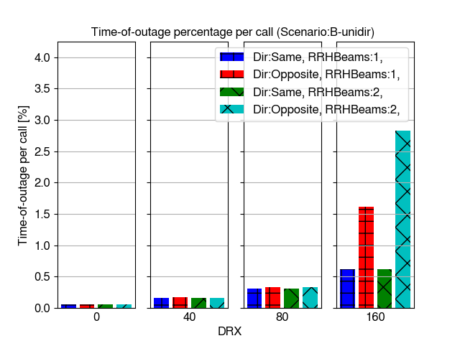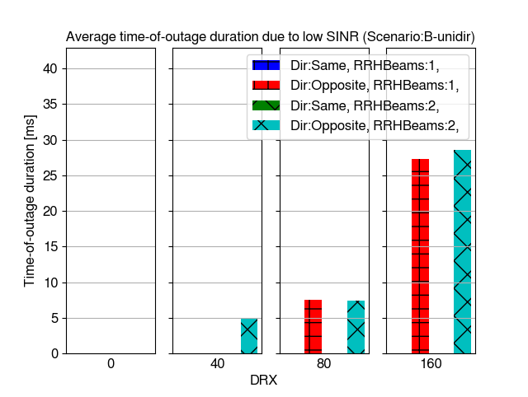

Figure 6.3.4.1.2.4-2 Time-of-outage per call and time-of-outage duration due to low SINR

Figure 6.3.4.1.2.4-3 shows beam failure indication rate as percentage of BFIs per beam switches. It is observed that failure indications only happen with DRX 160 ms and when train is traveling to opposite direction. Also, in this case the failure rate is lower than in Scenario-A.

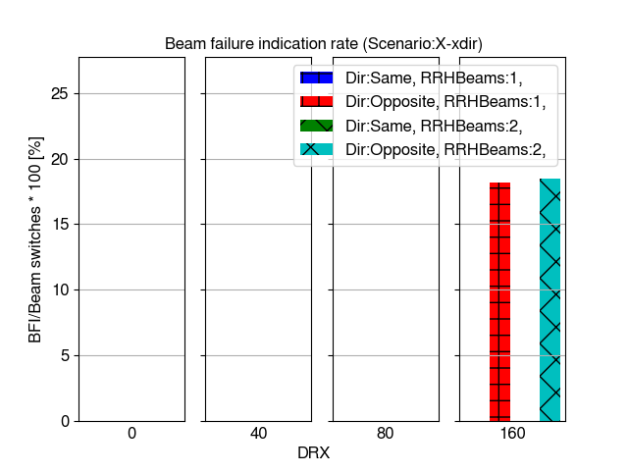

Figure 6.3.4.1.2.4-3 Beam failure indication rate

Figure 6.3.4.1.2.4-4 shows distribution of raw SINR values taken from the CQI measurements and it is observed that SINR level is high and clearly sufficient to support high mobility performance except it the cases with DRX 160 ms and train traveling to opposite direction.

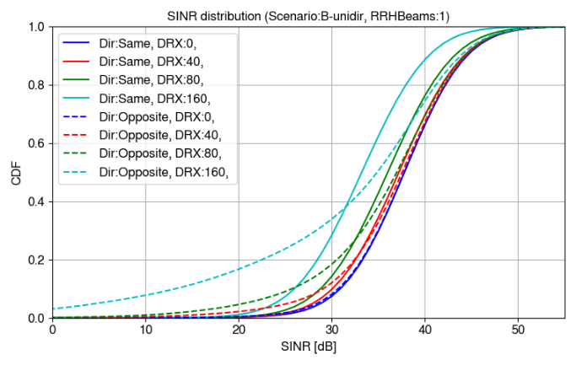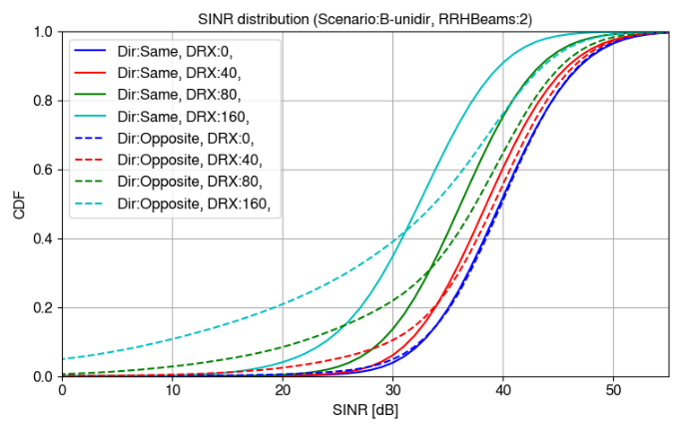

Figure 6.3.4.1.2.4-4 SINR distributions

###### 6.3.4.1.2.5 Bi-directional Scenario-B without DPS

This section shows system level simulation mobility performance results for bi-directional Scenario-B without DPS. Figure 6.3.4.1.2.5-1 shows successful handover rate per CPE per second and ping-pong rate as percentage of ping-pong handovers per all handovers. It is observed that general levels of handover and ping-pong rates are clearly higher in bi-directional scenario than in uni-directional scenario. Uni-directional Scenario-B as maximum of about 0.2 HO/CPE/s and bi-directional has almost 0.7 HO/CPE/s. Ping-pongs are much more common even with DRX in bi-directional scenario.

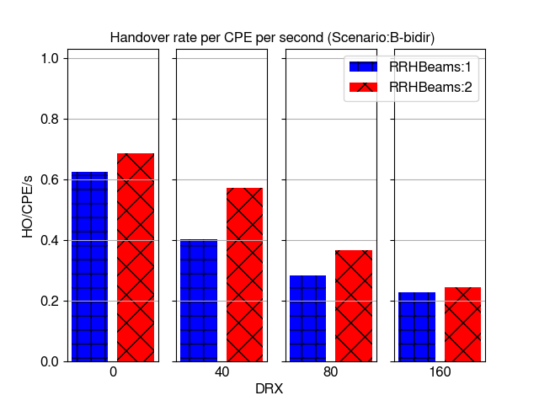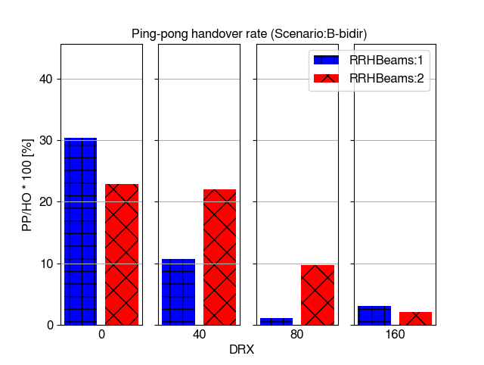

Figure 6.3.4.1.2.5-1 Handover and ping-pong handover rates

Figure 6.3.4.1.2.5-2 shows average time-of-stay in cell (RRH). It is observed that time-of-stay is significantly affected by DRX cycle and the number of beams per RRH. Generally, time-of-stay times in bi-directional scenario are about half of the times or lower in comparison to uni-directional scenario.

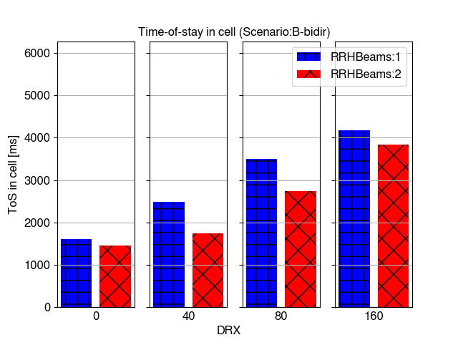

Figure 6.3.4.1.2.5-2 Time-of-stay in cell

Figure 6.3.4.1.2.5-3 shows time-of-outage percentage per call (existence of CPE in the simulation) and average time-of-outage duration due to low SINR (below -8 dB) conditions. It is observed that time-of-outage percentage per call is higher in bi-directional scenario than in uni-directional scenario mainly due to increased handovers. However, also in bi-directional Scenario-B clearly increased outage is only seen when DRX cycle is set to 160 ms.

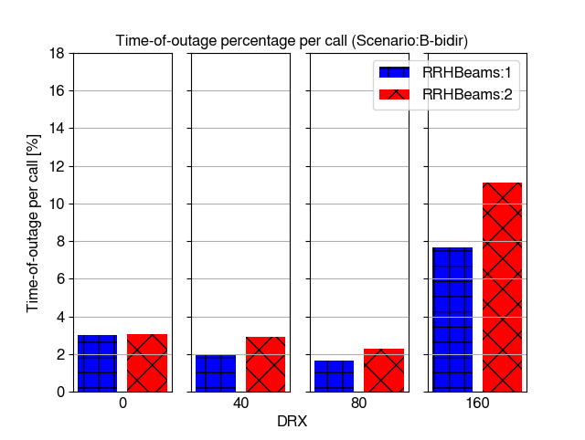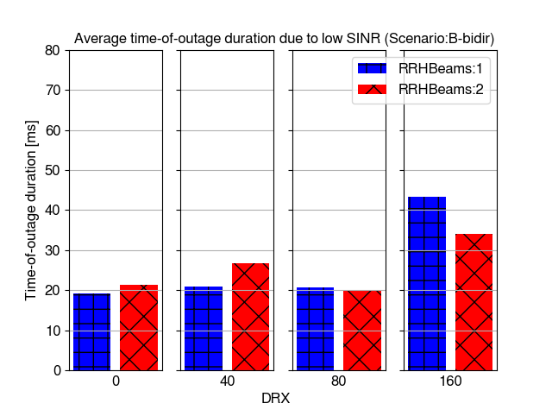

Figure 6.3.4.1.2.5-3 Time-of-outage per call and time-of-outage duration due to low SINR

Figure 6.3.4.1.2.5-4 shows inter-cell mobility failure rate (RLF + HOF percentage of all handover and failure events). It is observed that significant number of failures happen only with DRX cycle 160 ms.

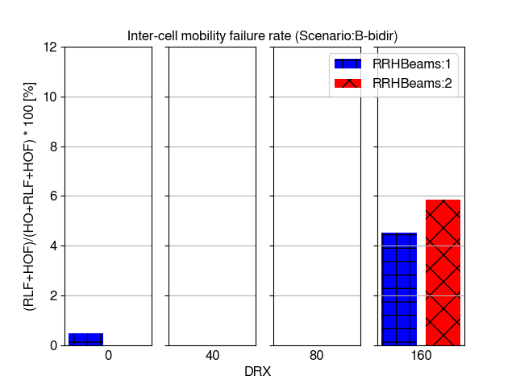

Figure 6.3.4.1.2.5-4 Mobility failure rate

Figure 6.3.4.1.2.5-5 shows distribution of raw SINR values taken from the CQI measurements and it is observed that SINR level is high and clearly sufficient to support always high mobility performance in all cases except DRX 160 ms. It is also observed than without DRX and DRX 40 ms there is clear gain in SINR from having 2 beams per RRH compared to 1 beam per RRH, but when longer DRX is applied the gain is no longer observed. This is caused by the delays in selecting optimal beams with longer DRX. It is noted that SINR level in low SINR percentiles is lower in bi-directional scenario than uni-directional Scenario-B. Possible reasons for this include using multi-panel UE assumption 1 in bi-directional scenario where two panels per CPE are used. With this assumption only one panel can be activated at the time and used for measurements causing some additional delays in mobility and beam management.

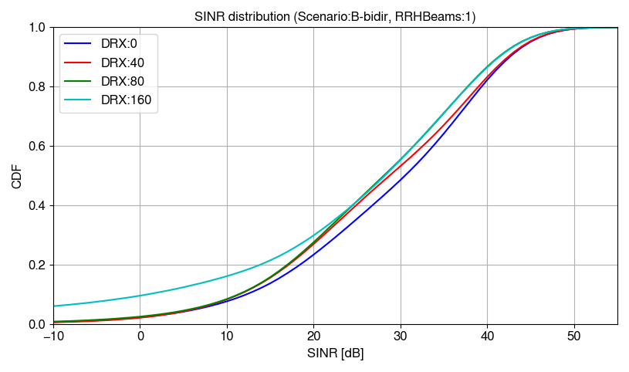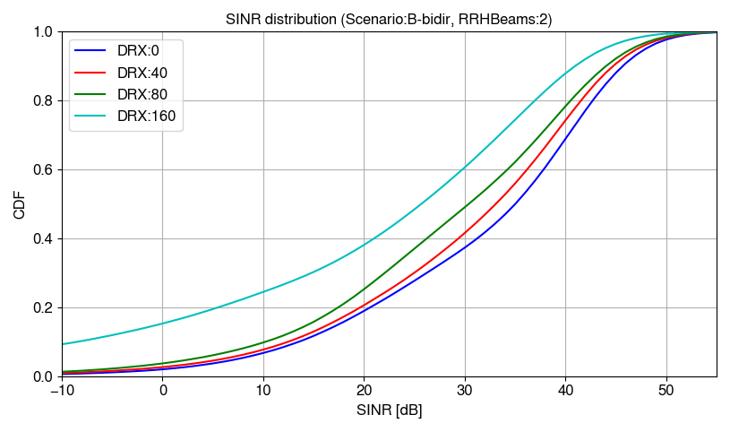

Figure 6.3.4.1.2.5-5 SINR distributions

###### 6.3.4.1.2.6 Bi-directional Scenario-B with DPS

This section shows system level simulation mobility performance results for bi-directional Scenario-B with DPS. Figure 6.3.4.1.2.6-1 shows successful beam switch rate per CPE per second and ping-pong rate as percentage of ping-pong beam switches per all beam switches. It is observed that DRX cycle and the number of beams per RRH have significant impact on beam switch rate by decreasing rate when DRX cycle increases. There are more beam switches with 2 beams per RRH than 1 beam per RRH as would be expected in DPS scenario.

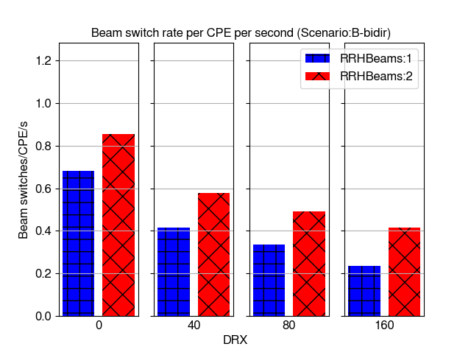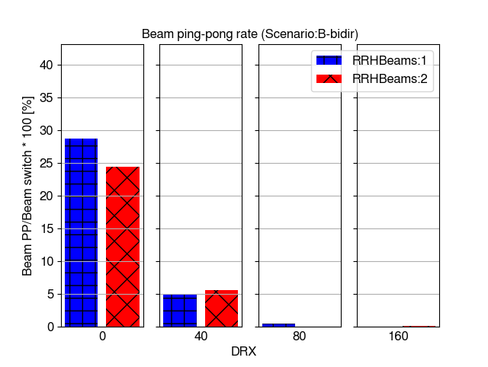

Figure 6.3.4.1.2.6-1 Beam switch and beam ping-pong rates

Figure 6.3.4.1.2.6-2 shows time-of-outage percentage per call (existence of CPE in the simulation) and average time-of-outage duration due to low SINR (below -8 dB) conditions. It is observed that the outage percentage per call is lower in DPS scenario than without DPS. This is caused by lower outage time in beam switch than handover. Only with DRX 160 ms the outage rate significantly increases from the level without DRX. This can be caused by less optimal beam selection.

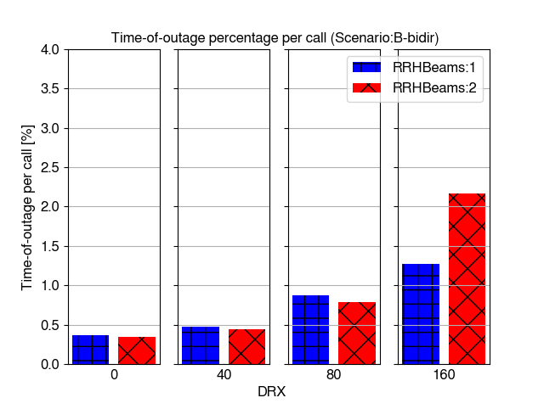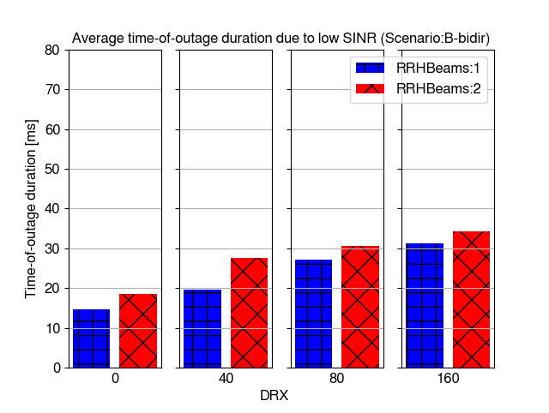

Figure 6.3.4.1.2.6-2 Time-of-outage per call and time-of-outage duration due to low SINR

Figure 6.3.4.1.2.6-3 shows beam failure indication rate as percentage of BFIs per beam switches. Only in case of DRX 160 ms a significant rate of failures is observed but remaining in low rate. This indicates good performance in beam management with DPS in bi-directional Scenario-B.

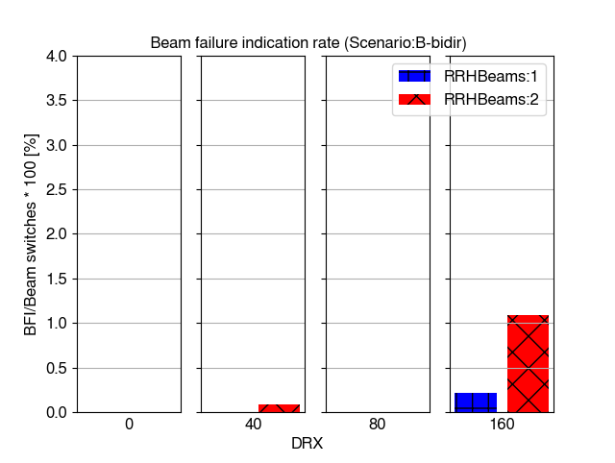

Figure 6.3.4.1.2.6-3 Beam failure indication rate

Figure 6.3.4.1.2.6-4 shows distribution of raw SINR values taken from the CQI measurements and it is observed that SINR level is high and clearly sufficient to support high mobility performance in the most cases. It is also observed that 2 beams per RRH only bring gain in cases where DRX cycle is lower than 160 ms. There is loss when the highest DRX cycle is used due to the least optimal beam management when longest delays are observed.

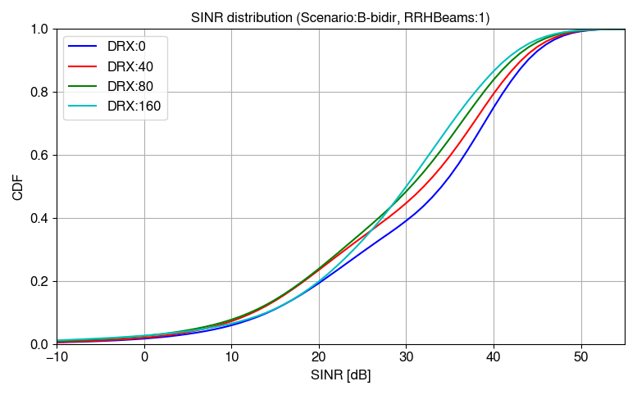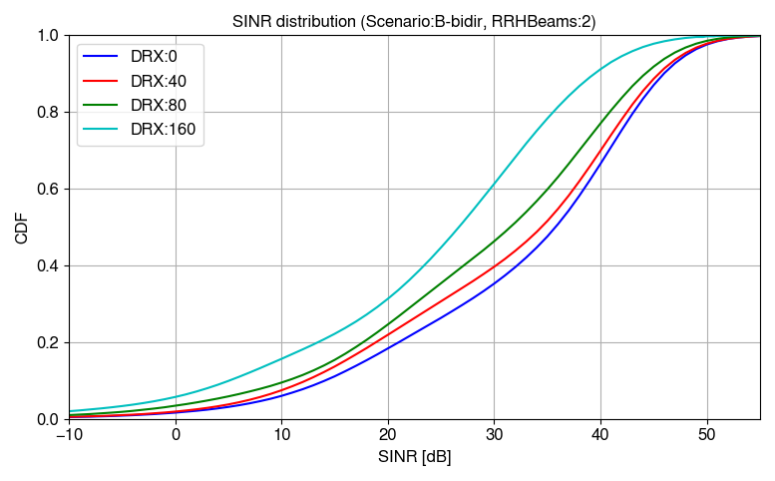

Figure 6.3.4.1.2.6-4 SINR distributions

###### 6.3.4.1.2.7 Bi-directional Scenario-A without DPS

This section shows system level mobility performance simulation results for bi-directional Scenario-A without DPS with enhanced RRM requirements. In addition to other parameters varied in the rest of the scenario the results with both multi-panel assumption 1 (MPUEAssumption:as1) and 3 (MPUEAssumption:as3) are shown here. With assumption 1, only one panel at a time can perform measurements and with assumption 3 both panels can measurement at the same time.

Figure 6.3.4.1.2.7-1 shows handover rate per CPE per second and ping-pong handover rate. It is observed that assumption 3 increases the number of handovers, but not the number of ping-pongs in this scenario. When measuring with both panels at the same time, the measurements are more up to date, which may reduce back-and-forth ping-pong handovers. As it can be seen in other scenarios, longer DRX cycles significantly reduce the number of handovers. Enhanced requirements increase the number of handovers compared to legacy requirements due to lower mobility delays from measurements.

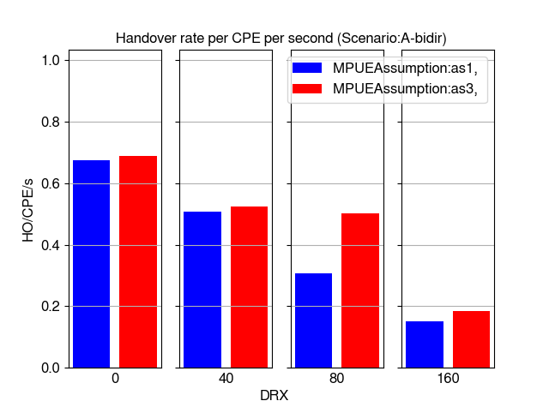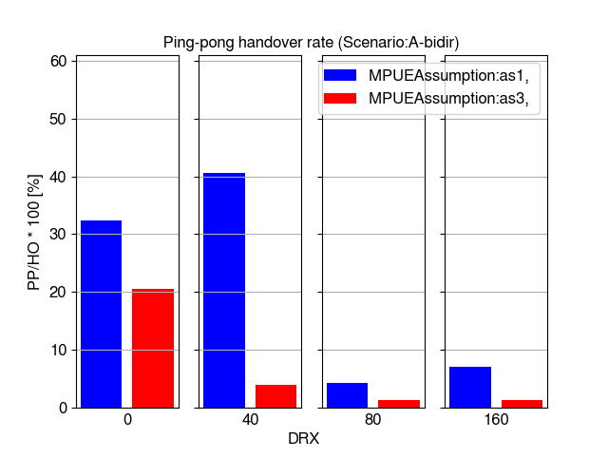

Figure 6.3.4.1.2.7-1 Handover and ping-pong handover rates

Figure 6.3.4.1.2.7-2 shows average time-of-stay in a cell. In bi-directional scenario, time-of-stay is very short without DRX due to frequent handovers. The time-of-stay increases with longer DRX cycles. The time-of-stay is generally shorter with enhanced requirements due to lower mobility delays compared to legacy requirements.

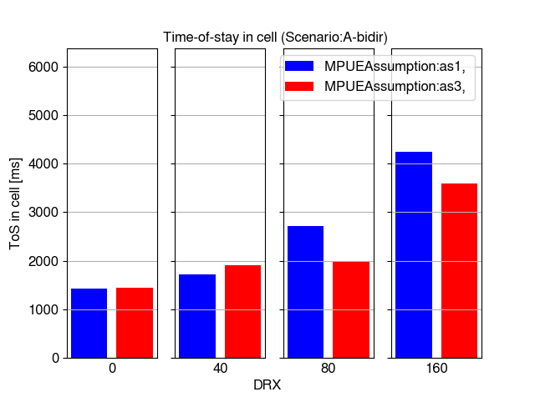

Figure 6.3.4.1.2.7-2 Time-of-stay in cell

Figure 6.3.4.1.2.7-3 shows time-of-outage statistics for both the total percentage of outage conditions relative to call length and average durations of outage due to low SINR level. Even with enhanced requirements the time-of-outage is very significant when multi-panel UE assumption 1 is configured and DRX is used. With longest DRX cycle, also outage with assumption 3 is high. However, the outage rates are much lower with these enhanced requirements than the legacy requirements.

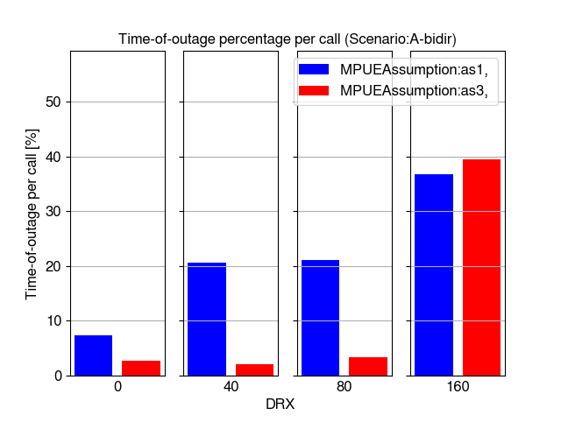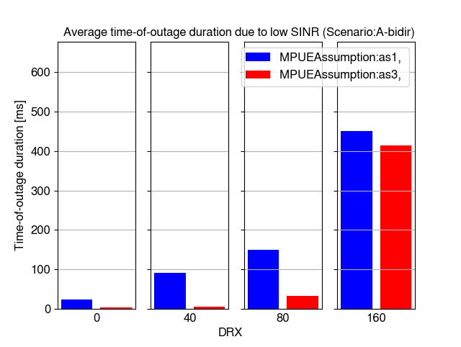

Figure 6.3.4.1.2.7-3 Time-of-outage per call and time-of-outage duration due to low SINR

Figure 6.3.4.1.2.7-4 shows mobility failure rates, and it is observed that in the similar way as time-of-outage, the failure rate is high particularly with DRX, but also without DRX in cases where assumption 1 is configured. However, the failure rates are much lower with these enhanced requirements than the legacy requirements.

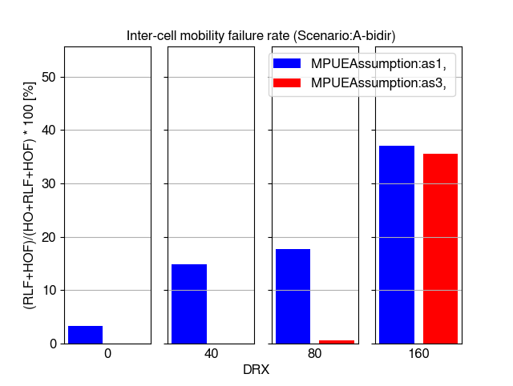

Figure 6.3.4.1.2.7-4 Mobility failure rate

Figure 6.3.4.1.2.7-5 shows SINR distributions for all simulated DRX cycles and multi-panel assumptions. It is observed that with enhanced requirements DRX cycles up to 80 ms with multi-panel assumption 3 can provide fast enough mobility procedures to maintain a good SINR level. Also, multi-panel assumption 1 can provide good SINR without DRX in over 95% of the samples. Higher DRX cycles have significantly degraded SINRs with assumption 1.

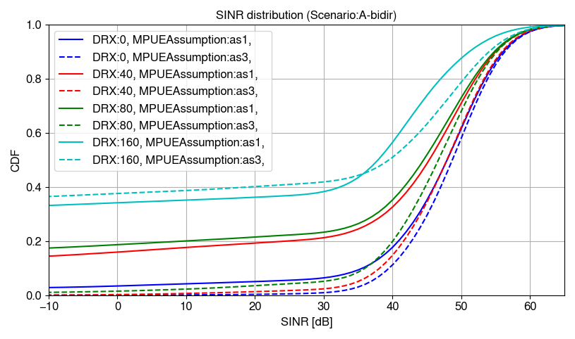

Figure 6.3.4.1.2.7-5 SINR distributions

###### 6.3.4.1.2.8 Bi-directional Scenario-A with DPS

This section shows system level mobility performance simulation results for bi-directional Scenario-A with DPS with enhanced RRM requirements.

Figure 6.3.4.1.2.8-1 shows beam switch and beam ping-pong rates. The results show that the beam switch rate is significantly higher with multi-panel assumption 3, except in the case without DRX where the numbers are rather equal. Also, longer DRX cycles decrease the number of beam switches. The beam switch rate is generally higher with enhanced requirements compared to legacy requirements. Ping-pong rates are quite equal between the multi-panel assumptions.

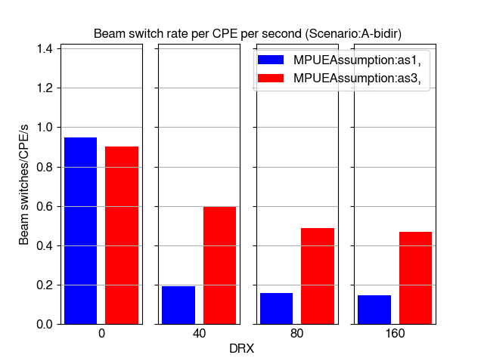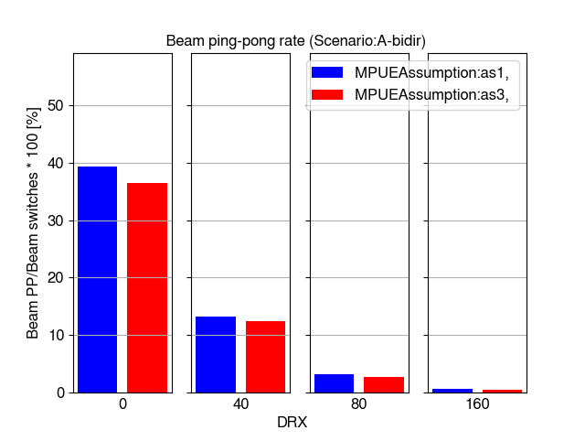

Figure 6.3.4.1.2.8-1 Beam switch and beam ping-pong rates

Figure 6.3.4.1.2.8-2 shows time-of-outage statistics with DPS. The results show generally very low outage rate with enhanced requirements up to DRX cycle 80 ms.

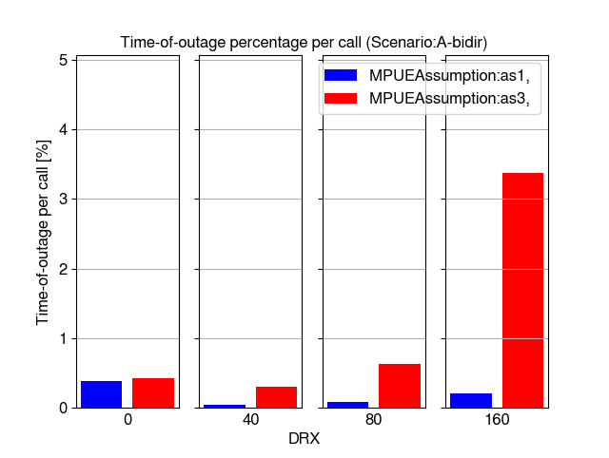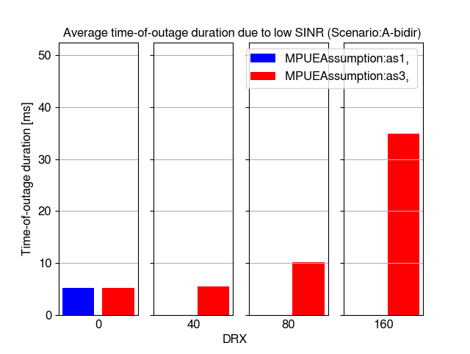

Figure 6.3.4.1.2.8-2 Time-of-outage per call and time-of-outage duration due to low SINR

Figure 6.3.4.1.2.8-3 shows beam failure indication rate with enhanced requirements. The rate is very low or zero up to DRX cycle 80 ms with both multi-panel assumptions-

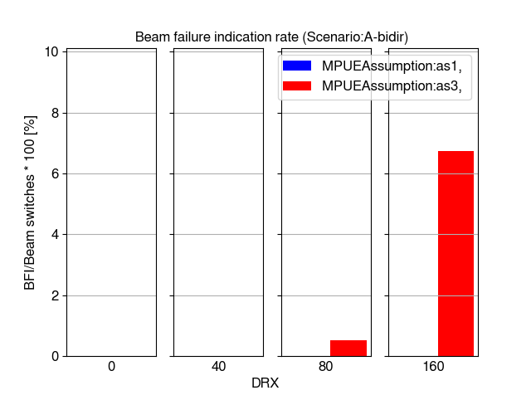

Figure 6.3.4.1.2.8-3 Beam failure indication rate

Figure 6.3.4.1.2.8-4 shows SINR distributions for all simulated DRX cycles and multi-panel assumptions with enhanced requirements. It is observed that SINR levels are generally good up to DRX cycle 80 ms and the SINRs with the longest DRX cycle 160 ms are much less degraded than in the scenario with legacy requirements. The SINR difference between multi-panel assumptions is not so clear as in non-DPS case in 6.3.4.1.2.7. Assumption 3 gives gain in median and peak percentiles of the CDF particularly without DRX, but assumption 1 can be better in low percentiles.

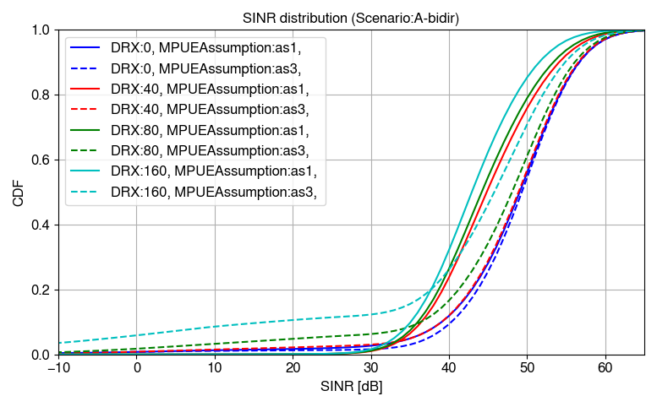

Figure 6.3.4.1.2.8-4 SINR distributions

###### 6.3.4.1.2.9 Uni-directional Tunnel scenario without DPS

This section shows system level simulation mobility performance results for uni-directional tunnel scenario without DPS. Figure 6.3.4.1.2.9-1 shows successful handover rate per CPE per second and ping-pong rate as percentage of ping-pong handovers per all handovers. Similar to open space scenarios, it is observed in general that handover and ping-pong rates are the highest without DRX and gradually decrease when DRX cycle is increased. Compared to the Scenario A, the successful handover rate is significantly lower for all DRX cycles when the train travels to opposite direction than the RRH beams are pointing to. This suggests that there may not be enough time to perform the handover in the tunnel scenario when the train is moving towards the serving beam.

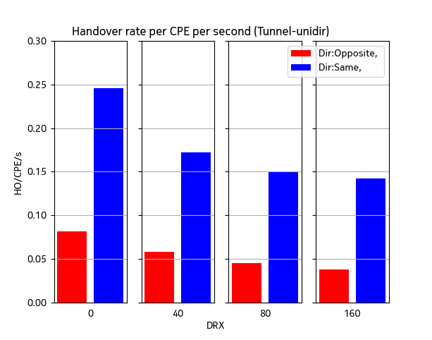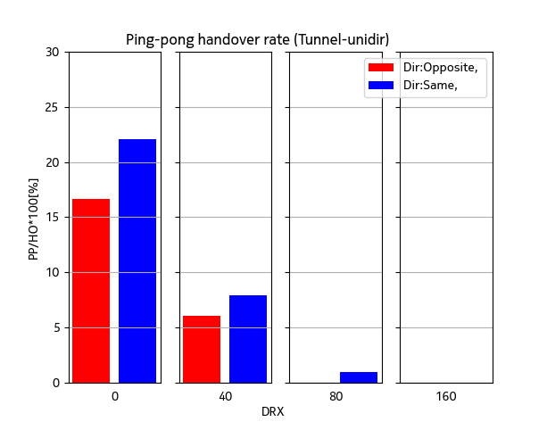

Figure 6.3.4.1.2.9-1 Handover and ping-pong handover rates

Figure 6.3.4.1.2.9-2 shows average time-of-stay in cell (RRH). It is observed that without DRX the time-of-stay in RRH is significantly lower than the time that the train with 350 km/h speed takes to travel the distance of one Ds of 700 meters (about 7.2 seconds). Compared to Scenario A when the train is traveling to the same direction as the RRH beam are pointing to, time-of-stay with low DRX (up to 40ms) is lower. This result is due to handover and ping-pongs rate observed in Figure 6.3.4.1.2.1-1 which is seen high with low DRX cycles in the tunnel scenario. With DRX cycles 80-160 ms the time-of-stay increases to about 7 seconds.

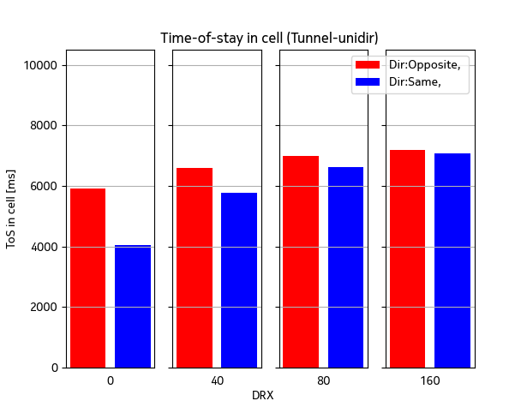

Figure 6.3.4.1.2.9-2 Time-of-stay in cell

Figure 6.3.4.1.2.9-3 shows time-of-outage percentage per call (existence of CPE in the simulation) and average time-of-outage duration due to low SINR (below -8 dB) conditions. It is observed from the results that significant outage is observed only in case the train travels to opposite direction than RRH beams are pointing to, even without DRX enabled.

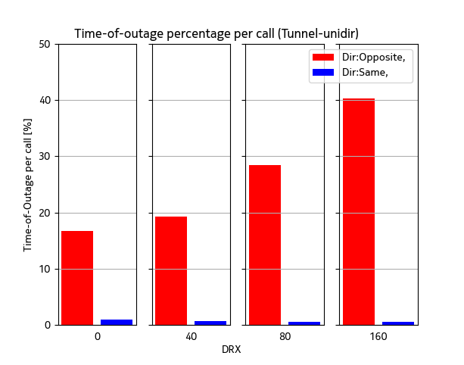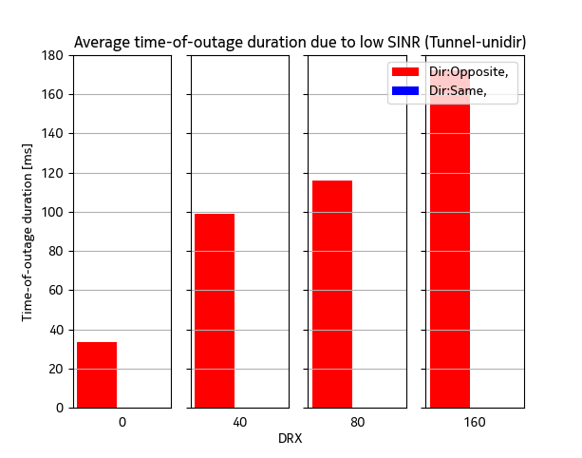

Figure 6.3.4.1.2.9-3 Time-of-outage per call and time-of-outage duration due to low SINR

Figure 6.3.4.1.2.9-4 shows inter-cell mobility failure rate (RLF + HOF percentage of all handover and failure events). It is seen that the failure rates are extremely high when the train travels to opposite direction than RRH beams are pointing to, i.e., the mobility failure rate is over 50% in this scenario even without DRX. No failures are observed when train is traveling to the same directíon as the RRH beams orientation.

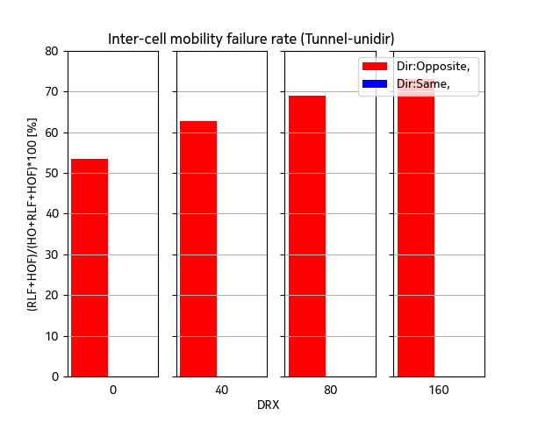

Figure 6.3.4.1.2.9-4 Mobility failure rate

Figure 6.3.4.1.2.9-5 shows distribution of raw SINR values taken from the CQI measurements. It is observed that SINR level is high and clearly sufficient to support high mobility performance for the case where the train is traveling into same direction as RRH beams are pointing to. However, when the train travels opposite to the RRH beam pointing direction, there are areas that SINR may drop low and insufficient to support the mobility especially when the DRX increases, whereas at some areas the SINR becomes extremely good.

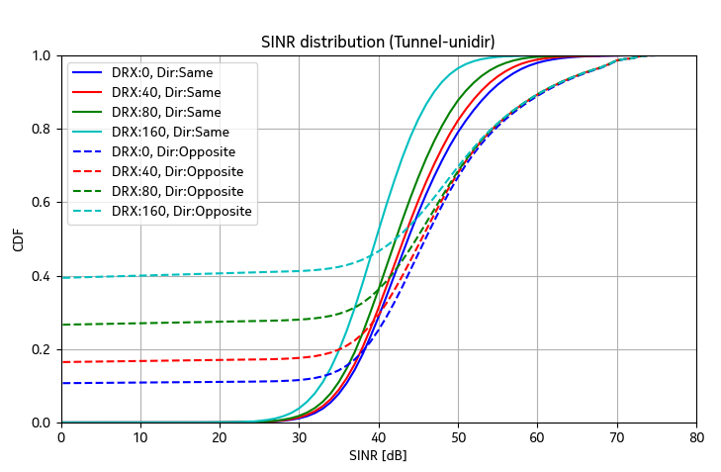

Figure 6.3.4.1.2.9-5 SINR distributions

###### 6.3.4.1.2.10 Uni-directional Tunnel scenario with DPS

This section shows system level simulation mobility performance results for uni-directional tunnel scenario with DPS. Figure 6.3.4.1.2.10-1 shows successful beam switch rate per CPE per second and ping-pong rate as percentage of ping-pong beam switches per all beam switches. Similar to Scenario-A, since there is just one Tx beam per RRH this means ping-pongs between RRHs. In DPS case the same trend is observed in beam switches as with handovers in non-DPS case, i.e., without DRX the rates are the highest and gradually rates decrease when longer DRX cycles are used. The differences between the rates in train travel direction are rather low.

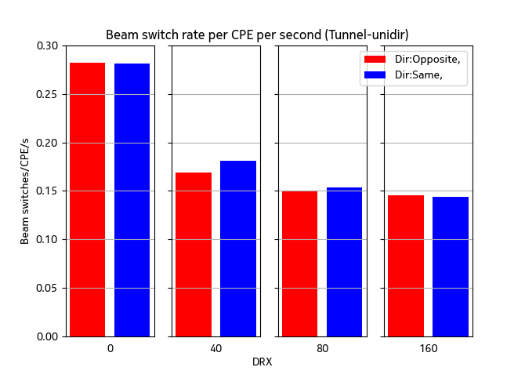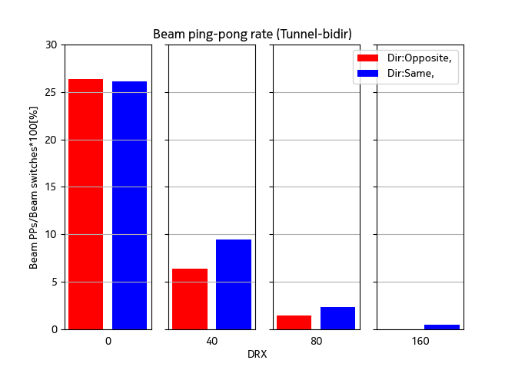

Figure 6.3.4.1.2.10-1 Beam switch and beam ping-pong rates

Figure 6.3.4.1.2.10-2 shows time-of-outage percentage per call (existence of CPE in the simulation) and average time-of-outage duration due to low SINR (below -8 dB) conditions. Similar trend is also observed here as without DPS that the time-of-outage rates are very low when train is traveling to the same direction as RRH beams are pointing to, whereas the outage is seen significant even without DRX enabled when train is traveling opposite to the pointing direction of the RRH beams.

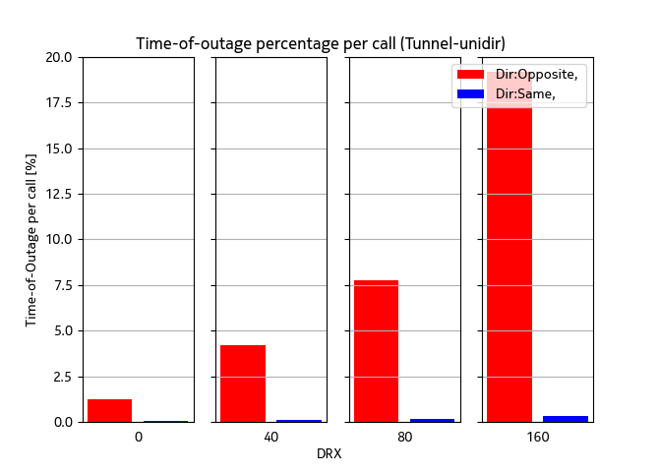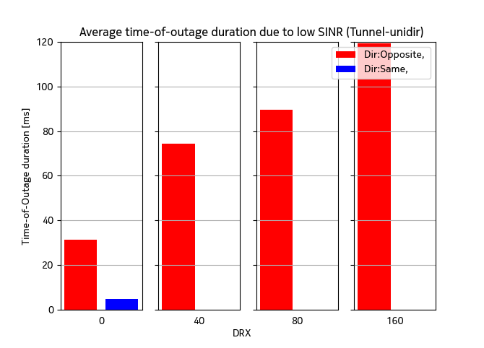

Figure 6.3.4.1.2.10-2 Time-of-outage per call and time-of-outage duration due to low SINR

Figure 6.3.4.1.2.10-3 shows beam failure indication rate (BFI) as percentage of BFIs per beam switches. Similar trend is observed without DPS that no failures happen among the studied DRX cycles when train is traveling to same direction as RRH beams are pointing to. On the other hand, significantly high failures are observed with train traveling to opposite direction.

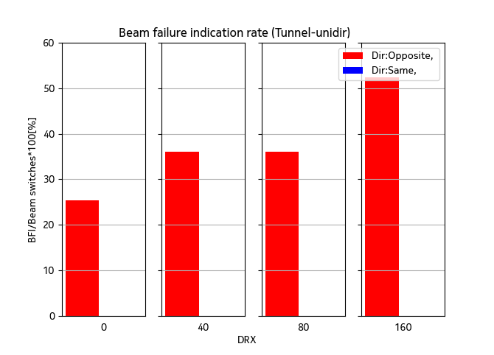

**Figure 6.3.4.1.2.10-3 Beam failure indication rate**

Figure 6.3.4.1.2.10-4 shows distribution of raw SINR values taken from the CQI measurements and it is observed that SINR level is high and clearly sufficient to support high mobility performance in cases when the train is traveling to same direction, but not in opposite traveling direction case. In general, compared to non-DPS case, the probability of low SINR samples below 0 dB are lower when DPS is used compared to non-DPS case. While comparing to open space scenarions, higher SINR values can be achieved in the tunnel case.

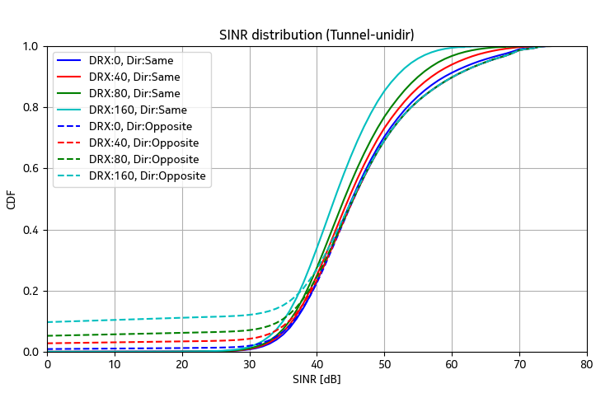

Figure 6.3.4.1.2.10-4 SINR distributions.

###### 6.3.4.1.2.11 Transition at the tunnel entrance/exit without DPS

The coverage of the open-space RRHs at the tunnel entrance/exit is likely limited since the RRH beams can be blocked by the tunnel’s outer wall. This is expected to have impacts to mobility performance in uni-directional deployment when the train is approaching/leaving the tunnel from/to the open space. This section demonstrates mobility performance such transition scenario. The aim is to provides insights on the impact of potential coverage issue at the tunnel entrance/exit to the mobility performance.





Figure 6.3.4.1.2.11-1 Coverage issue at the tunnel entrance in uni-directional deployment

The assumptions and setting for the simulation are as follows. Uni-directional deployment is considered for the RRH deployed outside the tunnel (RRH1 in Figure 6.3.4.1.2.11-2). Assume that the beam’s main lobe from RRH1 is pointing to the entrance/exit of the tunnel. Depending on the tunnel’s dimension, the LoS paths can be seen up to **d [**m] inside the tunnel, meaning that NLoS-only condition will exist after distance **d**. To enable the NLoS condition, the probability of LoS [TR38.901] in the channel model is set as

$${Pr}_{LoS}=\left\{\begin{aligned}1, d_{2D}\text{ ≤ }700+d \\ 0, d_{2D}>700+d\end{aligned}\right.$$

Distance **d** is given as d=300m for Scenario A and d=22.6m for Scenario B following the below assumption and estimation. Assume that a tunnel with dimensions:

- width (w) = 6m, and height (DTunnel,height ) = 5.5m

- Open space RRH: DRRH,height = 15m; CPE : DUE,height = 5m

It can be estimated that the coverage of RRH1’s beam behind the tunnel entrance/exit in vertical and horizonal direction are 300 m and 22.1 m for Scenario A, and 14.3m and 22.6m for Scenario B, respectively (Figure 6.3.4.1.2.11-1 for the calculation).

$$\frac{w/2}{D_{min}}=\frac{d}{d+D_{S}} ⟹ d= \frac{w/2×D_{S}}{D_{min}-w}$$

Scenario A: $d= \frac{w/2×D_{s}}{D_{min}-w}=\frac{3×700}{10-3}=300$

Scenario B: $d= \frac{w/2×D_{s}}{D_{min}-w}=\frac{3×700}{150-3}=14.3$





$$\frac{d}{h}=\frac{d+D}{H} \\ ⟹d= \frac{h×D}{H-h}=\frac{(D_{Tunnel,Height}-D_{UE, height})×\sqrt{{\text{D}}_{\text{S}}^{\text{2}}\text{+}{\text{D}}_{\text{min}}^{\text{2}}}}{D_{RRH,Height}-D_{Tunnel,Height}}$$

Scenario A: $d= \frac{0.3×\sqrt{{700}^{2}+{10}^{2}}}{15-5.5}=22.1$

Scenario B: $d= \frac{0.3×\sqrt{{700}^{2}+{150}^{2}}}{15-5.5}=22.6$

Figure 6.3.4.1.2.11-2 Calculation of LoS coverage of RRH1’s beam inside the tunnel.

Then, d=300m for Scenario A and d=22.6m for Scenario B which are probably the best possible case for the LoS channel condition at the tunnel entrance/exit.

Only non-DPS scheme (HO-based) is considered as the assumption is that open-space RRHs belong to different cell than those in the tunnel. However, the results for DPS scheme are expected similar. Other RRM parameters for the simulation follow the enhanced settings in Table 6.3.4.1.2-1.

The mobility robustness performances, which are measured by the time-of-outage and mobility failure rate, are presented.

6.3.4.1.2.11.1 Transition from open-space Scenario-A to the Tunnel

This section shows the mobility performance when the train is **moving into the tunnel** from Scenario A (i.e., corresponding to when the train is traveling to the **same** direction as RRH beam is pointing to, see Figure 6.3.4.1.2.11-1-(a)), and **leaving the tunnel** to the open space (i.e., corresponding to when the train is traveling to the **opposite** direction than RRH beams are pointing to, see Figure 6.3.4.1.2.11-1(b)).

Figure 6.3.4.1.2.11.1-1 shows time-of-outage percentage per call (existence of CPE in the simulation). Compared to Scenario A, time-of-outage in this transition case is seen to clearly increase for both traveling directions of the train. The increase is observed more significant when the train is traveling to the opposite direction of the RRH beams orientation and with longer DRX cycles due to the limited LoS coverage.

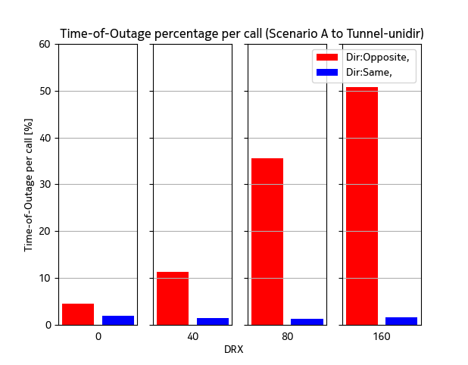

Figure 6.3.4.1.2.11.1-1 Time-of-outage percentage when UE transits from Scenario A and tunnel

Figure 6.3.4.1.2.11.1-2 shows inter-cell mobility failure rate (RLF + HOF percentage of all handover and failure events). It is observed that the limited coverage issue does not have any impact when the train is moving same with the beam pointing direction. However, failure rate is significantly increased when the train is moving opposite to beam direction (i.e., leaving the tunnel) and becomes unacceptable when high DRX cycles are considered.

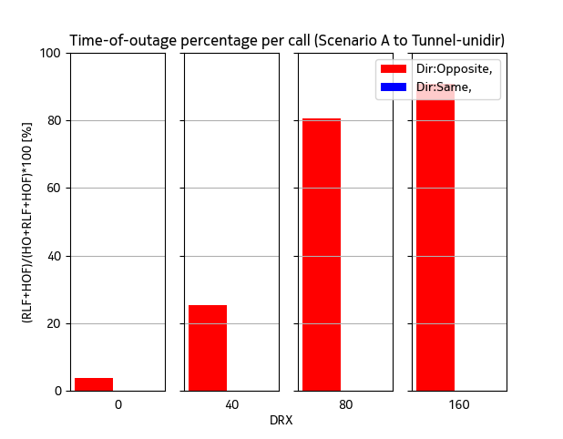

Figure 6.3.4.1.2.11.1-2 Inter-cell mobility failure rate when UE transits between Scenario A and tunnel

6.3.4.1.2.12.1 Transition from open-space Scenario-B to the Tunnel

This section shows the mobility performance when the train is entering/leaving the tunnel from/to Scenario B. Figure 6.3.4.1.2.11.2-1 shows time-of-outage percentage per call (existence of CPE in the simulation). Compared to Scenario B, time-of-outage is increased for both traveling directions of the train when taking into account the NLoS condition at the transition area. Longer DRX cycles result in higher time-of-outage rate. The increase is seen more significant when the train is traveling to the opposite direction than RRH beams are pointing to due to the limited LoS coverage.

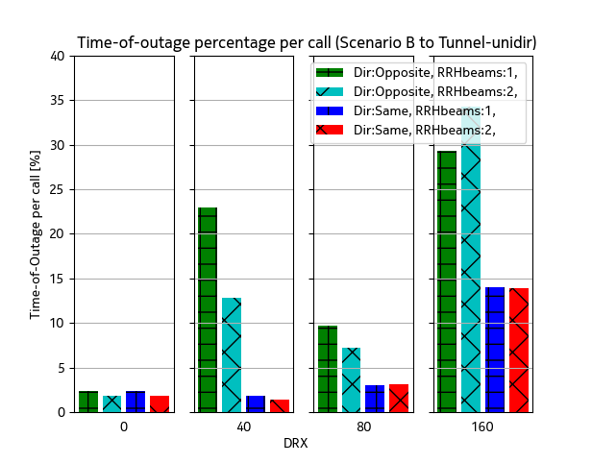

Figure 6.3.4.1.2.11.2-1 Time-of-outage percentage when UE transits between Scenario B and tunnel

Figure 6.3.4.1.2.11.2-2 shows inter-cell mobility failure rate (RLF + HOF percentage of all handover and failure events). When the train is moving same with the beam pointing direction, it is observed that the limited coverage issue starts making the impact to the mobility at DRX 80ms. When the train is moving opposite with the beam pointing direction, the failure rate is significantly increased especially with DRX enabled.

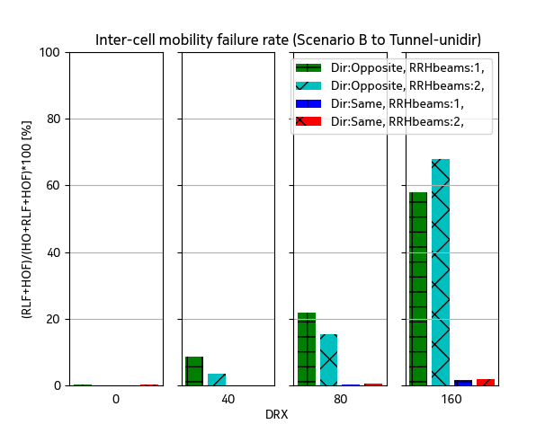

Figure 6.3.4.1.2.11.2-2 Inter-cell mobility failure rate when UE transits between Scenario B and tunnel

##### 6.3.4.1.3 Conclusions on mobility performance

**Mobility performance in** **open-space scenarios**:

In the previous sections (6.3.4.1.1.1, 6.3.4.1.1.2, 6.3.4.1.2.1, 6.3.4.1.2.2), it was demonstrated that HST FR2 Scenario-A deployment (Figure 6.3.4.1.3-1) where the train is travelling in the direction opposite to serving beam orientation may experience mobility challenges when DRX cycle of 40 ms is used with legacy requirements. This happens due to the very fast degradation of serving RRH signal (Figure 6.3.4.1.3-2). However, there is a significant improvement in Scenario-A from enhanced requirements compared to legacy requirements. With enhanced requirements, mobility robustness is sufficient when DRX cycle of 40 ms is used, but problems can be observed when DRX cycle is increased to 80 ms when the train is travelling in the direction opposite to serving beam orientation.



Figure 6.3.4.1.3-1: A scheme of HST FR2 opposite uni-directional Scenario-A.

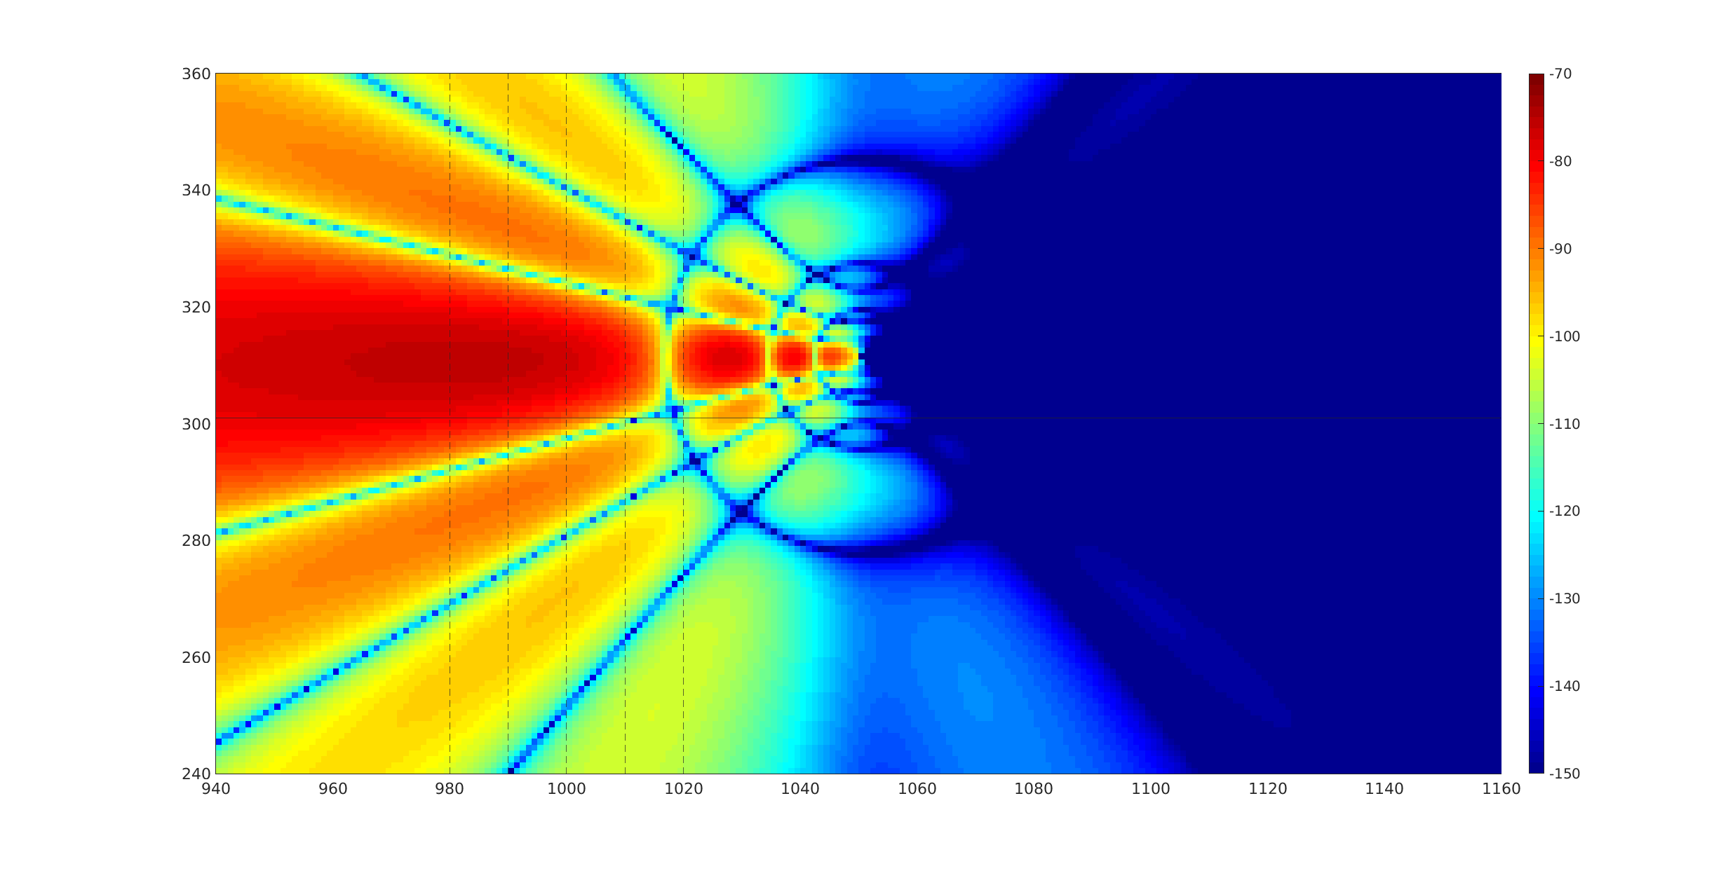

Figure 6.3.4.1.3-2: Propagation map of the serving RRH, antenna model without back lobe.

The RSRP traces of the serving (RRH1) and target (RRH2) RRHs are shown in Figure 6.3.4.1.3-3 with at different zoom levels. One can observe that the signal level from target RRH get high enough already much earlier than handover happens. However, the source RRH signal drops drastically near the RRH location. In this traced case, the handover happens early enough to transmit control messages even with realistic PDCCH model. It is also obvious that even slight delays in handover initiation will cause source RRH to drop to unreachable levels (e.g., RSRP below -120 dBm).

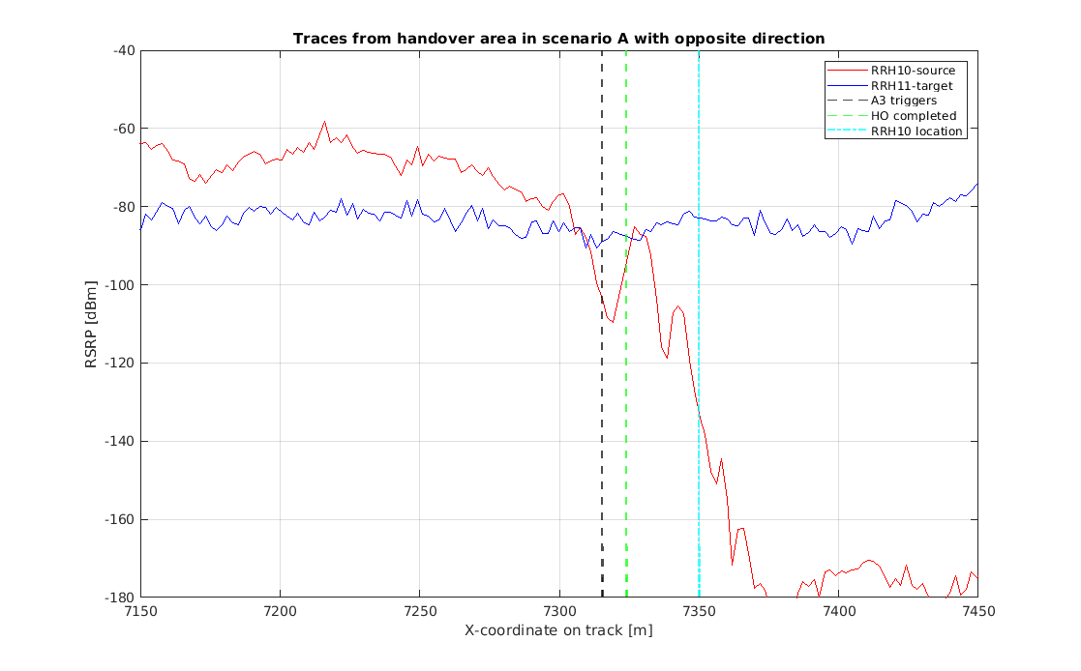 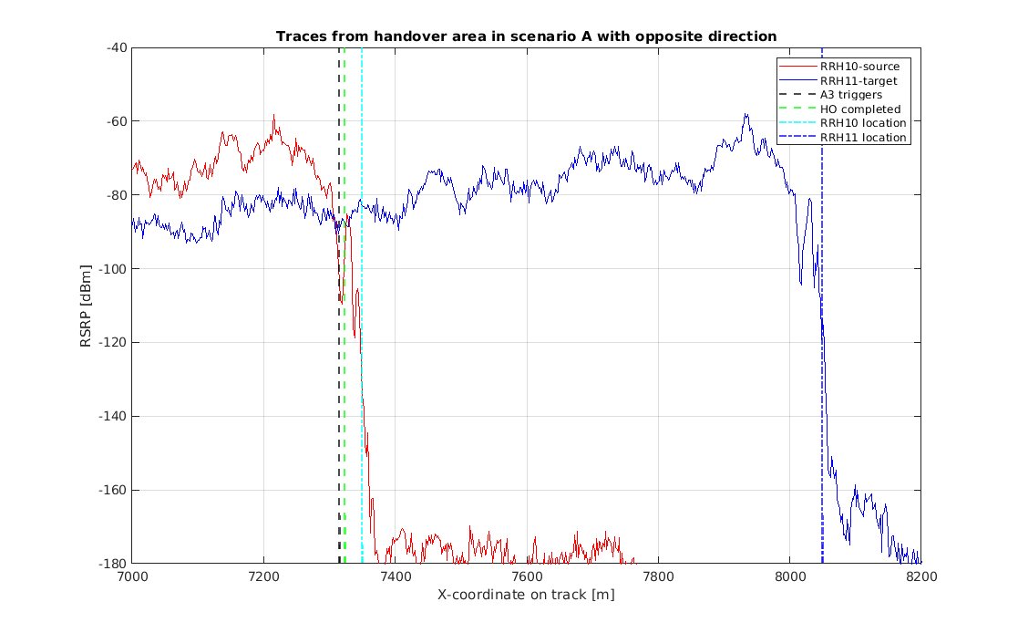

Figure 6.3.4.1.3-3: RSRP traces of serving and target RRHs at two different scales. Vertical lines show A3 trigger coordinate, HO complete, and source RRH location.

Based on the simulation results and analysis presented above we can conclude that DRX cycle of 80ms shall be used with precautions in uni-directional Scenario-A.

In sections (6.3.4.1.1.3, 6.3.4.1.1.4, 6.3.4.1.1.5, 6.3.4.1.1.6, 6.3.4.1.2.3, 6.3.4.1.2.4, 6.3.4.1.2.5, 6.3.4.1.2.6) it was demonstrated that Scenario-B mobility performance with enhanced RRM requirements in both uni-directional and bi-directional scenarios is sufficient with DRX cycles up to 80 ms. Compared to legacy RRM requirements the mobility robustness measured by mobility failure and time-of-outage rates is significantly improved with enhanced RRM requirements also in Scenario-B.

In sections 6.3.4.1.1.7, 6.3.4.1.1.8, 6.3.4.1.2.7, 6.3.4.1.2.8, it was shown that Scenario-A with bi-directional deployment needs similar precautions for DRX cycle of 80 ms as uni-directional scenario. Also, bi-directional scenario mobility robustness is significantly improved by the enhanced RRM requirements compared to legacy RRM requirements. Multi-panel UE measurement assumption was also shown to have significant impact to mobility robustness particularly in non-DPS scenario. Having UE capability to measure both directions at the same time can benefit mobility robustness.

**Mobility performance in** **tunnel scenarios**:

As demonstrated in previous sections (6.3.4.1.2.9, 6.3.4.1.2.10), the train travelling in the direction opposite to serving beam orientation likely experiences mobility challenges. The issue is more more severe than Scenario A as it may occur even when enhanced requirements are used and without DRX enabled. The root cause of such mobility issues is similar to what has been observed in Scenario A, i.e., the sudden drop of the source RSRP level near the source RRH which is due to the close distance between the RRH locations and the track (Dmin). As tunnel deployment has even shorter Dmin and lower DRRH,height, the source signal level drops more extreme causing high probability of mobility failure even when DRX is not enabled.



Figure 6.3.4.1.3-4: A scheme of HST FR2 opposite uni-directional Tunnel scenario.

Figure 6.3.4.1.3-5 shows propagation map around the source RRH location (the physical features of the tunnel like reflections are not considered). Only the source RRH is considered in the pathgain + antenna gain + beam gain of the map. It is observed that there is very strong signal level along the track until the RRH location, and with the backlobe suppressed signal level drops to unusable level right after the RRH if train is moving towards east and RRH antenna is pointed towards west.

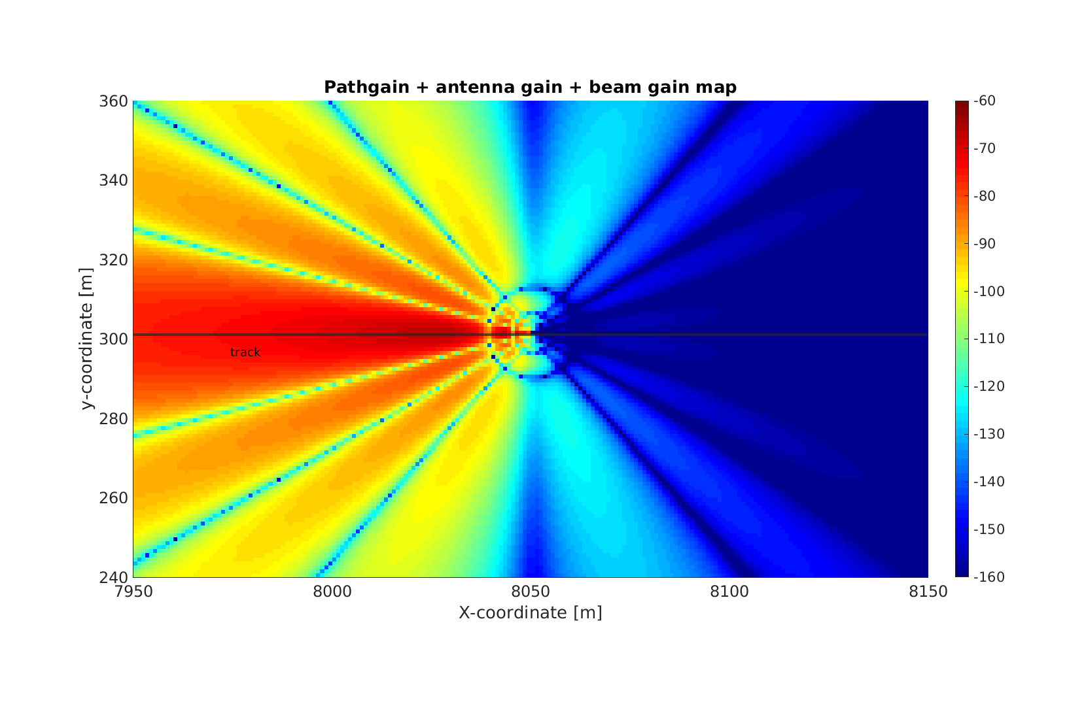

Figure 6.3.4.1.3-5: Propagation map of the serving RRH, antenna model without back lobe.

Figure 6.3.4.1.3-6 shows the RSRP traces of the source (RRH1) and target (RRH2) RRHs. It is observed that signal level from the serving beam increases when the train is approaching the source RRH, and suddenly drops drastically when the train is about 5m from the Source RRH location. One can also see that the first A3 event is triggered when the train is right under the source RRH where there is no longer coverage from serving beam. Later, several attempts for triggering A3 events are carried out in order to make HO, but there is no successful HO achieved. This can be understandable as the signal level source RRH has dropped to unreachable level causing the loss of HO command. After staying outage for a significantly long period, the cell selection procedure is initiated to make the UE connecting to the new cell.



Figure 6.3.4.1.3-6: RSRP traces of source and target. Vertical lines show A3 trigger coordinate, new cell selection, and source RRH location.

The system simulation results in Sections (6.3.4.1.2.9 and 6.3.4.1.2.10) pointed out the mobility issue for HST FR2 happened inside the tunnel. RAN4 studies concluded that multi-panel reception, in which the UE can receives the DL signals simultaneously from two opposite directions, is a candidate solution for the considered issue, i.e., if one link is failed, the UE still has connections to the network via the other link.

In Section 6.3.4.1.2.11, the mobility robustness was studied for the mobility at the tunnel entrance/exit. In such areas, the coverage of the RRHs outside the tunnel may be limited inside the tunnel due to the blockage of the tunnel outer surfaces. It was demonstrated that time-of-outage and inter-cell mobility failure rate both increase suggesting the potential mobility problem that may occur at the tunnel entrance/exit. Nevertheless, such issue can be resolved by deployment-based solutions, i.e., placing the open-space RRHs which is nearest to the tunnel entrance/exit closer to the railway track, e.g., the RRH2’s location shown in Figure 6.3.4.1.3-7.



Figure 6.3.4.1.3-7: Example of a special deployment for the open-space RRH next to the tunnel entrance.

### 6.3.5 Receive time difference

Not applicable to FR2 HST

### 6.3.6 Maximum supported Doppler frequency

Carrier frequency for Doppler frequency calculation

- 30GHz.

### 6.3.7 Maximum supported Speed

Companies’ observation on Maximum Speed feasibility:

- It is feasible to support maximum speed with 350km/h for downlink with TRS (4 symbol interval) for frequency offset tracking under unidirectional RRH deployment with 120KHz SCS.

- It is feasible to support maximum speed with 350km/h for downlink with TRS (4 symbol interval) +SSB for frequency offset tracking under unidirectional and bi-directional RRH deployment with 120KHz SCS.

- It is feasible to support maximum speed with 350km/h for downlink with TRS (4 symbol interval) + PTRS (L=1) for frequency offset tracking under bi-directional RRH deployment with 120KHz SCS.

- It is feasible to support maximum speed with 350km/h for downlink with PTRS or DMRS(1+1+1) + PTRS (L=1,K=2) configuration used for frequency offset tracking under single tap propagation conditions with 120KHz SCS.

Configure PTRS during the PDSCH demodulation test.

RS as baseline for frequency offset tracking to support 350km/h

- multiple options under discussion.

DMRS configuration for PDSCH demodulation requirement

- Option 1: 1 DMRS; and

- Option 2: 1+1+1 DMRS.

### 6.3.8 Beam dwelling time

#### 6.3.8.1 Simulation results

The system simulation assumptions for beam dwelling time are shown in table 6.3.8.1-1. The simulation results of beam dwelling time are obtained from system-level simulations which were carried out to evaluate legacy RRM requirements under high-speed train scenarios.

Table 6.3.8.1-1: Simulation assumptions for beam dwelling time

|  |  |
| --- | --- |
| Parameter | Value |
| Number of sites (separate gNBs) | 12 |
| Inter-site distance (ISD, Ds) | 700 m |
| RRH distance to track (Dmin) | 10 m (Scenario A), 150 m (Scenario B) |
| RRH height (D_RRH_Height) | 15 m |
| CPE height (D_CPE_Height) | 5 m |
| Carrier frequency | 28 GHz |
| Bandwidth | 50 MHz |
| Subcarrier spacing | 120 kHz |
| Propagation and channel model | TR 38.901 RMa with LOS only |
| RRH TX output power | 31 dBm |
| RRH antenna panel | [Mg, Ng, M, N, P] = [1, 1, 8, 8, 2]  Panel is pointing towards the track at the x-axis where the next site is situated (ISD away) |
| RRH antenna panel direction in relation to train in uni-directional deployments | Opposite direction (train moves east, RRHs pointing west)  Same direction (train moves east, RRHs pointing east) |
| SSB beams per RRH | Uni-directional:  1 beam:  Pointing into the boresight of the RRH antenna panel  2 beams:  One beam is pointing into the boresight and the other beam is pointing 20 degrees towards the track from boresight  4 beams:  One beam is pointing into the boresight and the other beams are pointing 20, 40, 60 degrees towards the track from boresight  Bi-directional:  1 beam:  Pointing into the boresight of the RRH antenna panel  2 beams:  One beam is pointing into the boresight and the other beam is pointing towards the track at Ds/2  4 beams:  One beam is pointing into the boresight and the other beams are pointing towards the track at Ds/2, Ds/4, Ds/8 |
| CPE (Train) speed | 350 km/h |
| CPE antenna panel | [Mg, Ng, M, N, P] = [1, 1 or 2, 4, 4, 2]  In uni-directional case where RRHs point east CPE has one antenna panel pointing west  In bi-directional case CPE has two antenna panels pointing to 180 degrees opposite directions (west-east)  MPUE assumption: only one panel can be used at a time for measurements |
| Number of beams per CPE panel | 1 beam (even though it is 1, scaling factor 8 is assumed for RRC measurements, L1 measurements and cell detection delays in simulations) |
| Traffic | DL Full Buffer |
| Inter-cell interference | Only one train with one CPE is simulated meaning there is no inter-cell interference |
| DRX | DRX disabled (DRX 0), 40, 80, 160, 256, 320 ms cycles |
| SMTC period | 20 ms |
| Handover assumptions | Event A3 with SS-RSRP  Offset: 3 dB  Time-to-trigger: 80 ms |
| RRC measurement period  L1 RSRP measurement period | Note: N=8 assumed in scaling  DRX 0: 480 ms  DRX 40: 1440 ms  DRX 80: 2880 ms  DRX 160: 5760 ms  DRX 256: 9216 ms  DRX 320: 11520 ms |
| Cell detection delay  (TPSS/SSS_sync_intra) | Note: N = 8 is assumed in scaling  DRX 0: 600 ms  DRX 40: 1440 ms  DRX 80: 2880 ms  DRX 160: 5760 ms  DRX 256: 9216 ms  DRX 320: 11520 ms |
| RLM assumptions | Note: N=8 assumed in scaling  TEvaluate_out_CSI-RS: 600, 3600, 7200, 14400, 23040, 28800 ms (DRX 0, 40, 80, 160, 256, 320)  TEvaluate_in_CSI-RS: 300, 1800, 3600, 7200, 11520, 14400 ms (DRX 0, 40, 80, 160, 256, 320)  N310: 2 samples  N311: 2 samples  Qout threshold SINR: -8 dB  Qin threshold SINR: -6 dB |
| BFD assumptions | Note: N=8 assumed in scaling  TEvaluate_BFD_CSI-RS: 300, 1800, 3600, 7200, 11520, 14400 ms (DRX 0, 40, 80, 160, 256, 320) |
| Simulation length | 100 seconds (20 drops of 100 seconds simulated, and statistics samples are gathered from all drops) |

The simulation results of beam dwelling time are shown in figures 6.3.8.1-1-3 for unidirectional scenarios with a different number beams transmitted by RRH. The simulation results of beam dwelling time are shown in figures 6.3.8.1-4-6 for bidirectional scenarios with different number of beams transmitted by RRH.

It is worth noting that the simulation results are the average beam dwelling time. In the simulation, beam dwelling time is influenced by beam coverage and beam switching rate (including hysteresis). Beam coverage is discussed in detail in clause 6.3.8.2, where ideal beam dwelling time is investigated.

In the case of multi-beam operation cases shown in figures 6.3.8.1-2, 6.3.8.1-3, 6.3.8.1-5 and 6.3.8.1-6, it can be observed that the dwelling time of Beam 0 is the shortest because the coverage of Beam 0 is the smallest.

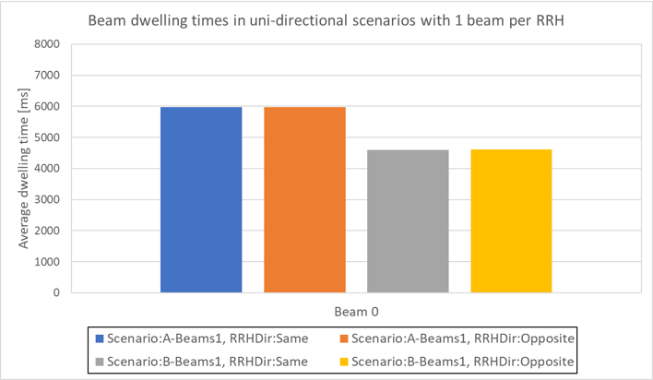

Figure 6.3.8.1-1: Average beam dwelling time with 1 beam per RRH for unidirectional scenarios

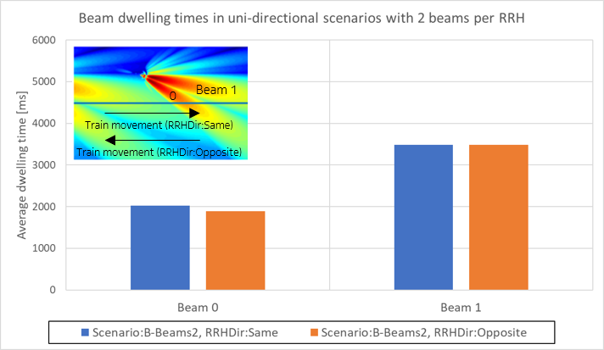

Figure 6.3.8.1-2: Average beam dwelling time with 2 beams per RRH for unidirectional scenarios

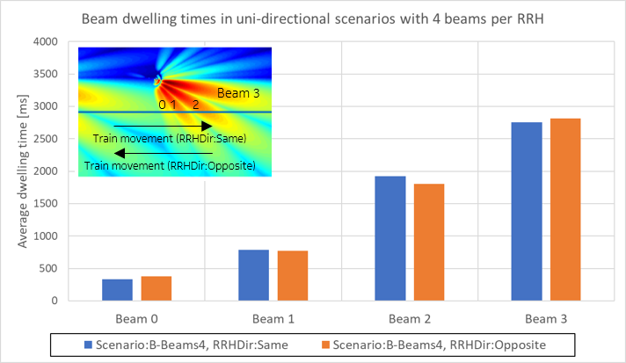

Figure 6.3.8.1-3: Average beam dwelling time with 4 beams per RRH for unidirectional scenarios

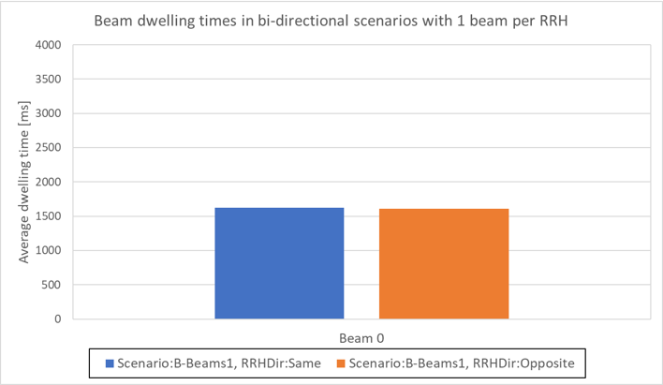

Figure 6.3.8.1-4: Average beam dwelling time with 1 beam per RRH for bidirectional scenarios

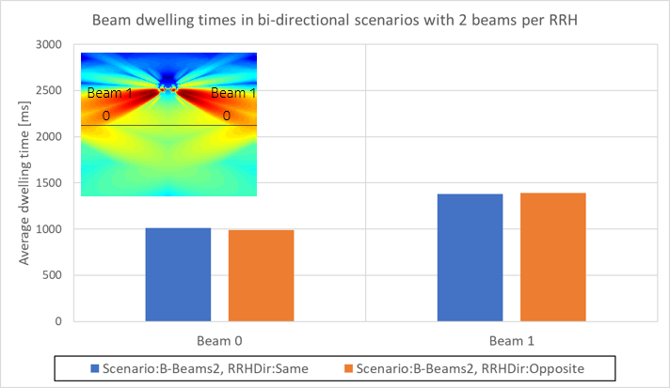

Figure 6.3.8.1-5: Average beam dwelling time with 2 beams per RRH for bidirectional scenarios

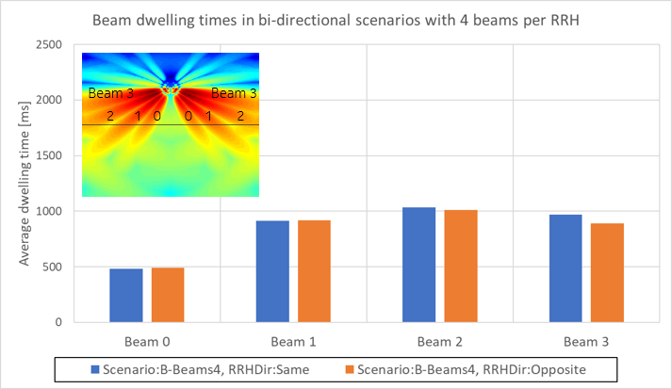

Figure 6.3.8.1-6: Average beam dwelling time with 2 beams per RRH for bidirectional scenarios

#### 6.3.8.2 Beam coverage analysis

In HST deployment scenarios, the footprint of an RRH beam can be represented by an ellipse as shown in figure 6.3.8.2-1. It is assumed that UE aboard an HST is moving with constant velocity $\vec{v}$ and its trajectory is a straight line. An RRH is located at the point $G(0,0,h_{RRH})$ in which its antenna array boresight for the $k$ th beam is oriented towards a point $P_{k}(D_{min},y_{k},h)$ which is along the trajectory of UE.



Figure 6.3.8.2-1: RRH beam footprint

The ellipse centred at $C\left(x_{c},y_{c},z_{c}\right)$ can be expressed as

${\frac{\left[\left(x-x_{c}\right)\cos{ϕ_{k}}+\left(y-y_{c}\right)\sin{ϕ_{k}}\right]}{a^{2}}}^{2}+\frac{{\left[\left(y-y_{c}\right)\cos{ϕ_{k}}-\left(x-x_{c}\right)\sin{ϕ_{k}}\right]}^{2}}{b^{2}}=1,$ $z=h,$ $0<h<h_{RRH}$

where

$a=\frac{\left|\vec{GQ}\right|}{2}\left[\tan\left(θ_{k}^{'}+\frac{θ_{HPBW}}{2}\right)-\tan\left(θ_{k}^{'}-\frac{θ_{HPBW}}{2}\right)\right]$, $\left(θ_{k}^{'}-\frac{θ_{HPBW}}{2}\right)<θ_{k}^{'}<\left(θ_{k}^{'}+\frac{θ_{HPBW}}{2}\right)<{90}^{°}$

$b=\underset{\left|\vec{GC}\right|}{\underbrace{\left|\vec{GQ}\right|\sec\left(θ_{c}^{'}\right)}}\tan\left(\frac{ϕ_{HPBW}}{2}\right)$

$x_{c}=\frac{\left|\vec{QC}\right|}{\sqrt{1+{\left(\frac{y_{k}}{u}\right)}^{2}}}$, $y_{c}=\frac{y_{k}}{u} x_{c}$, $z_{c}=h$

From trigonometry, $\left|\vec{QC}\right|$ can be derived from the elevation HPBW $θ_{HPBW}$, elevation pointing angle $θ_{k}^{'}$, semimajor axis $a$ and the magnitude of $\vec{GQ}$ as follows

$\left|\vec{QC}\right|=\left|\vec{GQ}\right|\tan\left(θ_{k}^{'}-\frac{θ_{HPBW}}{2}\right)+a$

In the equation of the semi-minor axis, $θ_{c}^{'}$ is the angle between the vectors $\vec{GQ}$ and $\vec{GC}$, which can be expressed in terms of the semi-major axis $a$, elevation HPBW $θ_{HPBW}$ and elevation pointing angle $θ_{k}^{'}$.

$θ_{c}^{'}=\tan^{-1}\left(\tan\left(θ_{k}^{'}-\frac{θ_{HPBW}}{2}\right)+\frac{a}{\left|\vec{GQ}\right|}\right)$

Referring to figure 6.3.8.2-1, the segment length of the UE’s trajectory covered by the footprint of beam $k$ is the line segment joining the points $P_{1}\left(D_{min},y_{1},h\right)$ and $P_{2}\left(D_{min},y_{2},h\right)$, which are the intersection points of the ellipse with the line $x=D_{min}$, $z=h$. In determining these two points, rewriting the ellipse equation as a quadratic equation for $y$ gives

$αy^{2}+βy+γ=0$

where the coefficients are

$α=a^{2}\cos^{2}{ϕ_{k}}+b^{2}\sin^{2}{ϕ_{k}}$

$β=2\left[y_{c}\left(-a^{2}\cos^{2}{ϕ_{k}}-b^{2}\sin^{2}{ϕ_{k}}\right)+\left(D_{min}-x_{c}\right)\left(b^{2}\cos{ϕ_{k}}\sin{ϕ_{k}}-a^{2}\cos{ϕ_{k}}\sin{ϕ_{k}}\right)\right]$

$γ=y_{c}^{2}\left(a^{2}\cos^{2}{ϕ_{k}}+b^{2}\sin^{2}{ϕ_{k}}\right)+2y_{c}\left(D_{min}-x_{c}\right)\left(a^{2}\cos{ϕ_{k}}\sin{ϕ_{k}}-b^{2}\cos{ϕ_{k}}\sin{ϕ_{k}}\right)+$

${\left(D_{min}-x_{c}\right)}^{2}a^{2}\sin^{2}{ϕ_{k}}+{\left(D_{min}-x_{c}\right)}^{2}b^{2}\cos^{2}{ϕ_{k}} -a^{2}b^{2}$

The two solutions to the quadratic equation are

$y_{1}=\frac{-β-\sqrt{β^{2}-4αγ}}{2α}$, $y_{2}=\frac{-β+\sqrt{β^{2}-4αγ}}{2α}$

The segment length $l_{k}$ (in metres) of the UE’s trajectory covered by beam $k$ is given by

$l_{k}=y_{2}-y_{1}$

Thus, the dwelling time $t_{k}$ (in seconds) for beam $k$ is defined by

$t_{k}=\frac{l_{k}}{\left|\vec{v}\right|}$

In order to determine the width of the footprint provided by beam $k$, it is the points of intersection of the ellipse with a straight line passing through $P_{k}\left(D_{min},y_{k},h\right)$ perpendicular to the line $x=D_{min}$, $z=h$. The width $w_{k}$ (in metres) of the footprint defined by beam $k$ is expressed as

$w_{k}=x_{2}-x_{1}$

where

$x_{1}=\frac{-β^{'}-\sqrt{{β^{'}}^{2}-4α^{'}γ^{'}}}{2α^{'}}$, ${ x}_{2}=\frac{-β^{'}+\sqrt{{β^{'}}^{2}-4α^{'}γ^{'}}}{2α^{'}}$

$α^{'}=a^{2}\sin^{2}{ϕ_{k}}+b^{2}\cos^{2}{ϕ_{k}}$

$β^{'}=2[x_{c}\left(-a^{2}\sin^{2}{ϕ_{k}}-b^{2}\cos^{2}{ϕ_{k}}\right)+(y_{k}-y_{c})(b^{2}\cos{ϕ_{k}}\sin{ϕ_{k}}-a^{2}\cos{ϕ_{k}}\sin{ϕ_{k}})]$

$γ^{'}=x_{c}^{2}\left(a^{2}\sin^{2}{ϕ_{k}}+b^{2}\cos^{2}{ϕ_{k}}\right)+2x_{c}\left(y_{k}-y_{c}\right)\left(a^{2}\cos{ϕ_{k}}\sin{ϕ_{k}}-b^{2}\cos{ϕ_{k}}\sin{ϕ_{k}}\right)+$

${\left(y_{k}-y_{c}\right)}^{2}a^{2}\cos^{2}{ϕ_{k}}+{\left(y_{k}-y_{c}\right)}^{2}b^{2}\sin^{2}{ϕ_{k}}$

Table 6.3.8.2-1 shows the coverage length, width and dwelling time for 3 beams where the boresight is pointing to different positions along the UE’s trajectory for Scenario A.

Table 6.3.8.2-1: Beam coverage length, width and dwelling time

|  |  |  |  |  |
| --- | --- | --- | --- | --- |
| $D_{min}=10 m$, $θ_{HPBW}={12.6}^{°}$, $ϕ_{HPBW}={12.6}^{°}$ | | | | |
| Beam $k$ | $$P_{k}\left(D_{min},y_{k},h\right)$$ | $$l_{k}$$ | $$w_{k}$$ | $$t_{k}$$ |
| 0 | $$P_{k}\left(D_{min},{5D}_{min},h\right)$$ | 57 m | 14 m | 0.6 s |
| 1 | $$P_{k}\left(D_{min},{7.5D}_{min},h\right)$$ | 244 m | 31 m | 2.5 s |
| 2 | $$P_{k}\left(D_{min},{8.5D}_{min},h\right)$$ | 813 m | 60 m | 8.4 s |

As can be observed in table 6.3.8.2-1, the beam coverage length shrinks as $y_{k}$ decreases, resulting in non-uniform beam coverage. A beam with very short beam segment length $l_{k}$ is not useful for HST because the UE may not be able detect it before moving to the adjacent beam. As such, the number of useful beams per RRH can be limited, which depends on deployment scenarios. Referring to the equation of the ellipse, the beam footprint size is a function of the semimajor axis $a$ and semiminor axis $b$. It can be observed from the equation that one key parameter that influences the magnitude of $a$ and $b$ is the elevation HPBW $θ_{HPBW}$ and azimuth HPBW $ϕ_{HPBW}$. This means, those beams with a short segment length can be increased by widening the HPBW. However, it is important to note that antenna array directivity is inversely proportional to the HPBW; that is, a wider HPBW leads to lower antenna-array directivity. As the RRH typically employs uniform rectangular antenna arrays, the directivity $D$ can be expressed in terms of the elevation and azimuth HPBW as [2]

$D≈\frac{π^{2}}{ϕ_{HPBW}θ_{HPBW}}$

For Beam $k$, if $θ_{HPBW}$ and $ϕ_{HPBW}$ are widened by a factor of $σ_{θ,k}$ and $σ_{ϕ,k}$, respectively, the resultant directivity $D_{k}$ is

$D_{k}=\frac{π^{2}}{\left(σ_{θ,k} θ_{HPBW}\right)\left(σ_{ϕ,k} ϕ_{HPBW}\right)}$

Let $D_{0}$ denote the original directivity of Beam 0 (where the HPBW is not widened) and dividing it by $D_{k}$ yields

$\frac{D_{0}}{D_{k}}=σ_{ϕ,k} σ_{θ,k}$

As compared with $D_{0}$, $D_{k}$ is now dropped by the product of $σ_{ϕ,k}$ and $σ_{θ,k}$, where both terms are real numbers. In order to ensure the link budget (or performance) of Beam $k$ is not worse than Beam $0$ as a consequence of using lower directivity, the product ($σ_{ϕ,k} σ_{θ,k}$) should be bounded by the condition

$1≤\left(σ_{ϕ,k} σ_{θ,k}\right)≤{\left(\frac{r_{0}}{r_{k}}\right)}^{2}$, $r_{k}<r_{0}$

where the term ${\left(\frac{r_{0}}{r_{k}}\right)}^{2}$ is the ratio of the free space path loss between Beams $0$ and $k$, and for $r_{0}=\left|\vec{{GP}_{0}}\right|$, and $r_{k}=\left|\vec{{GP}_{k}}\right|$. Beam $0$ serves as a baseline beam whose directivity equals the original unenlarged HPBW. When $σ_{ϕ,k}{ σ}_{θ,k}={\left(\frac{r_{0}}{r_{k}}\right)}^{2}$ the drop in directivity for Beam $k$ is equalized by the decrease in free space path loss with reference to Beam $0$.

Widening the HPBW of beams with a short segment length in coverage areas near to the RRH provides an alternative solution to mitigate the problem identified in clause 6.3.4.1 for unidirectional deployment scenarios, where the UE is moving in the opposite direction to the pointing direction of RRH Tx beams. It can also be used to extend coverage in areas near to RRH in bi-directional deployment scenarios, and to reduce the large propagation delay jump, which causes uplink timing issues.

# 7 Identified RAN4 requirements

## 7.1 CPE RF core requirements

RAN4 will further study and discuss the CPE core requirements.

Concerning the CPE RF requirements RAN will further discuss and select among following options for the baseline power class:

- Baseline power class for FR2 HST:

1) Option-1: PC4 as baseline, and FFS PC4 requirement is applicable to FR2 HST scenario; or

2) Option-2: To define new PC for FR2 HST; or

3) Option-2a: To define new PC for FR2 HST, with PC5 requirement as baseline.

Additionally, RAN4 will further discuss how the specify the UE RF requirements. Options listed are:

- Option-1: Provide an applicability rule of FR2 PC4 for the train-roof-mounted UE for FR2 HST scenario, i.e., the applicable FR2 PC4 requirement set for FR2 HST scenario; or

- Option-2: Revisit the full set of UE RF requirements for FR2 PC4 UE; or

- Option-3: New RF requirement is defined for FR2 HST UE which is different from PC4, specifically, the min peak EIRP for FR2 HST UE follows the agreement for PC5(new FR2 FWA UE).

For power class, it is agreed to introduce a new power class for FR2 HST UE (UE power class 6), by numbering as UE power class 6 and specifying UE type as ‘High Speed Train Roof-Mounted UE’:

Table 7.1-1: New power class 6 for FR2 HST UE

|  |  |
| --- | --- |
| UE Power class | UE type |
| 1 | Fixed wireless access (FWA) UE |
| 2 | Vehicular UE |
| 3 | Handheld UE |
| 4 | High power non-handheld UE |
| 5 | Fixed wireless access (FWA) UE |
| 6 | High Speed Train Roof-Mounted UE |

The RF requirement applicability rule (based on NW flag signalling) is not introduced. FR2 HST UE shall satisfy the relevant RF requirement, regardless of this NW flag signalling. Additionally, RAN4 define unified RF requirement for both uni- and bi-directional RRH deployment.

It was agreed that the UE TX minimum output power and transmit signal quality for FR2 PC6 UE, RAN4 adopt the same requirement as FR2 PC5 UE for are:

- Minimum output power, and

- Transmit signal quality

For UE TX requirement for UL-MIMO it was agreed that similar to other power classes, RAN4 define UL-MIMO TX requirements for FR2 PC6 UE, by following the same requirement as PC6 single TX port requirement numerically.

It was agreed that unified RF requirements for FR2 HST UE are defined except spherical coverage. RAN4 will further discuss the spherical coverage requirements:

- Option 1: use the union of the largest spherical coverage of theta and phi to define the unified requirements

- Option 2: The unified RF requirement for FR2 HST UE is defined based on one particular scenario requiring the largest spherical coverage

RAN4 agreed not to define core requirement for one-panel based spherical coverage requirement.

For UE RF requirement framework, RAN4 agreed to use the assumption, that UE has two panels, i.e., back-to-back panels, which will be used to derive spherical coverage requirements.

RAN4 will further discuss whether one panel based spherical coverage requirement will be specified and whether to mandate two panels for UE RF requirement framework. Concerning spherical coverage and the direction of the antenna panels RAN4 reached following agreements:

- Directions of antenna panels:

- Boresight directions for forward and backward panels shall be declared by UE vendors. It is FFS whether the limitation on the boresight directions is needed.

- Coordination system to be used for requirement definition:

- Option-1: absolute coordination system

- Option 2: relative coordination system (relative to the claimed boresight direction)

- Spherical coverage x%-tile point per panel:

- Azimuth angle (i.e., phi) range to cover:

- Option-1: [-45, +45] degree relative to absolute coordination system

- Option-2: [-25, +25] degree relative to UE declared boresight direction

- Other options are not precluded

- Elevation angle (i.e., theta) range to cover:

- Option-1: [45, 90] degree relative to absolute coordination system

- Option-2: [-10, +10] degree relative to UE declared boresight direction

Related to spherical coverage requirement – Coordination system RAN4 agreed to use the absolution coordination system as well as the following as baseline:

The minimum EIRP measured over the spherical coverage evaluation areas specified below is defined as the spherical coverage requirement and is found in Table 7.1-2 below. UE spherical coverage evaluation areas are found in Table 7.1-3 below, by consisting of Area-1 and Area-2, in the reference coordinate system in Annex J.1. The requirement is verified with the test metric of EIRP (Link= Spherical coverage grid, Meas=Link angle).

Table 7.1-2: UE spherical coverage for power class 6.

|  |  |  |
| --- | --- | --- |
| Band | MBP,n (dB) | MBS,n (dB) |
| n257 | 0.7 | 0.7 |
| n258 | 0.7 | 0.7 |
| n261 | 0.7 | 0.7 |

Table 7.1-3: UE spherical coverage evaluation areas for power class 6.

|  |  |  |
| --- | --- | --- |
|  | θ range (degree) | θ range (degree) |
| Area-1 | 90 to 60 | -37.5 to + 37.5 |
| Area-2 | 90 to 60 | 142.5 to 217.5 |
| NOTE 1: When testing power class 6 UEs, DUT orientation can be determined according to the UE spherical coverage evaluation areas, not necessarily following default alignment in Figure J.1-2 or positioning guidelines in clause J.3.  NOTE 2: High speed train deployment is expected to be w.r.t. the reference coordination system: θ = 90 (degree) corresponds to the ground plane the train is running on, and ϕ= 0 or 180 with θ = 90 are the train track directions | | |

Agreement is that network signaling is provided to configure UE to follow enhanced RRM requirement Set 2.

Evaluation on EIRP spherical coverage requirement over the above baseline for UE spherical evaluation areas is FFS.

RAN4 agreed that for FR2 HST UE, RAN4 adopt REFSENS requirement as PC5, that is:

Table 7.1-4: FR2 HST UE REFSENS requirement.

|  |  |  |  |  |
| --- | --- | --- | --- | --- |
| Operating Band | REFSENS (dBm) / Channel bandwidth | | | |
| 50 MHZ | 100 MHZ | 150 MHZ | 200 MHZ |
| n257 | -92.6 | -89.6 | -86.6 | -83.6 |
| n258 | -92.8 | -89.8 | -86.8 | -83.8 |
| n261 | -92.6 | -89.6 | -86.6 | -83.6 |
| NOTE 1: The transmitter shall be set to PUMAX as defined in clause 6.2.4 | | | | |

### 7.1.1 Minimum Peak EIRP

Minimum peak EIRP requirement for FR2 HST UE it is agreed to adopt 30.x dBm (similar to PC5) as baseline.

A multi-band relaxation factor of 0.7 dB which is similar to PC5 is introduced as shown in table 7.1.1-1.

Table 7.1.1-1: Multi-band relaxation.

|  |  |  |
| --- | --- | --- |
| Band | MBP,n (dB) | MBS,n (dB) |
| n257 | 0.7 | 0.7 |
| n258 | 0.7 | 0.7 |
| n261 | 0.7 | 0.7 |

Concerning Spherical coverage requirement and EIRP drop from min. Peak EIRP it was agreed to allow 10dB EIRP drop (i.e., x dB lower than min. Peak EIRP requirement).

### 7.1.2 Beam Correspondence

For the roof mounted HST UE the Rel-15 beam correspondence apply, and the FR2 HST UE (roof-mounted UE type) shall mandatorily support *beamCorrespondenceWithoutUL-BeamSweeping*.

No need to introduce Beam Correspondence tolerance requirement because all FR2 HST UE need mandatory support of Rel-15 BC without uplink beam sweeping. If Rel-15 Beam Correspondence feature *beamCorrespondenceWithoutUL-BeamSweeping* is mandatorily supported by FR2 HST UE, then by following PC3 BC requirement:

- For Rel-15 Beam Correspondence capable UE, the UE shall meet the minimum peak EIRP requirement and spherical coverage requirement with its autonomously chosen UL beams and without uplink beam sweeping. Such UE is considered to have met the beam correspondence tolerance requirement. In other words, no need to introduce Beam Correspondence requirement for as Rel-15 PC3.

FR2 HST UE support of Rel-16 feature *beamCorrespondenceSSB-based-r16* shall be mandated but the support of Rel-16 *beamCorrespondenceCSI-RS-based-r16* shall be optional.

For FR2 HST UE, the beam correspondence support can be summarized in the following table:

Table 7.1.2-1: Beam correspondence support for a UE supporting FR2 HST.

|  |  |  |  |  |  |
| --- | --- | --- | --- | --- | --- |
| FR2 Power Class | Rel-15 BC Feature beamCorrespondence  WithoutUL-BeamSweeping | Rel-16 SSB based enhanced BC beamCorrespondenceSSB-based-r16 | Rel-16 CSI-RS based enhanced BC beamCorrespondenceCSI-RS-based-r16 | Requirement Applicability for  (1) Minimum peak EIRP, spherical coverage requirement (2) BC Tolerance requirement | Side condition |
| FR2 HST UE  (PC X) | Supported  (Mandatory) | Supported  (Mandatory) | Not Supported | Meet (1) w/o UL beam sweeping  BC Tolerance req. (2) is met implicitly | Side condition for SSB based enh. BC  (CSI-RS not provided) |
| Supported | Side condition for CSI-RS based enh. BC  (weak SSB) |

For PC6 EIS spherical coverage requirement, the side conditions for beam correspondence requirement can be derived according by:

- Minimum SSB_RP = EIS spherical coverage(PC6, n259, 50MHz) - 10*log10(nrofRBs x 12) – SNR(at Refsens) + SSB Ês/Iot + ΔMBS

For EIS Spherical Coverage requirements, the text in the follow table is agreeable but the numbers in the table will be updated based on the agreements:

Table 7.1.2-2: EIS spherical coverage for power class 6

|  |  |  |  |  |
| --- | --- | --- | --- | --- |
| Operating Band | Max EIS over UE spherical coverage evaluation areas (dBm) / Channel bandwidth | | | |
| 50 MHZ | 100 MHZ | 200 MHZ | 400 MHZ |
| n257 | [-80.6] | [-77.6] | [-74.6] | [-71.6] |
| n258 | [-80.8] | [-77.8] | [-74.8] | [-71.8] |
| n261 | [-80.6] | [-77.6] | [-74.6] | [-71.6] |
| NOTE 1: The transmitter shall be set to PUMAX as defined in clause 6.2.4  NOTE 2: The EIS spherical coverage requirements are verified only under normal thermal conditions as defined in Annex E.2.1 | | | | |

## 7.2 RRM requirements

Concerning the maximum supported speed for FR2 HST RAN4 agreed to use 350kmph as a reference maximum train speed and define RRM requirements to guarantee that.

It was agreed to add a flag to enable the UE to identify different/enhanced RRM requirements in HST FR2 deployments. FR2 HST UE has the capacity to support both unidirectional and bidirectional deployment scenarios. RAN4 agreed to introduce network assistance to inform UE on the FR2 HST deployment type (uni-directional or bi-directional). No enhanced requirement should be applied to other than PC6 UEs even when HST FR2 flags are configured.

PC6 shall be used to identify the feature support of HST FR2 operation.

RAN4 agreed to introduce dedicated new RRC based network signalling flag will be specified to enable/disable one shot large UL timing adjustment. Such RRC based network signalling is not limited to a particular FR2 HST deployment and/or scenarios, i.e., bi-directional scenario or uni-directional scenario.

In Scenario A, whether the RRH position on one side or both sides of railway tracks have no impact on RRM requirements under the assumption that FR2 HST UE boresight direction (or the beam direction if there is only one beam) is parallel to the track.

Under FR2 HST scenarios, the PSS/SSS detection is robust to deal with ISI and time differences.

Additional need for network signalling and CPE capabilities for HST FR2 deployments continued based on the deployment options and presence of non-CPE UEs. It was agreed that it is not necessary to introduce UE capability to indicate the support of FR2 HST.

It was also concluded that there is no need for CPE capability to change beam sweep number in uni-/bi-directional operation.

RAN4 agreed to introduce network signaling to configure UE to follow either Set 1 or Set 2 RRM requirements.

Concerning the number of Rx Beams from RRM perspective RAN4 agreed that related to the scope of the RRM requirements and the requirements for Scenario A and scenario B to only define two sets of enhanced RRM requirements in terms of number of RX beams (i.e. RX beam sweeping scaling factor) per UE:

- Set 1: 2 RX beams

- Set 1: 6 RX beams

RAN4 will introduce network signalling to configure UE to follow either Set 1 or Set 2 RRM requirements.

Set 1 requirements are developed based on the analysis with Dmin = 10m and Ds = 750m, and the recommended applicable range of Dmin for Set 1 requirement is Dmin <= [30] m. For the deployment with a larger Dmin, set 2 requirements are recommended to be configured by the network.

Regarding RRM requirements for scenario A and scenario B, for uni-directional and bi-directional deployments, it was agreed that there separate requirements for uni-/bi-directional deployments will not be developed.

For scenario B only, when considering requirements for RRH deployment on both sides of the track, the RRH positions at one/both sides of rail track doesn’t have impact on 6Rx beams agreement in Scenario B (set 2).

Concerning Lightweight network assistance signaling it will be discussed further which NWA signaling is needed:

- Option 1: Enable network assisted signaling of SSB index and order per RRH

- Option 2: The network assistance signaling of SSB configuration shall not be introduced in Rel-17

- Option 3: Introduce inter-RRH indication

- Option 4: Other options are not precluded

For Inter-RRH indication RAN4 agreed not introduce explicit inter-RRH indication signalling for NR FR2 HST in Rel-17.

UE capabilities:

FR2 HST UE (power class 6 UE) shall mandatorily support both Set 1 and Set 2 enhanced RRM requirements, in terms of different RX beams (i.e., RX beam sweeping scaling factor) per UE.

It is agreed to introduce feature group x-2 “Support of one shot large UL timing adjustment” with prerequisite feature group (x-1, “Support of FR2 HST operation”).

### 7.2.1 Idle/inactive mode

RAN agreed for idle/inactive mode that the cell reselection requirements in IDLE/INACTIVE mode are enhanced.

Concerning requirements for when UE is applying long DRX RAN4 agreed to apply the existing R16 requirements for when the long DRX cycles are used, i.e. above the upper bound of DRX cycle.

HST FR2 enhanced requirement is applied to SMTC <=40ms. SMTC periodicity is not restricted.

RAN4 will only define enhanced requirements for DRX 320 ms and requirements for longer DRX cycles are left without changes.

For the M2 scaling factor for short DRX the way forward is to use as baseline: M2 = 1.5 if SMTC periodicity > [40] ms, otherwise M2=1. Discussion continues whether different scaling factor is needed for scenario-B with two-side RRH.

RAN4 defined enhanced requirements for Cell reselection in IDLE/INACTIVE mode for DRX 320 ms in HST FR2 deployments according to table:

Table 7.2.1-1: Cell reselection in IDLE/INACTIVE mode.

|  |  |  |  |  |
| --- | --- | --- | --- | --- |
| DRX cycle length [s] | Scaling Factor (N1) | Tdetect,NR_Intra [s] (number of DRX cycles) | Tmeasure,NR_Intra [s] (number of DRX cycles) | Tevaluate,NR_Intra  [s] (number of DRX cycles) |
|  |
| 0.32 | 2 or 6Note1 | 2.56 x N1 x M2 (8 x N1 x M2) | 0.32 x N1 x M3 (1 x N1 x M3) | 0.96 x N1 x M4 (3 x M4) |  |
| 0.64 | 5 | 17.92 x N1 (28 x N1) | 1.28 x N1 (2 x N1) | 5.12 x N1 (8 x N1) |  |
| 1.28 | 4 | 32 x N1 (25 x N1) | 1.28 x N1 (1 x N1) | 6.4 x N1 (5 x N1) |  |
| 2.56 | 3 | 58.88 x N1 (23 x N1) | 2.56 x N1 (1 x N1) | 7.68 x N1 (3 x N1) |  |
| NOTE 1: N1 refers to the number of Rx beams and equals 2 for Set 1, and 6 for Set 2  NOTE 2: when SMTC < = 40 ms, M2 = M3 = M4 = 1; and when SMTC > 40 ms, M2 = 1.5, M3 = M4 = 2  NOTE 3: The requirement in this table shall only apply to power class 6 UE*,* when the network signaling [*highSpeedMeasFlag-r17]* is configured to [set1] or [set2]*.* | | | | |  |

N1 refers to the number of Rx beams and equals 2 for Set 1, and 6 for Set 2

### 7.2.2 Connected mode

For connected mode mobility RAN4 agreed not to support RRC Release with Redirection in the FR2 HST scenario.

RAN4 agreed to revise the TCI state known conditions for the FR2 HST scenario.

Concerning requirements for when UE is applying long DRX RAN4 agreed to apply the existing R16 requirements for when the long DRX cycles are used, i.e. above the upper bound of DRX cycle.

HST FR2 enhanced requirement is applied to SMTC <=40ms. SMTC periodicity is not restricted.

For handover and the criteria of known cell for FR2, the target FR2 cell is known if it has been meeting the relevant cell identification requirement during the last 5 seconds; otherwise, it is unknown.

For RLM and BFD the current sharing factor P and PCBD can be reused for FR2 HST.

For the Connected mode, RAN4 assumes that as baseline for developing the UE requirements, the DRX upper bound for enhanced RRM HST FR2 requirements is [80]ms

For Handover RAN4 will not enhance requirements for HO to unknown cell. Additionally, as current, if the target cell is a known cell, then Tsearch = 0 ms.

Deployment-related issues:

The DRX upper bound = 80 ms applies both to Sets 1 (Scenario-A) and 2 (Scenario-B), there will be no special consideration for two-side RRH deployment for RRM requirements definition.

For the change of RRH panel orientation in uni-directional deployments RAN4 will not define defined additional network signalling to identify to the UE a change of RRH panel orientation in uni-directional deployment.

For RLM/BFD requirements:

It was agreed that the existing 1280ms duration for known condition is applied for FR2 HST scenario. RAN4 will further study the RLM/BFD requirements for DRX <=80ms for FR2 HST scenarios:

- Option 1: following RX beam factor for set-1 and set-2

- Option 2: The existing RLM/BFD requirements for DRX <=80ms is applied

For CSI-RS based RLM and BFD, there is no standard impact for Rel-17 FR2 HST UE (i.e., FR2 PC6 UE).

For CBD requirements:

RAN4 will not develop enhancement on CBD requirements for DRX <=80ms.

For PSS/SS and intra-frequency measurement:

It was agreed to reuse the Rel-16 FR1 HST scaling factor M2 for FR2 HST with the same SMTC periodicity bound of 40ms unless technical issues identified

For L1-RSRP measurement:

RAN4 will reuse the Rel-16 FR1 HST scaling factor K for FR2 HST L1-RSRP measurement requirement, with the same SMTC periodicity bound of 40ms unless technical issues identified. It is also agreed to define separate sets of requirements for deployment Scenarios A and B

Table 7.2.2-1: L1-RSRP measurement requirements for deployment Set-1.

|  |  |
| --- | --- |
| Configuration | TL1-RSRP_Measurement_Period_SSB (ms) |
| non-DRX | max(TReport, ceil(M*P*NA)*TSSB) |
| DRX cycle ≤ 80ms | max(TReport, ceil(M*P*NA*M2)*max(TDRX,TSSB)) |
| NOTE 1: TSSB = ssb-periodicityServingCell is the periodicity of the SSB-Index configured for L1-RSRP measurement. TDRX is the DRX cycle length. TReport is configured periodicity for reporting.  NOTE 2: M2 = 1.5 if SMTC periodicity > 40 ms; otherwise M2 = 1 | |

NA = 2

Table 7.2.2-2: L1-RSRP measurement requirements for deployment Best-2.

|  |  |
| --- | --- |
| Configuration | TL1-RSRP_Measurement_Period_SSB (ms) |
| non-DRX | max(TReport, ceil(M*P*NB)*TSSB) |
| DRX cycle ≤ 80ms | max(TReport, ceil(M*P*NB*M2)*max(TDRX,TSSB)) |
| NOTE 1: TSSB = ssb-periodicityServingCell is the periodicity of the SSB-Index configured for L1-RSRP measurement. TDRX is the DRX cycle length. TReport is configured periodicity for reporting.  NOTE 2: M2 = 1.5 if SMTC periodicity > 40 ms; otherwise M2 = 1 | |

NB = 6

RAN4 is still FFS whether enhanced requirement should be applied to other than PC6 UEs even when HST FR2 flags are configured.

Scheduling Restrictions:

Concerning scheduling restriction related to large propagation delay difference caused by inter-RRH beam switching in FR2 HST:

- Option 1: FFS the necessity of UL scheduling restriction (i.e., the UE is not expected to transmit PUCCH/PUSCH/SRS) after cross-RRH TCI state switch until the first TRS is received after the TCI state switch; or

- Option 2: RAN4 introduce scheduling restriction for the symbol before and after reference symbols used for L1-RSRP measurement and Such scheduling restriction shall be specified in clauses of L1 measurement (i.e., L1-SINR and L1-RSRP).

It was agreed that no enhancements are needed in HO requirement. Additionally, it was agreed not to define RRC Re-establishment requirement to known cell for HST FR2. RAN4 will define RRC connection re-establishment requirement to unknown NR intra-frequency cell Tidentify_intra_NR = MAX (1000 ms, 10 x N1 x TSMTC) when SINR≥ -8dB, the value of N1 refers to agreed RX beam number.

Cell detection requirements for Set 1:

Table 7.2.2-3: Time period for PSS/SSS detection when [flag1] is configured, (Frequency range FR2).

|  |  |
| --- | --- |
| DRX cycle | TPSS/SSS_sync_intra |
| No DRX | max(600ms, ceil([6] x Kp x Klayer1_measurement)x SMTC period)Note 1 x CSSFintra |
| DRX cycle≤ 80 ms | max(600ms, ceil([6] x M2Note 2 x Kp x Klayer1_measurement)x max(SMTC period,DRX cycle)) x CSSFintra |
| 80ms< DRX cycle≤ 320ms | max(600ms, ceil(M2 x Mpss/sss_sync_w/o_gaps  x Kp x Klayer1_measurement)x max(SMTC period,DRX cycle)) x CSSFintra |
| DRX cycle>320ms | ceil(Mpss/sss_sync_w/o_gaps  x Kp x Klayer1_measurement) x DRX cycle x CSSFintra |
| NOTE 1: If different SMTC periodicities are configured for different cells, the SMTC period in the requirement is the one used by the cell being identified  NOTE 2: M2 = 1.5 if SMTC periodicity > 40 ms; otherwise M2 = 1 | |

Cell detection requirements for Set 2:

Table 7.2.2-4: Time period for PSS/SSS detection when [flag2] is configured, (Frequency range FR2).

|  |  |
| --- | --- |
| e | TPSS/SSS_sync_intra |
| No DRX | max(600ms, ceil([18] x Kp x Klayer1_measurement)x SMTC period)Note 1 x CSSFintra |
| DRX cycle≤ 80ms | max(600ms, ceil([18] x M2Note 2 x Kp x Klayer1_measurement)x max(SMTC period,DRX cycle)) x CSSFintra |
| 80ms< DRX cycle≤ 320ms | max(600ms, ceil(M2 x Mpss/sss_sync_w/o_gaps  x Kp x Klayer1_measurement)x max(SMTC period,DRX cycle)) x CSSFintra |
| DRX cycle>320ms | ceil(Mpss/sss_sync_w/o_gaps  x Kp x Klayer1_measurement) x DRX cycle x CSSFintra |
| NOTE 1: If different SMTC periodicities are configured for different cells, the SMTC period in the requirement is the one used by the cell being identified  NOTE 2: M2 = 1.5 if SMTC periodicity > 40 ms; otherwise M2 = 1 | |

Measurement period for Set-1:

Table 7.2.2-5: Measurement period for intra-frequency measurements without gaps when [flag1] is configured (FR2).

|  |  |
| --- | --- |
| DRX cycle | T SSB_measurement_period_intra |
| No DRX | max(400ms, ceil([6] x Kp x Klayer1_measurement) x SMTC period)Note 1 x CSSFintra |
| DRX cycle≤ 80ms | max(400ms, ceil([6] x M2Note 2 x Kp x Klayer1_measurement) x max(SMTC period,DRX cycle)) x CSSFintra |
| 80ms< DRX cycle≤ 320ms | max(400ms, ceil(M2x Mmeas_period_w/o_gaps x Kp x Klayer1_measurement) x max(SMTC period,DRX cycle)) x CSSFintra |
| DRX cycle>320ms | ceil(Mmeas_period_w/o_gaps xKp x Klayer1_measurement ) x DRX cycle x CSSFintra |
| NOTE 1: If different SMTC periodicities are configured for different cells, the SMTC period in the requirement is the one used by the cell being identified  NOTE 2: M2 = 1.5 if SMTC periodicity > 40 ms; otherwise M2 = 1 | |

Measurement period for Set-2:

Table 7.2.2-6: Measurement period for intra-frequency measurements without gaps when [flag2] is configured (FR2).

|  |  |
| --- | --- |
| DRX cycle | T SSB_measurement_period_intra |
| No DRX | max(400ms, ceil([18] x Kp x Klayer1_measurement) x SMTC period)Note 1 x CSSFintra |
| DRX cycle≤ [80ms] | max(400ms, ceil([18] x M2Note 2 x Kp x Klayer1_measurement) x max(SMTC period,DRX cycle)) x CSSFintra |
| 80ms< DRX cycle≤ 320ms | max(400ms, ceil(M2x Mmeas_period_w/o_gaps x Kp x Klayer1_measurement) x max(SMTC period,DRX cycle)) x CSSFintra |
| DRX cycle>320ms | ceil(Mmeas_period_w/o_gaps xKp x Klayer1_measurement ) x DRX cycle x CSSFintra |
| NOTE 1: If different SMTC periodicities are configured for different cells, the SMTC period in the requirement is the one used by the cell being identified  NOTE 2: M2 = 1.5 if SMTC periodicity > 40 ms; otherwise M2 = 1 | |

RAN4 agreed to define the scaling factors factors (Mpss/sss_synch_w/o_gaps and Mmeas_period_w/o_gaps) equal to 6 for Set 1 and [18] for Set 2.

Define scaling factor N for no DRX and DRX cycle <=80 ms by following the number of RX beams per UE for Set 1 and Set 2: Set 1: 2 RX beams; (2) Set 2: 6 RX beams.

TCI switching delay:

RAN4 will introduce additional TCI switching delay for UE to perform fine downlink timing tracking. Additionally, an additional symbol of delay during TCI switching when TOk=0 for PC6 UEs will be defined

Uplink Spatial Relation Switch Delay:

For the known conditions for spatial relation when associated with DL-RS, the requirement defined in Rel-16 shall be reused, and no standard impact is expected for Rel-17 FR2 HST

#### 7.2.2.1 UE UL transmit timing

RAN4 discussed the UE requirements related to UE transmit timing and the UE gradual timing adjustment if the necessary adjustments to be made to the UE uplink timing exceed the current adjustment rules.

RAN4 agreed that it is up to network configuration to enable one shot large uplink timing adjustment mechanism. If one shot large uplink timing adjustment is disabled, existing uplink timing adjustment, i.e., RA based mechanism, and related existing RAN4 requirements will be applied when needed. Otherwise, RAN4 will introduce a mechanism for one shot large uplink timing adjustment for FR2 HST scenarios with UE allowed to adjust uplink timing beyond Tq.

With network signalling to enable one shot large timing adjustment UE shall apply one shot large timing adjustment on TCI switching occasion if UE measurement on DL timing difference is larger than a timing difference threshold:

- Option 1: 9*64*Tc = CP/2

- Option 2: Tq = 4.5*64*TC = CP/4

- Option 3: Select a threshold from above options or new options, and the performance degradation due to timing error on both DL and UL to UE and network after TCI state switch is expected if network assistant signalling to inform UE on cross RRH TCI state switch is not introduced.

- Other options are not precluded

RAN4 will further study RRM requirement, and acceptable value of residual error in UE large one-shot UL timing adjustment. RAN4 will further discuss the accuracy performance and testing issues based on conclusion of related procedures.

Random Access Procedure:

No specification change shall be introduced for the current RA procedure due to Rel-17 FR2 HST.

##### 7.2.2.1.1 Random Access based timing adjustment

When large one-shot UL timing adjustment procedure is disabled, i.e., when the *highSpeedLargeOneStepUL-TimingFR2-r17* flag defined in TS 38.331 is false, there is still a need to adjust UL timing of the UE to address a large difference in radio propagation delays in between the source and the target beams.

A large jump in propagation delays is typical for inter-RRH TCI state switch in uni-directional scenarios, e.g., shown in Figure 5.2.1-2. However, RAN4 has also agreed that *highSpeedLargeOneStepUL-TimingFR2-r17* signaling is not limited to a particular FR2 HST deployment and/or scenarios, i.e., bi-directional scenario or uni-directional scenario. Therefore, network-based solution shall also be applicable for the bi-directional scenarios (e.g., shown in Figures 5.2.2-5,6,7) where the jump in propagation delays cannot be avoided either.

Since beam management procedures were originally designed in NR Rel-15, it is generally assumed that the Tx beams are collocated, i.e., a large propagation delay difference in between the source and the target beams is not expected. Hence, TCI state change does not imply any explicit UL synchronization procedure, such as RA as a part of HO.

The straightforward approach in the term of HST FR2 Rel-17 WI is to use already existing and standardized procedures for UL timing adjustment. Random Access (RA) towards the target TCI state provides a possibility for the network to measure the propagation delay from the RA preamble and to signal the accurate UL timing advance value with random access reply (RAR). Transmission of RA preamble itself can be triggered with the PDCCH order.

An example of sequence diagram of the procedure is shown in Figure 7.2.2.1-1. The upper box includes the beam management related operations that are repeated periodically, such as transmission of reference signals in the UL, network-initiated and small-scale autonomous UL timing adjustments, beam/SSB measurements, detection, and reporting, etc. The core of the network-controlled UL timing adjustment mechanism is contained in the lower box that is executed when the NW triggers TCI state switch.



Figure 7.2.2.1.1-1: A sequence diagram of RA-based UL timing adjustment at TCI state switch.

## 7.3 Demodulation performance requirements

It is feasible to support maximum speed with 350km for uplink with PTRS or DMRS+PTRS configuration used for frequency offset tracking with 120KHz SCS

Configure PTRS during the PUSCH demodulation test

DMRS+PTRS configuration for PUSCH demodulation requirement with single-tap channel model

- Option 1: 1 DMRS +PTRS (L=1,K=2); or

- Option 2: 1+1 DMRS +PTRS (L=1,K=2); or

- Option 3: 1+1+1 DMRS+PTRS(L=1, K=2).

Agreed Simulation assumption for PDSCH requirement for FR2 HST are captured in R4-2120704.

### 7.3.1 UE demodulation requirements

RAN4 agreed following baseline assumption: No NWA signalling needed to differentiate the Deployment type, Intra/Inter-RRH TCI Switching type from RAN4 demodulation performance requirements perspective if no clear performance benefits identified with such new NWA signalling.

From demodulation requirements aspect, it is agreed that there is no need to define network assistance signalling to indicate TCI state switching type or deployment type.

RAN4 agreed not to introduce UE capability for Uni-directional and Bi-directional deployment scenario from UE demodulation aspect.

No need to define additional signalling to indicate UE supporting of demodulation requirements for FR2 HST, if UE indicates supporting FR2 HST operation with FR2 UE power class PC6 signalling.

Test Scope of DL requirements:

- Only define PDSCH demodulation performance requirements in Rel-17 FR HST WI.

- Doppler frequency for PDSCH requirement in Bi-directional deployment scenario, if Bi-directional deployment scenario is introduced:

- Option 1: 9722Hz targeting 350km/h at 30GHz

- Option 2: 7000Hz with the smallest RS range of frequency offset estimation

- the maximum Doppler frequency offset for PDSCH requirement in unidirectional deployment scenario

- 9722 Hz targeting 350km/h at 30 GHz

- RAN4 decided not define PDSCH requirement with HST single-tap channel.

- RAN4 decided to define PDSCH requirement in Bi-directional scenario with Doppler Frequency as 9722Hz.

Requirement for uni-and bi-directional RRH deployment scenarios:

- Consider output of FR2 HST Deployment scenarios discussion whether to cover uni- and/or bi-directional RRH deployment.

- No dedicated PDSCH requirement for bidirectional Scenario A

- Introduce PDSCH requirement for unidirectional Scenario A if the feasibility of unidirectional deployment is confirmed

- Introduce PDSCH requirement in unidirectional and bidirectional for Scenario B

Transmission schemes:

- No PDSCH requirement with SFN joint transmission scheme in Rel-17 FR2 HST WI.

- DPS transmission schemes in uni-directional RRH deployment scenario. Introduce DPS scheme 1a and scheme 1b for PDSCH requirement in uni-directional scenario if the feasibility of uni-directional deployment is confirmed:

- Option 1: scheme 1a

- Option 2: scheme 1b

- Option 3: both scheme 1a and scheme 1b

RAN4 define UE demodulation requirements with transmission schemes as Case 1: Uni-directional scenario A with DPS scheme 1b.

- DPS transmission scheme in bi-directional RRH deployment scenario. Introduce DPS scheme 1a for PDSCH requirement in bi-directional scenario of scenario B:

- Option 1: scheme 1a

- Option 2: scheme 1b

- Option 3: both scheme 1a and scheme 1b

RAN4 define UE demodulation requirements with transmission schemes as Case 2: Bi-directional scenario B with DPS scheme 1a.

- Channel Model names for DPS transmission schemes:

- Uni-directional scenario A: HST-DPS-FR2-UNI-A

- Bi-directional scenario B: HST-DPS-FR2-BI-B

- Test applicability rule.:

- Option 1: If UE is capable of more than 1 activated TCI state, UE should pass test both case 1 and case 2, otherwise, UE should only pass test of case 2

- Option 2:

- If UE is capable of more than 1 activated TCI state, UE should pass test both case 1 and case 2, otherwise, UE should only pass test of case 2

- If UE passes case 1 (Uni-directional scenario A with DPS scheme 1b), the performance of Uni-directional scenario B with DPS scheme 1b are also guaranteed

PDSCH requirement for Uni-directional scenario:

For TCI switching scheduling it is agreed to schedule the active TCI switching for PDSCH demodulation test with the channel model assuming the Uni-directional Scenario A as follows: switch from RRH #(k-1) to RRH #k at the location of (k-1)⋅D_s-D_(s_offset),k=0,1,2,…, illustrated in figure 7.3.1-1



Figure 7.3.1-1: TCI switching for Uni-directional Scenario A

The number of RRH and SSB(TRS) per Cell for test RAN4 will use infinite RRHs per Cell, configure the maximum number 4 of SSB and TRS index. Additionally, RAN4 is assuming PDSCH is not scheduled in slots #160n, n=0,1,2.

Slot for scheduling TCI switching command is slot#57600 n (Assuming UE speed =350km/h, the UE start position (t=0) is the coverage area of the first RRH as following (option1), which is aligned the channel model used for demodulation requirement:



Figure 7.3.1-2: TCI switching for Uni-directional Scenario A

PDSCH allocation time for Uni-directional scenario with DPS scheme 1b:

RAN4 will not consider the following period after receiving MAC CE active TCI switching from the throughput statistics. RAN4 will use THARQ+TMAC Pro as baseline, where:

- THARQ: Number of slots between PDSCH and corresponding HARQ-ACK information, THARQ = 4 (slots), and

- TMAC proc: Number of slots for MAC CE processing, TMAC proc = 24 (slots)

FFS the value of THARQ, TMAC Proc.

PDSCH requirement for Bi-directional scenario:

For TCI switching scheduling it is agreed to schedule the active TCI switching for PDSCH demodulation test with the channel model assuming the Bi-directional Scenario B as follows:

- Switch from RRH #(k-1) to RRH #(k+1) at the location of 2k⋅1/2 D_s,k=0,1,2,…

- Switch from RRH #(k+1) to RRH #k at the location of 2(k+1)⋅1/2 D_s,k=0,1,2,…

Illustrated in figure 7.3.1-2:



Figure 7.3.1-3: TCI switching for Bi-directional Scenario B

For the number of RRH and SSB(TRS) per Cell for test RAN4 will assume infinite RRHs per Cell, configure the maximum number 8 of SSB and TRS index. Additionally, RAN4 will be assuming PDSCH is not scheduled in slots #160n and #160n+1, n=0, 1, 2…

Slot for scheduling TCI switching command is slot#28800 n (Assuming UE speed =350km/h, the UE start position (t=0) is the closest area of the first RRH as following, which is aligned the channel model used for demodulation requirement:

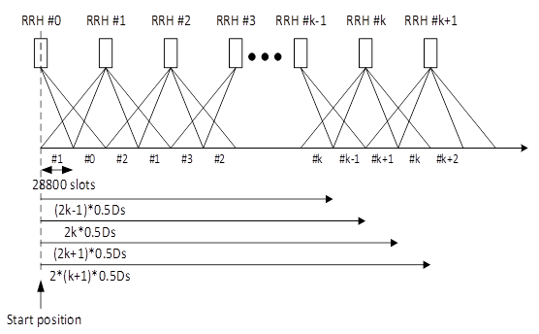

Figure 7.3.1-4: TCI switching for Bi-directional Scenario B

PDSCH allocation time for Bi-directional scenario with DPS scheme 1a

RAN4 apply the following value for PDSCH allocation timeline for Bi-directional scenario A with DPS scheme 1a:

- THARQ = 4 (slots)

- TMAC proc = 24 (slots)

- TTRSproc  = 16 (slots)

- TSSB pros = 16 (slots)

- TfirstSSB = 132 (slots)

- TfirstTRSafterSSB =66 (slots)



Figure 7.3.1-4: PDSCH allocation timeline for Bi-directional scenario B with DPS scheme 1a

RAN4 will not consider the following period after receiving MAC CE active TCI switching from the throughput statistics:

- THARQ+TMAC Proc+TfirstSSB + TSSB proc +TfirstTRSafterSSB+ TTRS pro as baseline, where:

- THARQ: Number of slots between PDSCH and corresponding HARQ-ACK information

- TMAC proc: Number of slots for MAC CE processing

- TfirstSSB is the number of slots to the first SSB transmission occasion after MAC CE command is decoded by the UE

- TSSB proc is the number of slots for SSB processing

- TfirstTRSafterSSB is the number of slot to the first TRS transmission occasion available after (TfirstSSB + TSSB proc)

- TTRS pro is the number of slots for TRS processing

FFS the value of THARQ, TMAC Proc, TfirstSSB, TfirstTRSafterSSB, TTRS pro

SCS and BW:

- Option 1: 120KHz with 100MHz; or

- Option 2: 120KHz with 200MHz.

BW:

- 200 MHz CBW is defined.

Regarding the test setup for PDSCH RAN4 has reached following agreements:

RS configuration:

1) the assumption of RS for frequency offset tracking is up to UE implementation. The RS configuration for PDSCH requirement is FFS and options are:

a) Configure SSB every 20ms; and

b) Configure TRS every 10ms; and

c) Configure PTRS with KPT-RSS=2 and LPT-RS=1.

- It is agreed to configure SSB transmission period as 20ms and TRS transmission period as 10ms for FR2 HST UE PDSCH demodulation requirement test. Configuration SSB slot offset as 0 as baseline

DMRS configuration. RAN4 has agreed:

- 1+1+1 DMRS configuration for DPS scheme.

UE frequency error:

- RAN4 agreed not consider extra UE frequency error for demodulation tests in FR2 HST WI. Any impact of UE frequency error can be included in companies’ impairment results when RAN4 sets the UE demodulation requirement for FR2 HST.

PDSCH simulation assumptions:

Simulation assumptions for results alignment and further requirements definition are summarized in Table 1.

Table 7.3.1-1: Simulation assumptions for results alignment and further requirements definition.

|  |  |  |  |
| --- | --- | --- | --- |
| Parameter | | | Value |
| Carrier frequency | | | 30 GHz |
| Duplex mode | | | TDD |
| SCS | | | 120 kHz |
| CBW | | | 200 MHz |
| Antenna configuration | | | 2x2 |
| TDD pattern | | | DDDSU, S: 10D + 2G + 2U  Schedule PDSCH in special slots (Note 1) |
| PDSCH DMRS configuration | DMRS type | | Type 1 |
| Number of additional DMRS | | 2 |
| Maximum number of OFDM symbols for DL front loaded DMRS | | 1 |
| PDSCH configuration | Mapping type | | Type A |
| Starting symbol (S) | | 1 |
| Length (L) | | 13 |
| PRB bundling size | | 2 |
| Resource allocation type | | Type 0 |
| RGB size | | Config2 |
| CSI-RS for tracking | Resource set #1 | First OFDM symbol in the PRB used for CSI-RS | l0 = 5 for CSI-RS resource 1 and 3  l0 = 9 for CSI-RS resource 2 and 4 |
| CSI-RS density | 3 |
| CSI-RS periodicity | 80 slots for CSI-RS resource 1,2,3,4 |
| CSI-RS offset | 2 for CSI-RS resource 1 and 2 3 for CSI-RS resource 3 and 4 |
| Frequency occupation | Start PRB 0  Number of PRB =  ceil(BWP size/4)*4 |
| QCL info | TCI state #2 |
| Resource set #2 | First OFDM symbol in the PRB used for CSI-RS | l0 = 6 for CSI-RS resource 5 and 7  l0 = 10 for CSI-RS resource 6 and 8 |
| CSI-RS density | 3 |
| CSI-RS periodicity | 80 slots for CSI-RS resource 5,6,7,8 |
| CSI-RS offset | 2 for CSI-RS resource 5 and 6 3 for CSI-RS resource 7 and 8 |
| Frequency occupation | Start PRB 0  Number of PRB =  ceil(BWP size/4)*4 |
| QCL info | TCI state #3 |
| TCI state #0 | Type 1 QCL information | CSI-RS resource | CSI-RS for resource 1 from “CSI-RS for tracking Resource set #1” configuration |
| QCL type | Type A |
| Type 2 QCL information | CSI-RS resource | CSI-RS for resource 1 from “CSI-RS for tracking Resource set #1” configuration |
| QCL type | Type D |
| TCI state #1 | Type 1 QCL information | CSI-RS resource | CSI-RS for resource 5 from “CSI-RS for tracking Resource set #2” configuration |
| QCL type | Type A |
| Type 12QCL information | CSI-RS resource | CSI-RS for resource 5 from “CSI-RS for tracking Resource set #2” configuration |
| QCL type | Type D |
| TCI state #2 | Type 1 QCL information | SSB index | SSB #0 |
| QCL type | Type C |
| Type 2 QCL information | SSB index | SSB #0 |
| QCL type | Type D |
| TCI state #3 | Type 1 QCL information | SSB index | SSB #1 |
| QCL type | Type C |
| Type 2 QCL information | SSB index | SSB #1 |
| QCL type | Type D |
| PTRS configuration | Frequency density (KPT-RS) | | 2 |
| Time density (TPT-RS) | | 1 |
| MCS and Rank | | | MCS 17 and Rank 2 |
| Number of HARQ processes | | | 8 |
| SSB and CSI-RS for tracking assumptions | | | 2 SSBs associated with 2 CSI-RS resources sets for PDSCH requirement, where SSB # (k mod 2), CSI-RS (for tracking) resource set # ((k mod 2) + 1), CSI-RS (for CSI acquisition) resource set # ((k mod 2) + 3) and CSI-RS (for beam refinement) resource set # ((k mod 2)+5) are transmitted by kth RRH |
| SSB periodicity | | | 20ms |
| SSB slot offset | | | 0 |
| Propagation conditions | | | Uni-directional Scenario A, Bi-directional Scenario B |
| Maximum Doppler shift | | | 9722 |
| Test metric | | | SNR at 70% of maximum throughput |
| NOTE 1: For further study  NOTE 2: Other remaining parameters can be found in TS 38.101-4 Table 7.2-1 and Table 7.2.2.2.1-2 | | | |

CSI-RS/TRS configuration:

RAN4 will use TRS configuration for TRS resource set 2 with l0 =4/8

NZP CSI-RS resources configuration:

In the test, configure NZP CSI-RS resources for CSI acquisition for all the TCI states so that the target TCI sate is known at the active TCI switching.

UE demodulation test:

For Test cases definition and test applicability rule RAN4 will define UE demodulation requirements with transmission schemes with test applicable rule as:

1) Case 1: Uni-directional scenario A with DPS scheme 1b.

2) Case 2: Bi-directional scenario B with DPS scheme 1a.

3) Test applicable rule

a) If UE is capable of more than 1 activated TCI state, UE should pass test both case 1 and case 2, otherwise, UE should only pass test of case 2

4) It is RAN4 common understanding that if UE passes case 1 (Uni-directional scenario A with DPS scheme 1b), the performance of Uni-directional scenario B with DPS scheme 1b are also guaranteed.

Test setup for PDSCH allocation timeline for Uni-directional scenario:

1) Step 1: Two RRHs of RRH#(2k), RRH#(2k+1) are assumed, and SSB#(2k mod 4) and SSB#((2k+1 )mod 4) are transmitted for each TRPs, separately, where k is the RRH number with k =0, 1, 2, ….

a) UE is configured with TCI#(2k mod 4) and TCI #((2k+1)mod 4) that are associated with TRS #(2k mod 4) and TRS#((2k+1)mod 4) transmitted from RRH#(2k) and RRH#(2k+1) respectively by RRC signalling tci-StatesToAddModList in the PDSCH-Config and tci-PresentInDCI is not configured;

b) All the configured TCI states are known to UE. UE is configured with NZP-CSI-RS resource for L1-RSRP measurements by RRC signalling nzp-CSI-RS-ResourceSet within the CSI-ResourceConfig and periodic CSI reporting by setting reportConfigType to periodic and reportQuantity to cri-RSRP (Note: reported L1-RSRP mesurements are not tested)

2) Step 2: TE actives TCI #0 for PDCCH by “TCI State Indication for UE-specific PDCCH MAC CE”;

3) Step 3: PDSCH associated with TCI #0 is transmitted during the slots from 0 to [n+ THARQ + TMAC]

4) Step4 : In slot n TE start triggering TCI state switching command to TCI #1 by “TCI State Indication for UE-specific PDCCH MAC CE with MCS 4”;

5) Step 5: PDSCH associated with TCI #1 is transmitted in slots from n+1 + THARQ + TMAC to [N].

6) PDSCH associated with TCI#(k mod 4) (k=1) is transmitted in slot from 0 to [n + THARQ + TMAC]

7) PDSCH associated with TCI #(k mod 4) (k=2, 3,…) is transmitted in slot from [(k-1)*n+1 + THARQ + TMAC] to [(k*n+ THARQ + TMAC], where n =57600 is the number of slots between the location of (k-1)Ds- DS_offset and the location of (k)⋅DS-DS_offset. And k is the RRH number in the channel model.

8) PDCCH and PDSCH are DTXed in other slots in which throughput statistics are not considered

9) The output of RRM discussion regarding FR2 HST TCI state switching delay can be considered to PDSCH requirement test setup.

Test setup for PDSCH allocation timeline for Bi-directional scenario:

1) Step 1: Three RRHs of RRH#(k-1), RRH#(k), RRH#(k+1) are assumed, and SSB#((2(k-1)+l)mod8), SSB#((2k+l)mod8), and SSB#((2(k+1)+l)mod8) are transmitted from each TRPs, separately, where k is the RRH number with k=1,2,3,…, l is the SSB index with l=0,1

a) UE is configured with TCI#((2(k-1)+1) mod 8) (l=0,1) , TCI #((2k+1) mod 8) (l=0,1) and TCI#(((2k+1)+1)mod 8) (l=0,1) transmitted from RRH#(k-1), RRH#(k) and RRH#(k+1) respectively by RRC signalling tci-StatesToAddModList in the PDSCH-Config and tci-PresentInDCI is not configured;

b) All the configured TCI states are known to UE. UE is configured with NZP-CSI-RS resource for L1-RSRP measurements by RRC signalling nzp-CSI-RS-ResourceSet within the CSI-ResourceConfig and periodic CSI reporting by setting reportConfigType to periodic and reportQuantity to cri-RSRP (Note: reported L1-RSRP measurements are not tested)

2) Step 2: TE actives TCI #2 for PDCCH by “TCI State Indication for UE-specific PDCCH MAC CE”;

3) Step 3: PDSCH associated with TCI #2 is transmitted during the slots from 0 to [n + THARQ + TMAC pros ];

4) Step 4: In slot n TE start triggering TCI state switching command to TCI #1 by “TCI State Indication for UE-specific PDCCH MAC CE with MCS 4”;

5) Step 5: PDSCH associated with TCI #1 is transmitted in slots from n+1 + THARQ + TMAC proc + TfirstSSB + TSSB proc + TfirstTRSafterSSB + TTRS proc to [2n+ THARQ + TMAC proc]

6) Step 6: In slot 2n TE start triggering TCI state switching command to TCI# 4 by “TCI State Indication for UE-specific PDCCH MAC CE with MCS 4”

7) Step 7: PDSCH associated with TCI #4 is transmitted in slots from [2n+1 + THARQ + TMAC proc + TfirstSSB + TSSB proc + TfirstTRSafterSSB + TSSB proc] to [3n+THARQ + TMAC proc];

8) PDSCH associated with TCI#(2k mod 8) (k=1) is transmitted in slot from 0 to [n+ THARQ + TMAC proc]

9) PDSCH associated with TCI #(2k mod 8) (k=2,3, …) is transmitted in slot from [(2k-2)n +1 + THARQ + TMAC proc + TfirstSSB + TSSB proc + TfirstTRSafterSSB + TTRS proc] to [(2k-1)n + THARQ + TMAC proc]

10) PDSCH associated with TCI #((2k+1)mod 8) (k=0,1,2,…) is transmitted in slot from [(2k+1)n +1+ THARQ + TMAC proc + TfirstSSB + TSSB proc + TfirstTRSafterSSB + TTRS proc] to [(2(k+1)n+ THARQ + TMAC proc) where n =28800 slots is the half of the number of slots between two RRHs.

11) PDCCH and PDSCH are DTXed in other slots in which throughput statistic are not considered

12) The output of RRM discussion regarding FR2 HST TCI state switching time line can be considered to PDSCH requirement test setup

### 7.3.2 BS demodulation requirements

Define manufacturer declaration, applicable to BS Type 2-O, for PUSCH additional DM-RS in FR2 HST scenario.  
The intention is that all combinations of pos0, pos1, and pos2 should be possible to declare. Exact wording is FFS.

FR2 HST PUSCH requirement test shall apply only for the additional DM-RS position declared to be supported.   
If more than one DMRS configuration is declared to be supported, the test shall be done for the minimum number of DMRS supported.

RAN4 will adopt the following manufacturer declaration for different additional DM-RS position support for FR2 HST:

- Additional DM-RS position for FR2 high speed train: Declaration of supported additional DM-RS position(s) for FR2 high speed train scenario for PUSCH and UL timing adjustment, i.e., pos0, pos1, pos2, or any combination.

Test scope of UL requirements. RAN4 will only define the following BS demodulation performance requirements in Rel-17 FR HST WI

- PUSCH

1) RAN4 agreed to introduce PUSCH requirement with Doppler frequency as 19444Hz targeting 350km/h at 30GHz.

2) Additionally, RAN4 has agreed not introduce PUSCH requirement with Doppler frequency as 14444Hz targeting 260km/h at 30GHz, if no issue with supporting 350km/h was identified.

3) No dedicated PUSCH requirement for bidirectional Scenario A

4) Introduce PUSCH requirement for unidirectional and bidirectional Scenario B

5) Introduce PUSCH requirement in Uni-directional for Scenario A if the feasibility of Uni-directional deployment is confirmed.

6) Define only one set of requirements for PUSCH.

7) Define HST FR2 model based on Bi-directional scenario-B model.

8) No test applicability rules are needed.

- UL timing adjustment

1) PRACH

Test Setup for PUSCH requirements:

1) Waveform:

a) Only CP-OFDM.

2) SCS&BW:

a) Option 1: 120KHz SCS with 50MHz, 100MHz or 200MHz; and

b) Option 2: 120KHz SCS with 100MHz; and

c) Option 3: 120KHz SCS with 200MHz.

3) Antenna Configuration:

1) 1Tx2Rx Low.

4) Resource mapping type: type B.

5) Length of data symbol:

The length of PUSCH data symbol is 10.

6) MCS:

a) Only MCS19.

RAN4 agreed to define PUSCH requirements with MCS(s) between MCS16-20 that is/are feasible and testable.

It was agreed to assume a receiver with post FFT FOC.

7) RS configuration:

a) Option 1: 1 DMRS +PTRS (L=1,K=2); and

b) Option 2: 2 DMRS+ PTRS (L=1,K=2); and

c) Option 3: 3 DMRS +PTRS (L=1,K=2) with Option 3a: If companies have strong concern about DMRS 1+1, create an applicability rule that only one DMRS configuration shall be tested by manufacture declaration.

RAN4 agreed following:

a) Define requirement with 1 DMRS + PT_RS (L=1, K=2) configuration

- Define FRC for 1 DMRS + PT_RS (L=1, K=2)

b) Define requirement based on the simulation results with 2 DMRS+ PT_RS (L=1, K=2) configuration, but the final requirements are applicable for both 2 DMRS+ PT_RS (L=1, K=2) and 3 DMRS + PT_RS (L=1, K=2)

- Define FRC for 2 DMRS + PT_RS (L=1, K=2)

- Define FRC for 3 DMRS + PT_RS (L=1, K=2)

8) CBW:

Both 50MHz and 200MHz CBWs are defined with the test applicability rule that only one of them is tested based on BS manufacturer.

9) Phase noise model:

a) No explicit phase noise modelling in the alignment results

b) Realistic phase noise modelling is left up to the contributing entities

c) The phase noise impact can be included in the impairment results, but it is left up to companies

RAN4 agreed no explicit phase noise modelling in the alignment result. Phase noise impact can be included in the impairment results, but it is left up to companies.

10) With regard to the test metric for PUSCH requirements, only 70% of the throughput is used

Table 7.3.2.1 Simulation assumption for PUSCH requirement

|  |  |  |
| --- | --- | --- |
| Parameter | | Value |
| Channel Model | | Uni-directional scenario A and B  Bi-directional scenario B  The details can be referred as R4-2115725 |
| Transform precoding | | Disabled |
| Default TDD UL-DL pattern (Note 1) | | 120kHz SCS:  3D1S1U, S=10D:2G:2U |
| HARQ | Maximum number of HARQ transmissions | 4 |
| RV sequence | 0, 2, 3, 1 |
| DM-RS | DM-RS configuration type | 1 |
| DM-RS duration | single-symbol DM-RS |
| Additional DM-RS symbols | Pos0, Pos1 and Pos2 |
| Number of DM-RS CDM group(s) without data | 2 |
| Ratio of PUSCH EPRE to DM-RS EPRE | -3 dB |
| DM-RS port(s) | {0} |
| DM-RS sequence generation | NID=0, nSCID =0 |
| Time domain resource | PUSCH mapping type | B |
| Start symbol index | 0 |
| Allocation length | 10 |
| Frequency domain resource | RB assignment | 50MHz and 200MHz |
| Frequency hopping | Disabled |
| Code block group based PUSCH transmission | | Disabled |
| PT-RS configuration | Frequency density (KPT-RS) | 2 |
| Time density (LPT-RS) | 1 |
| NOTE 1: The same requirements are applicable to TDD with different UL-DL patterns | | |

Test Setup for UL timing adjustment requirement:

It was agreed to introduce UL timing adjustment requirements for FR2 HST. For test applicability it was agreed to share the same applicability rule with PUSCH. Additionally, it was agreed the manufacturer declaration on HST FR2 DM-RS support – UL TA – to share the same manufacturer declaration with PUSCH.

1) Waveform:

a) Only CP-OFDM.

2) CBW: align CBW for UL timing adjustment and PUCH requirements. 50MHz and 200MHz CBWs are defined with the test applicability rule that only one of them is tested based on BS manufacturer. The existing PUSCH applicability rule for different channel bandwidth for UL timing adjustment requirements are:

a) For each subcarrier spacing declared to be supported, the test requirements for a specific channel bandwidth shall apply only if the BS supports it.

b) Unless otherwise stated, for each subcarrier spacing declared to be supported, the tests shall be done only for the widest supported channel bandwidth. If performance requirement is not specified for this widest supported channel bandwidth, the tests shall be done by using performance requirement for the closest channel bandwidth lower than this widest supported bandwidth; the tested PRBs shall then be centered in this widest supported channel bandwidth.

3) PUSCH resource allocation:

a) 50MHz CBW: 16RBs for each UE, Moving UE RBs: 0~15; Stationary UE RBs: 16~31

b) 200MHz CBW: 66RBs for each UE, Moving UE RBs: 0~65; Stationary UE RBs: 66~131

4) RS configuration:

a) Align RS configuration for UL timing adjustment requirement and PUSCH requirement

RAN4 agreed following:

a) Define requirement with 1 DMRS + PT_RS (L=1, K=2) configuration

- Define FRC for 1 DMRS + PT_RS (L=1, K=2)

b) Define requirement based on the simulation results with 2 DMRS+ PT_RS (L=1, K=2) configuration, but the final requirements are applicable for both 2 DMRS+ PT_RS (L=1, K=2) and 3 DMRS + PT_RS (L=1, K=2)

- Define FRC for 2 DMRS + PT_RS (L=1, K=2)

- Define FRC for 3 DMRS + PT_RS (L=1, K=2)

5) PUSCH mapping type:

a) Type B.

6) Length of PUSCH allocation. Align with PUSCH for UL timing adjustment:

a) Option 1: 10; and

b) Option 2: 9.

7) MSC, Align with PUSCH for UL timing adjustment:

a) Only MCS16 is used.

8) SRS bandwidth configuration:

a) 50MHz CBW (32RBs)~C_SRS =9, B_SRS =0

b) 200MHz CBW (132RBs)~ C_SRS=33, B_SRS=0

9) SRS Transmission comb: KTC=2. SRS transmission in UL timing adjustment requirement is optional

10) SRS Transmission periodicity : KSRS=10.

11)  Slots in which sounding RS is transmitted:

a) The last symbol in slot#3 in radio frames for 120KHz SCS.

It was agreed that the SRS transmission location is the last symbol in slot#3 in radio frame with TDD pattern as DDDSU, S=10:2:2

12) Test Parameters for timing offset:

a) Option 1: A: 1.25 us and Δw: 1.04 s-1 corresponding to 120KHz SCS for HST FR2 UL timing adjustment requirements; and

b) Option 2: FFS on A =2.5 us; and

c) Other options are not preluded

RAN4 agreed to use Option 1.

13) Test different between moving UE and stationary UE:

a) Option 1: [Δt-(TA-31)x16*8Tc]. Note: The timing different can be updated with taken into account the output of possible enhancements for timing adjustment command discussion in RRM session

RAN4 agreed to apply the timing difference between moving UE and stationary UE as Δτ-(TA-31)x16*8Tc for UL timing adjustment requirement

14) The length of PUSCH data is 10

15) Test Scenario:

a) Scenario Y.

16) Simulation Assumption for scenario Y:

a) Option 1.

Table 7.3.2.2 Simulation assumption for UL timing adjustment requirement

|  |  |
| --- | --- |
| Parameter | Value |
| Channel Model | Follow same approach as existing PUSCH UL timing adjustment requirement demodulation requirement specified in TS 38.104 |
| UE Speed | 350 km/h |
| Waveform | CP-OFDM |
| CP Length | Normal |
| A | 1.25 μs |
| ∆ꞷ | 1T2R |
| MCS | 16 |
| CBW | 50MHz and 200MHz |
| DM-RS type | Type 1 |
| Mapping type | B |
| Length of PUSCH data | 10 |
| RS configuration | 1DMRS+PT-RS(L=1,K=2)  2DMRS+PT-RS(L=1,K=2)  3DMRS+PT-RS(L=1,K=2) |
| Number of DM-RS CDM group(s) without data | 2 |
| Ratio of PUSCH EPRE to DM-RS EPRE | -3dB |
| DM-RS port | {0} |
| DM-RS sequence generation | NID0=0, nSCID =0 for moving UE  NID0=1, nSCID =1 for stationary UE |
| PUSCH resource allocation | 50MHz: 0 to 15 RB for moving UE, 16 to 31 for stationary UE (if 100MHz  200MHz: 0 to 65RB for moving UE, 66 to 131 for stationary UE |
| SRS resource allocation | 50MHz CBW (32RBs)~C_SRS =9, B_SRS =0  200MHz CBW (132RBs)~ C_SRS=33, B_SRS=0 |

FRC for FR2 HST PUSCH UL timing adjustment with different RS configuration as following:

Table 7.3.2.3 FRC parameters for FR2 PUSCH performance requirements, transform precoding disabled, Additional DM-RS position = pos0 and 1 transmission layer (16QAM, R=658/1024)

|  |  |  |
| --- | --- | --- |
| Reference channel | G-FR2-Ax-xx | G-FR2-Ax-xx |
| Subcarrier spacing [kHz] | 120 | 120 |
| Allocated resource blocks | 16 | 66 |
| CP-OFDM Symbols per slot (Note 1) | 9 | 9 |
| Modulation | 16QAM | 16QAM |
| Code rate (Note 2) | 658/1024 | 658/1024 |
| Payload size (bits) | 4480 | 18432 |
| Transport block CRC (bits) | 24 | 24 |
| Code block CRC size (bits) | - | 24 |
| Number of code blocks - C | 1 | 3 |
| Code block size including CRC (bits) (Note 2) | 4504 | 6176 |
| Total number of bits per slot with PT-RS (Note 3) | 6624 | 27324 |
| Total symbols per slot with PT-RS | 1656 | 6831 |
| NOTE 1: *DM-RS configuration type* = 1 with *DM-RS duration = single-symbol DM-RS* and the number of DM-RS CDM groups without data is 2, *Additional DM-RS position = pos0*, *l0*= 0 and *l* =10 for PUSCH mapping type B as per table 6.4.1.1.3-3 of TS 38.211 [5].  NOTE 2: Code block size including CRC (bits) equals to *K'* in clause 5.2.2 of TS 38.212 [15].  NOTE 3: PT-RS configuration *KPT-RS =2, LPT-RS =1*. | | |

Table 7.3.2.4 FRC parameters for FR2 PUSCH performance requirements, transform precoding disabled, Additional DM-RS position = pos1 and 1 transmission layer (16QAM, R=658/1024)

|  |  |  |
| --- | --- | --- |
| Reference channel | G-FR2-Ax-xx | G-FR2-Ax-xx |
| Subcarrier spacing [kHz] | 120 | 120 |
| Allocated resource blocks | 16 | 66 |
| CP-OFDM Symbols per slot (Note 1) | 8 | 8 |
| Modulation | 16QAM | 16QAM |
| Code rate (Note 2) | 658/1024 | 658/1024 |
| Payload size (bits) | 2976 | 16392 |
| Transport block CRC (bits) | 24 | 24 |
| Code block CRC size (bits) | - | 24 |
| Number of code blocks - C | 1 | 2 |
| Code block size including CRC (bits) (Note 2) | 2992 | 8232 |
| Total number of bits per slot with PT-RS (Note 3) | 5888 | 24288 |
| Total symbols per slot | 1472 | 6072 |
| NOTE 1: *DM-RS configuration type* = 1 with *DM-RS duration = single-symbol DM-RS* and the number of DM-RS CDM groups without data is 2, *Additional DM-RS position = pos0*, *l0*= 0 for PUSCH mapping type B as per table 6.4.1.1.3-3 of TS 38.211 [5].  NOTE 2: Code block size including CRC (bits) equals to *K'* in clause 5.2.2 of TS 38.212 [15].  NOTE 3: PT-RS configuration *KPT-RS =2, LPT-RS =1*. | | |

Table 7.3.2.5 FRC parameters for FR2 PUSCH performance requirements, transform precoding disabled, Additional DM-RS position = pos2 and 1 transmission layer (16QAM, R=658/1024)

|  |  |  |
| --- | --- | --- |
| Reference channel | G-FR2-Ax-xx | G-FR2-Ax-xx |
| Subcarrier spacing [kHz] | 120 | 120 |
| Allocated resource blocks | 16 | 66 |
| CP-OFDM Symbols per slot (Note 1) | 7 | 7 |
| Modulation | 16QAM | 16QAM |
| Code rate (Note 2) | 658/1024 | 658/1024 |
| Payload size (bits) | 3496 | 14344 |
| Transport block CRC (bits) | 24 | 24 |
| Code block CRC size (bits) | - | 24 |
| Number of code blocks - C | 1 | 2 |
| Code block size including CRC (bits) (Note 2) | 3512 | 7208 |
| Total number of bits per slot with PT-RS (Note 3) | 5152 | 21252 |
| Total symbols per slot | 1288 | 5313 |
| NOTE 1: *DM-RS configuration type* = 1 with *DM-RS duration = single-symbol DM-RS* and the number of DM-RS CDM groups without data is 2, *Additional DM-RS position = pos0*, *l0*= 0 for PUSCH mapping type B as per table 6.4.1.1.3-3 of TS 38.211 [5].  NOTE 2: Code block size including CRC (bits) equals to *K'* in clause 5.2.2 of TS 38.212 [15].  NOTE 3: PT-RS configuration *KPT-RS =2, LPT-RS =1*. | | |

Test setup for PRACH:

1) PRACH format:

- only C2;

- Channel

- AWGN

2) Frequency offset:

a) 19444Hz with 350km/h at 30GHz carrier frequency.

3) Test Preamble Configuration for Ncs. RAN4 agreed to use option 1 as baseline.:

a) Ncs=0

4) Timing offset configuration:

a) Option 1: Reuse Rel-15 FR2 timing offset configuration for PRACH, i.e., 0.8us; and

b) Option 2: Update the timing offset configuration based on the largest expected cell radius, i.e., derived from scenario B. Note:

- Scenario A (Ds=700m, Dmin=10m), cell radius = 700m

- Scenario B (Ds=700m, Dmin=150ms), cell radius = 716ms

RAN4 decided to use one timing offset configuration. Configure the maximum timing offset (i.e., the end of the tested range) in FR2 HST testing setup equal to 4.8us:

- Value of Timing offset: 0

- Step of Timing offset increase: 0.48us

5) Timing error tolerance:

a) 0.07us for AWGN, as a default value for 120KHz SCS.

Table 7.3.2.3 Simulation assumption for PRACH requirement

|  |  |
| --- | --- |
| Parameters | Value |
| Ncs | 0 |
| Logical sequence index | 0 |
| v | 0 |
| Channel | AWGN |
| Antenna configuration | 1T2R |
| SCS | 120KHz |
| Frequency offset | 19444Hz |
| Time error tolerance | 0.07us |
| Timing offset | 4.8us with TO range 0:0.48:4.8 |

Requirement selection:

Apply standard requirement selection to (post-FFT) results with outlier selection, as in Rel-15 [R4-1904713] [R4-19004714]. Choose ideal result alignment threshold as [2.5dB], and impairment threshold as [4dB].

# 8 Conclusion

Annex A (informative):  
Change history

|  |  |  |  |  |  |  |  |
| --- | --- | --- | --- | --- | --- | --- | --- |
| **Change history** | | | | | | | |
| **Date** | **Meeting** | **TDoc** | **CR** | **Rev** | **Cat** | **Subject/Comment** | **New version** |
| 2021-04 | RAN4#98 | R4-2103240 |  |  |  | Way forward on Deployment Scenario and UE RF Requirement for FR2 HST | 0.0.1 |
| 2021-05 | RAN4#98bis | R4-2105794 |  |  |  | WF on FR2 HST RRM requirements | 0.0.1 |
| 2021-05 | RAN4#98bis | R4-2106100 |  |  |  | WF on FR2 HST Deployment Scenario Analysis | 0.0.1 |
| 2021-05 | RAN4#98bis | R4-2106101 |  |  |  | Way Forward on Channel Modeling for FR2 HST | 0.0.1 |
| 2021-05 | RAN4#98bis | R4-2106102 |  |  |  | WF on Demodulation requirement for FR2 HST | 0.0.1 |
| 2021-08 | RAN4#99 | R4-2107861 |  |  |  | WF on UE RF requirement for FR2 HST | 0.1.0 |
| 2021-08 | RAN4#99 | R4-2108660 |  |  |  | WF on FR2 HST Deployment Scenario Analysis | 0.1.0 |
| 2021-08 | RAN4#99 | R4-2108661 |  |  |  | WF on Channel Modeling for FR2 HST | 0.1.0 |
| 2021-08 | RAN4#99 | R4-2108637 |  |  |  | WF for FR2 HST Demodulation | 0.1.0 |
| 2021-08 | RAN4#99 | R4-2108342 |  |  |  | WF on FR2 HST RRM requirements | 0.1.0 |
| 2021-08 | RAN4#99 | R4-2105025 |  |  |  | Channel modeling for FR2 HST and TP to TR 38.854 | 0.1.0 |
| 2021-11 | RAN4#100 | R4-2114976 |  |  |  | WF on UE RF requirement for FR2 HST | 0.1.0 |
| 2021-11 | RAN4#100 | R4-2115725 |  |  |  | WF on Remaining issues on FR2 HST deployment scenario and channel modeling | 0.1.0 |
| 2021-11 | RAN4#100 | R4-2115726 |  |  |  | WF for FR2 HST Demodulation | 0.1.0 |
| 2021-11 | RAN4#100 | R4-2115334 |  |  |  | WF on FR2 HST RRM requirements (part 1) | 0.1.0 |
| 2021-11 | RAN4#100 | R4-2115335 |  |  |  | WF on FR2 HST RRM requirements (part 2) | 0.1.0 |
| 2021-11 | RAN4#100 | R4-2115809 |  |  |  | TP to TR 38.854 – beam dwelling time for FR2 HST | 0.1.0 |
| 2022-01 | RAN4#101 | R4-2120066 |  |  |  | WF on FR2 HST UE requirements | 0.2.0 |
| 2022-01 | RAN4#101 | R4-2120701 |  |  |  | TP to TR 38.854 on Deployment Scenario Analysis for FR2 HST | 0.2.0 |
| 2022-01 | RAN4#101 | R4-2120775 |  |  |  | WF on general and UE demodulation requirement for FR2 HST | 0.2.0 |
| 2022-01 | RAN4#101 | R4-2120703 |  |  |  | WF on BS demodulation requirement for FR2 HST | 0.2.0 |
| 2022-01 | RAN4#101 | R4-2120704 |  |  |  | Simulation assumption for PDSCH requirement for FR2 HST | 0.2.0 |
| 2022-01 | RAN4#101 | R4-2120292 |  |  |  | WF on FR2 HST RRM requirements (part 1) | 0.2.0 |
| 2022-01 | RAN4#101 | R4-2120416 |  |  |  | WF on FR2 HST RRM requirements (part 2) | 0.2.0 |
| 2022-01 | RAN4#101bis | R4-2202594 |  |  |  | WF on FR2 HST RRM requirements (part 1) | 0.3.0 |
| 2022-01 | RAN4#101bis | R4-2202767 |  |  |  | WF on uplink timing for FR2 HST | 0.3.0 |
| 2022-01 | RAN4#101bis | R4-2201847 |  |  |  | TP to TR 38.854 on Mobility Performance in HST FR2 Deployment Scenarios | 0.3.0 |
| 2022-01 | RAN4#101bis | R4-2201848 |  |  |  | TP to TR 38.854 on the Number of Rx beams | 0.3.0 |
| 2022-01 | RAN4#101bis | R4-2202270 |  |  |  | WF on UE RF requirement for FR2 HST | 0.3.0 |
| 2022-01 | RAN4#101bis | R4-2203088 |  |  |  | TP to TR 38.854 on Deployment Scenario Analysis for FR2 HST | 0.3.0 |
| 2022-01 | RAN4#101bis | R4-2203089 |  |  |  | TP to TR 38.854: Coverage analysis | 0.3.0 |
| 2022-01 | RAN4#101bis | R4-2203093 |  |  |  | WF on UE demodulation requirement for FR2 HST | 0.3.0 |
| 2022-01 | RAN4#101bis | R4-2203094 |  |  |  | Simulation assumption for PDSCH requirement for FR2 HST | 0.3.0 |
| 2022-01 | RAN4#101bis | R4-2203006 |  |  |  | WF on BS demodulation requirement for FR2 HST | 0.3.0 |
| 2022-03 | RAN4#102 | R4-2206520 |  |  |  | WF on remaining issues for FR2 PC6 for HST Scenarios | 0.4.0 |
| 2022-03 | RAN4#102 | R4-2206848 |  |  |  | WF on FR2 HST RRM (part 1) | 0.4.0 |
| 2022-03 | RAN4#102 | R4-2207230 |  |  |  | WF on UE demodulation requirement for FR2 HST | 0.4.0 |
| 2022-03 | RAN4#102 | R4-2207235 |  |  |  | WF on BS demodulation requirement for FR2 HST | 0.4.0 |
| 2022-03 | RAN4#102 | R4-2205896 |  |  |  | TP to TR 38.854 – beam coverage for FR2 HST | 0.4.0 |
| 2022-03 | RAN4#102 | R4-2205960 |  |  |  | TP to TR 38.854 on Legacy RRM Requirement Mobility Performance in HST FR2 Deployment Scenarios | 0.4.0 |
| 2022-03 | RAN4#102 | R4-2205961 |  |  |  | TP to TR 38.854 on Analysis of Mobility Performance in HST FR2 Deployment Scenarios | 0.4.0 |
| 2022-03 | RAN4#102 | R4-2206849 |  |  |  | TP to TR 38.854 on the Number of Rx beams | 0.4.0 |
| 2022-03 | RAN#95 | RP-220425 |  |  |  | TR for 1 step approval | 1.0.0 |
| 2022-03 | RAN#95 | RP-220918 |  |  |  | TR for 1-step approval (with editorial changes to comply with TR rules) | 1.0.1 |

|  |  |  |  |  |  |  |  |
| --- | --- | --- | --- | --- | --- | --- | --- |
| **Change history** | | | | | | | |
| **Date** | **Meeting** | **TDoc** | **CR** | **Rev** | **Cat** | **Subject/Comment** | **New version** |
| 2022-03 | RAN#95 |  |  |  |  | Approved by plenary – Rel-17 spec under change control | 17.0.0 |
| 2022-06 | RAN#96 | RP-221681 | 0001 |  | F | CR to TR 38.854 on Bi-directional Scenario-A Mobility Performance | 17.1.0 |
| 2022-06 | RAN#967 | RP-221681 | 0002 |  | F | CR to TR 38.854 on Throughput Performance in HST FR2 Scenarios | 17.1.0 |
| 2022-06 | RAN#96 | RP-221681 | 0003 | 1 | F | CR to TR 38.854 on HST FR2 RA-Based Timing Adjustment | 17.1.0 |
| 2023-06 | RAN#100 | RP-231354 | 0004 |  | F | CR to TR 38.854 on HST FR2 RA-Based Timing Adjustment | 17.2.0 |
| 2023-06 | RAN#100 | RP-231354 | 0005 |  | F | CR to TR 38.854 on Throughput Performance in HST FR2 Scenarios | 17.2.0 |
| 2023-09 | RAN#101 | RP-232491 | 0006 | 1 | F | [NR_HST_FR2] CR to TR 38.854 Rel-17 on UL timing adjustment in between TA | 17.3.0 |

|  |  |  |  |  |  |  |  |
| --- | --- | --- | --- | --- | --- | --- | --- |
| **Change history** | | | | | | | |
| **Date** | **Meeting** | **TDoc** | **CR** | **Rev** | **Cat** | **Subject/Comment** | **New version** |
| 2023-09 | RAN#101 | RP-232515 | 0008 |  | B | CR to TR 38.854 on HST-FR2 Enhanced Tunnel Deployment | 18.0.0 |